Nazarbayev Intellectual school of Physics and Mathematics

Project Work on Information and Communication Technology

Title:  
**School system management NIS PMD Shym. SSM.**

School: Nazarbayev Intellectual School Physics & Mathematics, Shymkent

Performed By: Sadyr Ariana

Accepted by: Baimussayev Sherkhan

2021

Оглавление

(a) Definition, investigation, and analysis 2

(i) Definition – features of objective 2

(ii) Investigation and analysis 3

Investigation 3

Analysis: 7

(b) Design 12

(i) Nature of the solution: 12

Objectives of the system: 12

Entity-relationship diagram: 12

Data flow diagram of the new system: 13

Flow chart of the new system: 14

Data dictionary: 15

Menu and module design: 15

Input Designs: 16

Output Designs: 18

(ii) Intended benefits: 20

(iii) Limits of the scope of the solution: 20

(c) Software development, programming, testing and installation 21

(i) Development 21

(ii) Programming 23

Starting page 23

Signing page 25

Main page 28

Form entry page 30

Photo upload page 34

Page for input of details 38

Searching page 40

Form output page 42

Photo show page 44

Page for output of details 45

Page for output of details for teachers 46

(iii) Testing 48

Test №1 51

Test №2 52

Test №3 55

Test №4 57

Test №5 61

Test №6 64

Test №7 67

Test №8 67

Test №9 71

Test №10 73

Test №11 74

# Definition, investigation, and analysis

## (i) Definition – features of objective

**Description of the organization**

Nazarbayev Intellectual School Physics & Mathematics, Shymkent is a public school for intellectual students who have passed the Cambridge test.

The building consists of 3 floors and 4 blocks. Currently, it has 630 students and 100 Kazakhstani and 10 foreign teachers. Teachers are also hired on condition that they pass the probationary period and examinations. Pupils study up to the 12th grade and each tutor works with a certain class.

Pupils' grades are put in electronic form and are indicated in the diary of the IOS website

**Methods, which are used now**

At the school, information about students is stored on paper or in spreadsheets. The curator collects the documents and stores them in the portfolios of the particular student, which are protected by the archive. There is a school web site where you can view grades and there are tables, where curators enter data and store it on their computer

**Data origin**

The collection of information about students begins at the beginning of the first academic year. Students are divided into classes according to certain categories. Each class is assigned a curator who is responsible for storing the data. Certificates received by a student after contests or olympiads are collected in the student's portfolio.

**Forms the data takes**

The general portfolio has copies of the applicant's birth certificate, applicant's IIN, a copy of the identity card of the parents or the legal representative with an indication of the IIN, medical certificate form 086, address information, a copy of the report card for grade 5 and for the first six months of grade 6 and photos of the applicant size 3x4, 2 pcs. The portfolio is updated every year or month, especially by collecting residence certificates, parental work certificates and copies of identity card in 16th age.

## 

## (ii) Investigation and analysis

### Investigation

The research and information gathering for the future system was done through methods such as interviews and observation. The client is asked certain questions that need to be answered in detail, and thus the advantages and disadvantages of the current system, as well as the detailed features of the future program, are identified. Observation allows the programmer to assess the situation and determine the data used in the school website.

#### Interview

***Q:*** *This year, you became the new curator of the 11E class, with a different line-up. What did you face when you were given control of each student in another class?*

**A:** The problems were related to every student in the class because I didn't know anything about them. I didn't know his parents, their profession and the interests of the student, and I had to collect a little information

***Q:*** *How did you gather information about 23 students? What methods were used?*

**A:** I asked the students myself, and then I looked into their personal files, which included their basic data.

***Q:*** *Where do you keep your students' and their parents' records?*

**A:** All information is stored in his personal file, which is held by the clerk. Records, notifications, receipts are stored in my folders

***Q:*** *What are the challenges of your current work?*

**A:** You need to open personal files, view, sort documents and work with papers manually.

***Q:*** *Do you need a backup?*

**A:** I'm just scanning documents and keeping them in electronic folders. It's not their backup.

***Q:*** *How do you imagine a modern technology or modernized system that can replace the current state of affairs?*

**A:** I think it is possible to make a link that will give both parents and curators access to it and fill in the place of birth, place of residence, phones, e-mail, work, etc.

***Q:*** *How does a computer help your work?*

**A:** Without a computer, it's impossible to work because I'm writing reports, documentation there. If there's anything I need, I'm looking for it on my computer. It is an integral part of my work

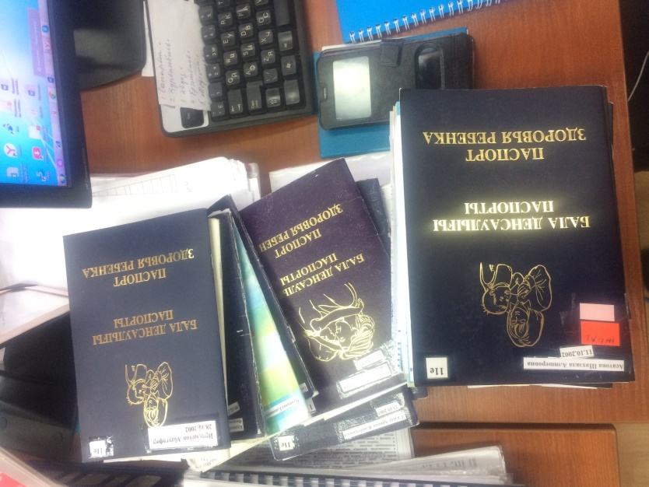

Evidence 1. Medical documents of the student

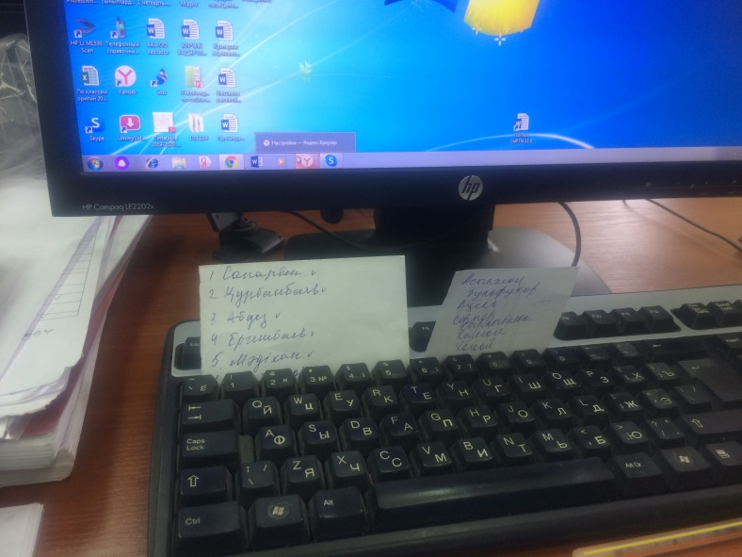

Evidence 2. The notes of the client

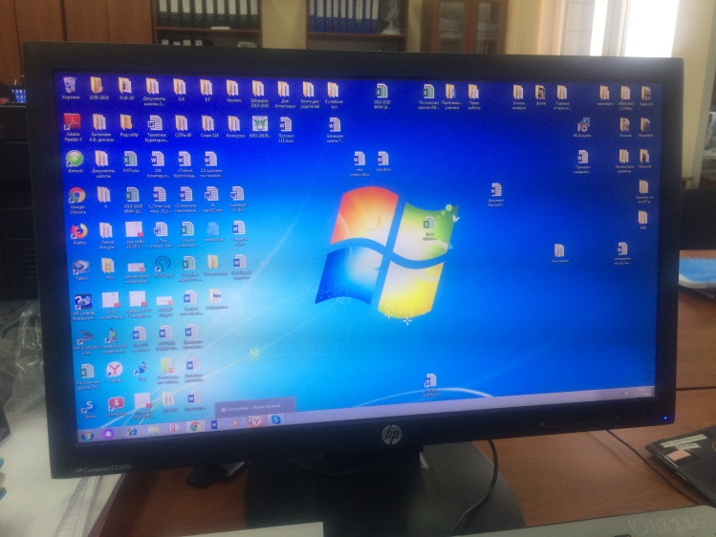

Evidence 3. PC of the client

**Observation:**

In the information-gathering phase, such as observation, I have drawn the following conclusions:

*the curator asks the student or parent to fill out a form or bring a document to gather information

*students sometimes forget or postpone such cases

*to fill the electronic version of the document, curators print it;

*only after students have finished, they copy them into the electronic document;

*documents may be lost and electronic data may not be backed up;

* They manually print and fill the journals;

* Lots of paperwork.

*In addition, a website has been created for curators and it does not store complete information about students. For example, there is the reference 086 and social status. This site is used only by curators. For administrators and teachers there is no access to it.

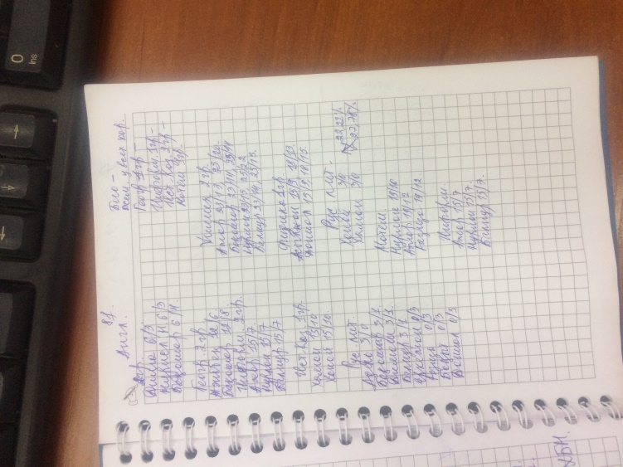

Evidence 4. The notebook of the client

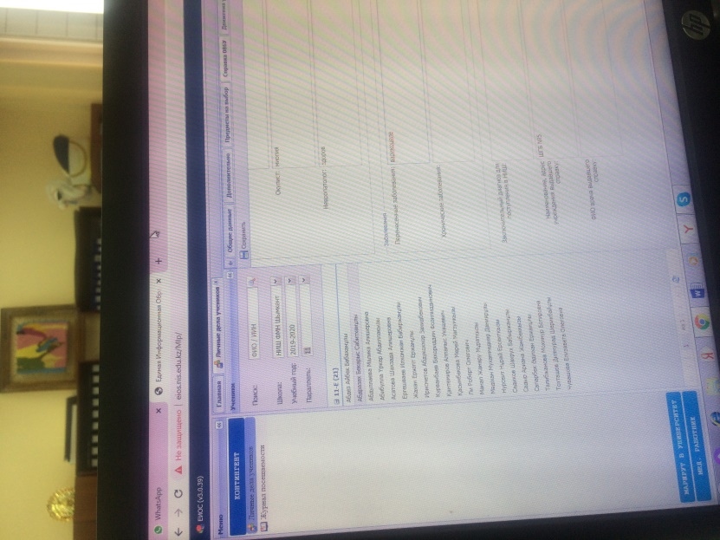

Evidence 5. A school web-site IOS

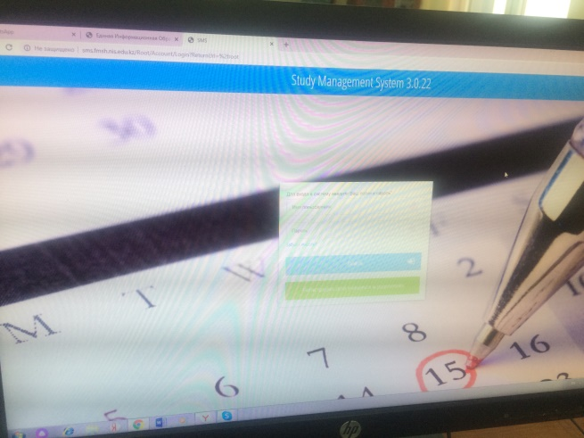

Evidence 6. A school web-site IOS

### 

### Analysis:

From the study, I found out how the information about the students is being collected by the Mentor. The programmer determined what types of processes were needed to enter and output the data. Therefore, they will improve in the future system

#### Input and output processes of the current system:

|  |  |
| --- | --- |
| **Input** | **Processes** |
| Information about student  Information about parents  Medical certificates  Achievements  Grades | Gathering documents  Sorting and categorizing  Putting into portfolios  Updating documents periodically  Informing students and parents to bring them |
| **Output** | **Store** |
| Portfolio  Report card | Students’ portfolio  IOS site |

#### 

#### Input and output of the new system:

|  |  |
| --- | --- |
| **Input** | **Processes** |
| Information about student  Information about parents  Medical certificates  Achievements  Grades | Scanning documents, certificates or other files  Entering data  Searching |
| **Output** | **Store** |
| Electronic-version of documents | User’s login details  Reports |

#### 

#### Data flow diagram of the current system:

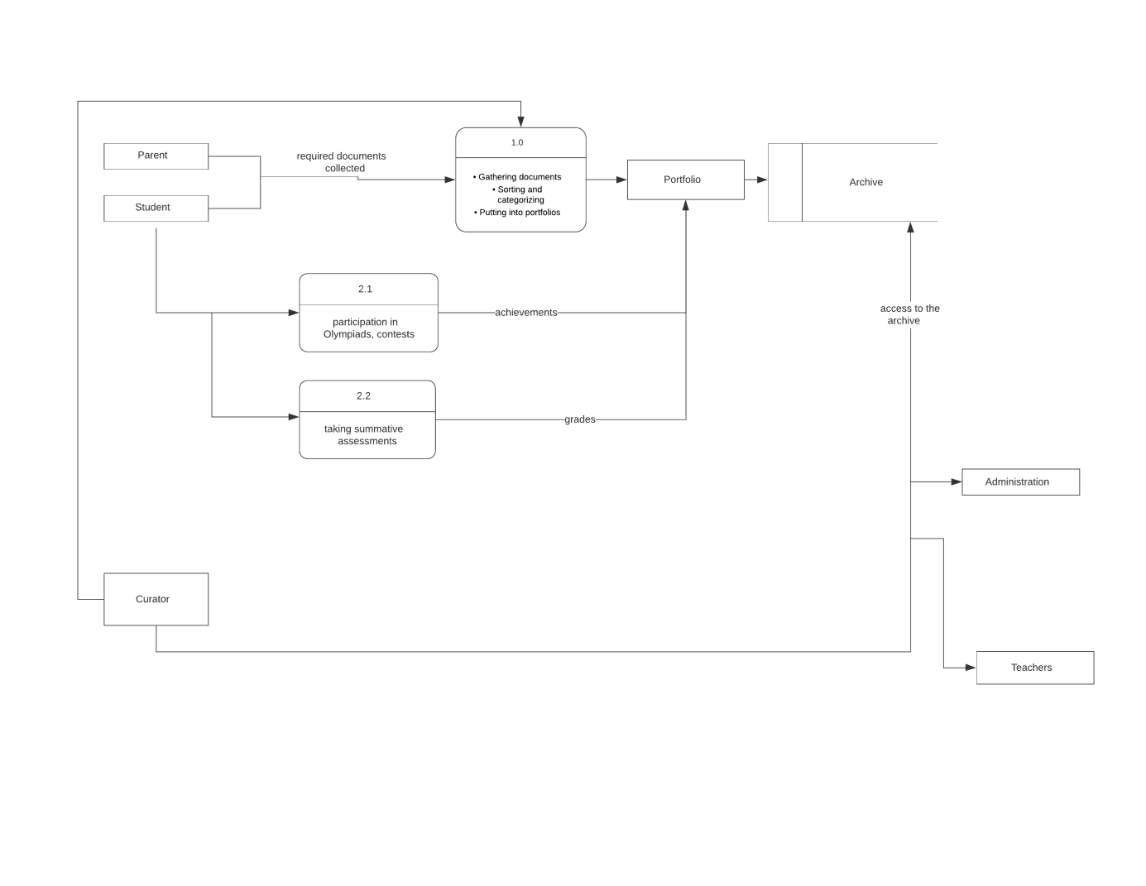

#### Flowchart:

No

No

Yes

Yes

Was the doc.lost?

Administrator request some documents from curator

Curator request this document from student

Did student give this doc.?

Yes

Tick in the curator’s note

Pick x in note

Save this doc. In portfolio

Store info. In excel

Leave portfolio in archive room

Did administrator find doc?

No

Curators look for doc. And give it to administrator

Administrator or teacher took this doc. about student

#### Alternative ways of solving problems:

|  |  |  |
| --- | --- | --- |
| **Approaches** | **Advantages** | **Disadvantages** |
| **PHP web-application** | It is open source and free of cost. It can be downloaded anywhere and readily available to use for the development of web applications.  Platform independent. PHP based applications can run on any operating system  If an individual [knows C programming](https://www.educba.com/career-in-c-programming/) can easily work on PHP. | It is not that secure  PHP do not allow the change or modification in core behavior of the web applications. |
| **Mobile application with android studio** | Full access to the device, in software and hardware  Vision from app stores, and integration with wearables | Different programming languages and skills depending on operating system. |
| **Windows App using VB.NET** | creating web applications with modern features  creating your web forms with much ease through the visual forms designer | working of these apps depends on certain machine  requires memory from the computer and does not work without an object-oriented environment |
| **Saving in electronic folders** | The quickest and potentially qualitative solution of the problem  Curator is able to directly transfer documents into folders | Curator will not have access to information anywhere  Data may be accidentally deleted |

After a thorough review of the pros and cons of all the programs, I decided to create a website, as it can be accessed quickly and easily, is open to a wide audience and I will be able to include creativity in the design myself. I will also learn the new PHP language

**Requirements:**

* The website should contain a database of students
* He must work with the input data
* The site can store scans of references, certificates
* Curator can change information periodically without spending much time on it
* Users will have login and password to access the site
* The site runs a command to search for information about a student
* It can sort information about students and their parents by grade, name, year of birth, curator
* Site has user friendly interface and comfortable design for simplifying system and making it work easily even for people, who cannot fully understand computer commands

#### Software requirements

* Platforms, like Blogger.com, live journal, wordpress.com
* Knowledge about language HTML, CSS, PHP
* Access to the internet

#### Hardware requirements

(I) = Input device  
(O) = Output device

* Mouse - to navigate and move the pieces
* Keyboard - to type in passwords and user details
* (O) Monitor - to display the program
* (IO) PC Computer - to run the code
* (IO) USB - to install
* (IO) Network cards - to share files between users

# Design

## Nature of the solution:

## Objectives of the system:

* work on different Operating Systems
* has user-friendly interface
* allow Mrs. Aizhanat to add a new student
* allow users to sign in with their accounts
* allow Mrs. Aizhanat to manage students’ profiles
* allow Mrs. Aizhanat to manage students’ marks
* provide quick search
* allow administration to find full information about certain student
* allow teachers to find the necessary information
* keep strong security of storing

### Entity-relationship diagram:

There are several students in the same class, and since each person has an individual portfolio, the relationship between them is many to many. There is only one tutor for one class, so the relationship between them is many to one

Curator

Portfolio

Profile

Student

### 

### Data flow diagram of the new system:

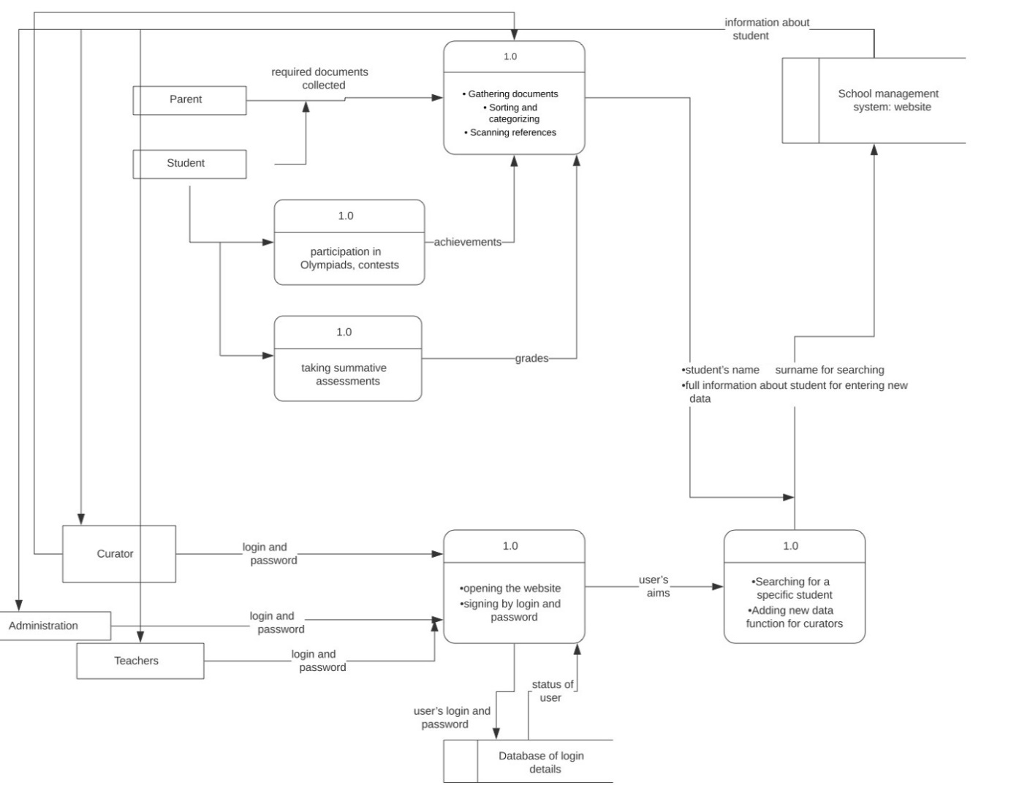

### 

### 

### Flow chart of the new system:

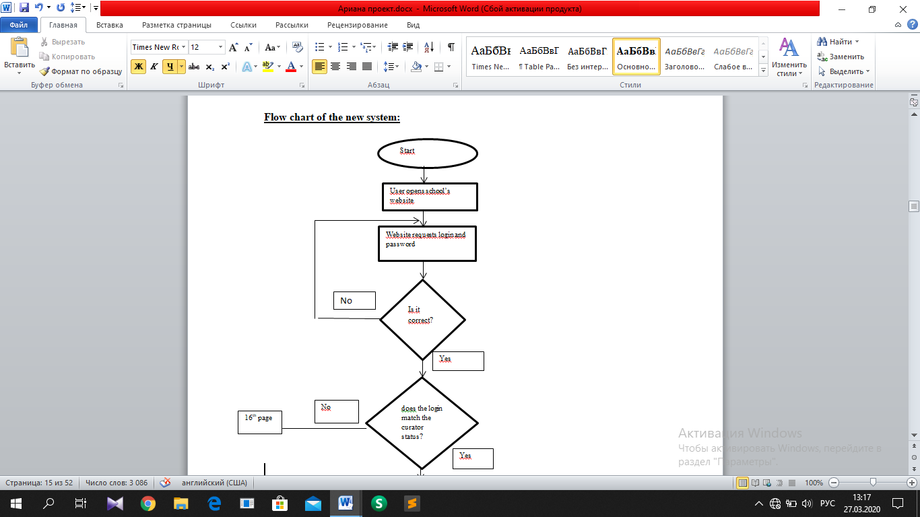

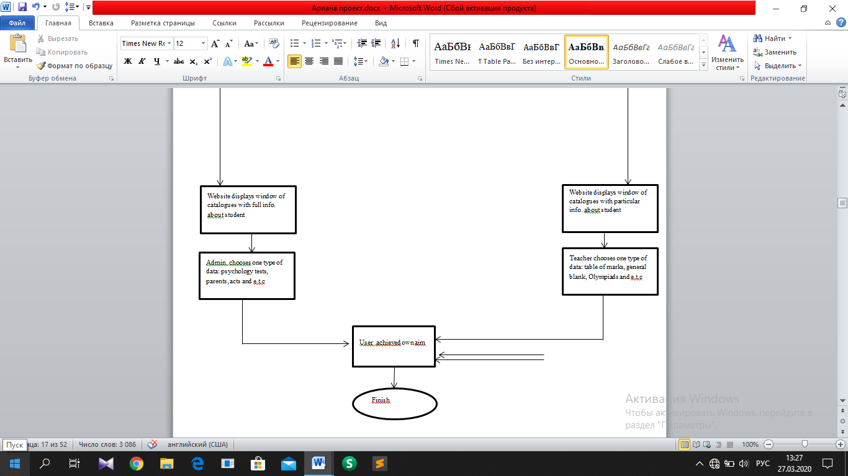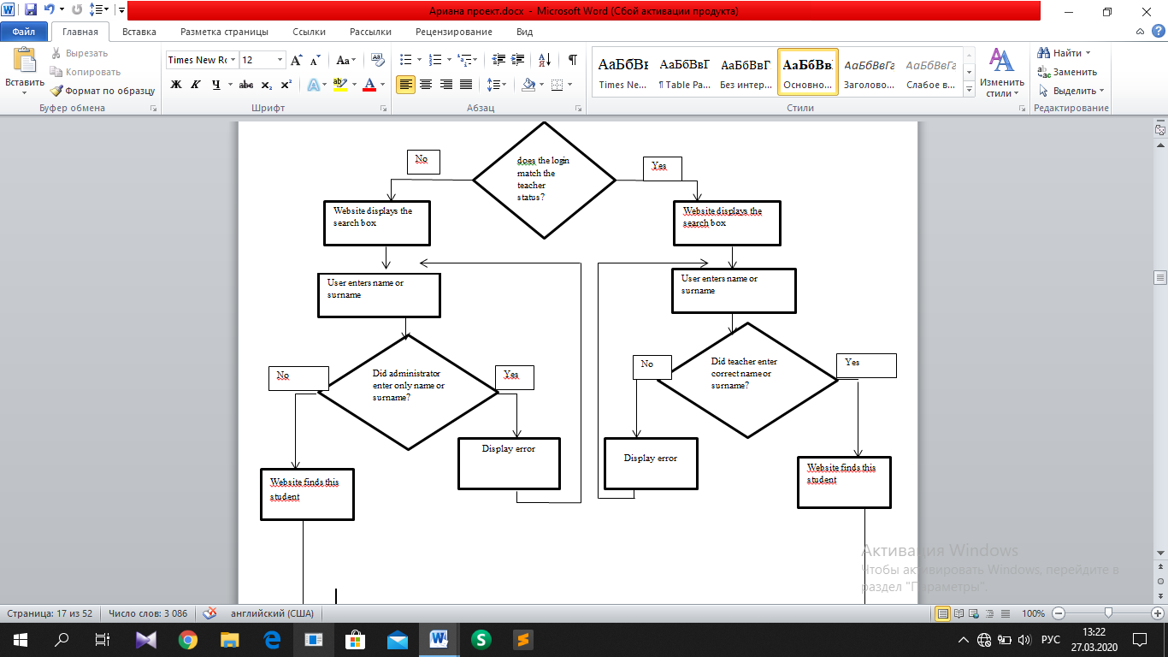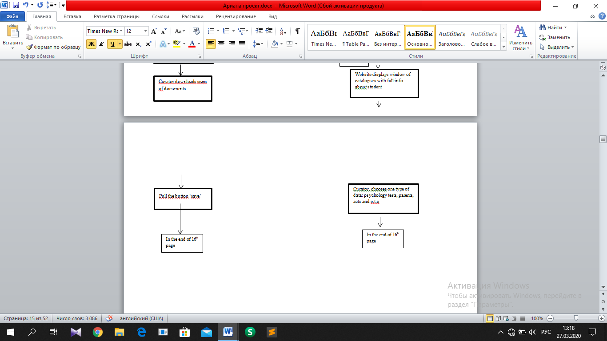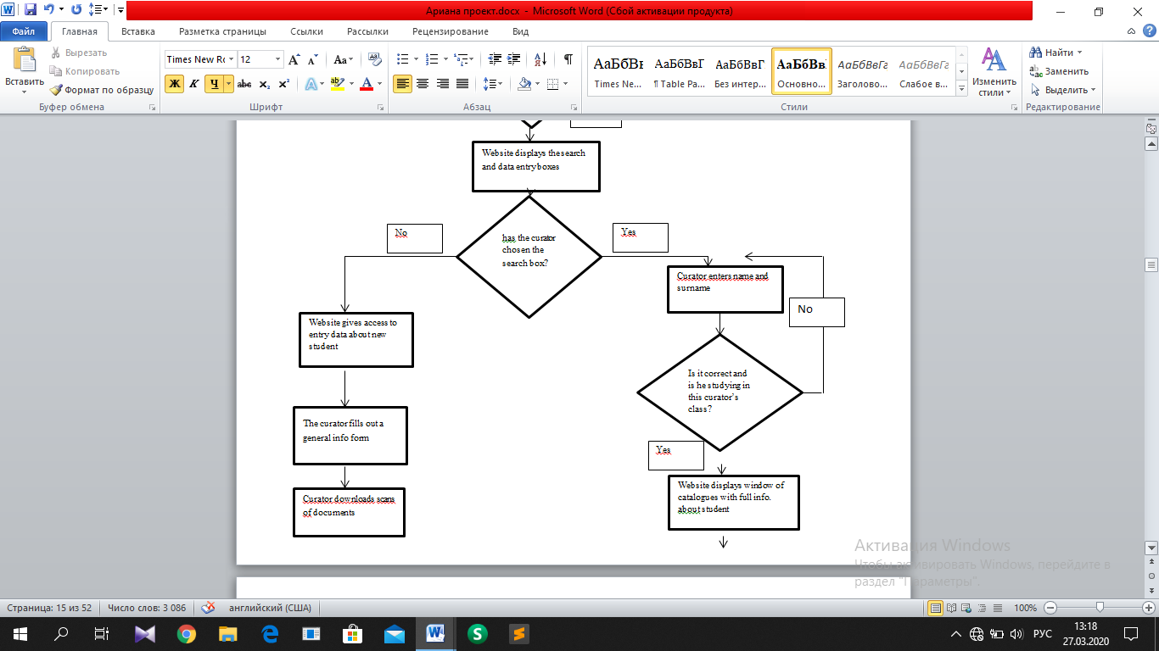

Data dictionary:

|  |  |  |  |  |  |
| --- | --- | --- | --- | --- | --- |
| Field Name | Type | Length | Validation | Description | Example |
| Username | String | 16 | Presence check | name of the user | AizhanatBerdikulovna |
| Password | integer | 12 | Presence check | password of the user | 871205400668 |

Table 1: Users

|  |  |  |  |  |  |
| --- | --- | --- | --- | --- | --- |
| Field Name | Type | Length | Validation | Description | Example |
| IIN | integer | 12 | Unique | unique number of student | 030809500849 |
| Grade | string | 3 | Presence check | grade of the student | 11d |
| Name | string | 16 | Presence check | name of the student | Rakhat |
| Surname | string | 16 | Presence check | the surname of the student | Abdikul |
| Birthday date | date/time | 8 | Valid date | date of birth of the student | 9/08/2003 |

Table 2: Students

### Menu and module design:

This system will be divided into several pages, forming a correctly working site. The link between the pages is important for the work of the site, as only curators can enter information about students and administrators, teachers can only view everything.

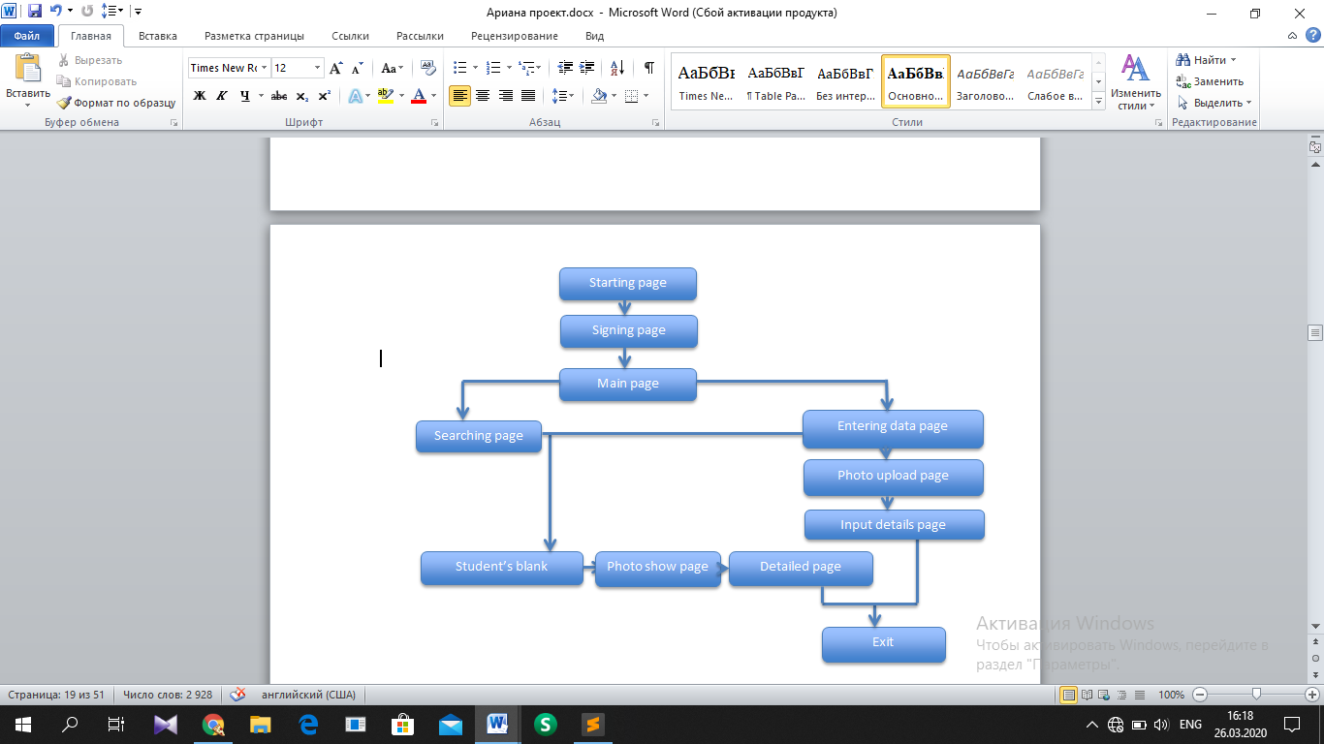

### 

### Input Designs:

**The signing page**

The page displays two fields for login and password to go to the main system

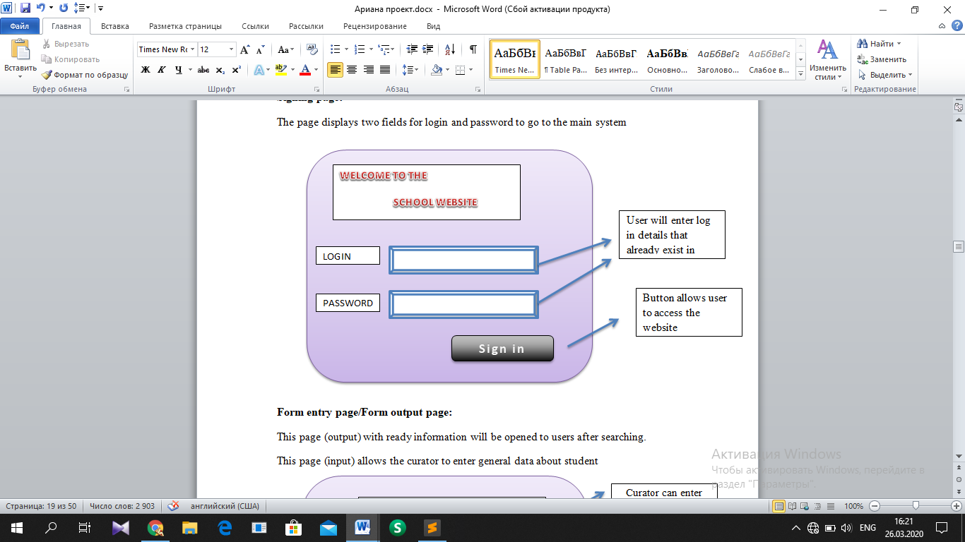

**Form entry page/Form output page:**

This page (output) with ready information will be opened to users after searching.

This page (input) allows the curator to enter general data about student.

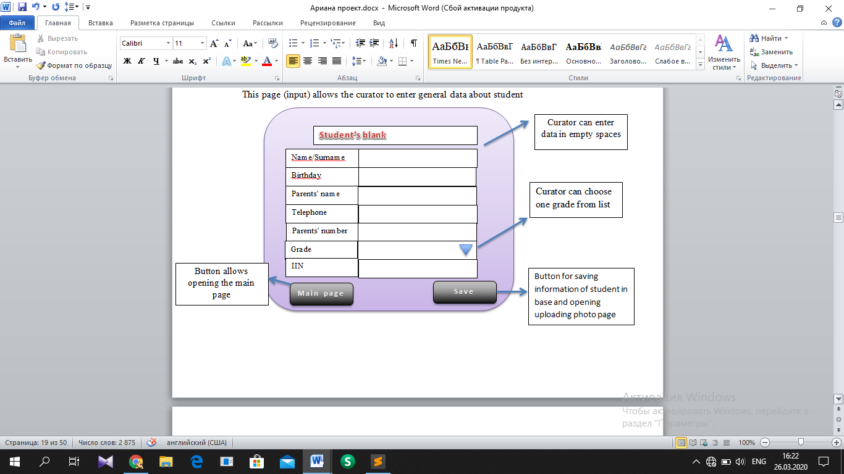

**Upload photo page/ Photo show page:**

After filling blank, curator uploads 3*4 photo of student in this page. Other users can see photo of student by entering his/her IIN in the field instead of button ‘Choose photo’

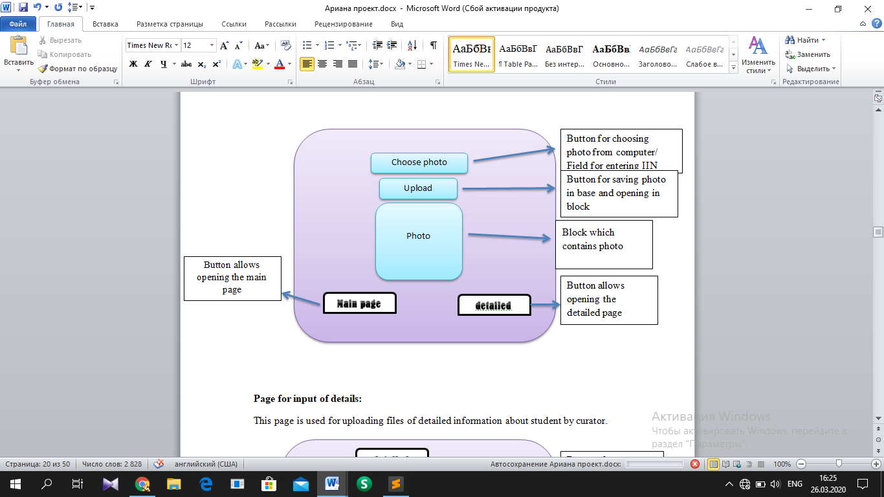

**Page for input of details:**

This page is used for uploading files of detailed information about student by curator.

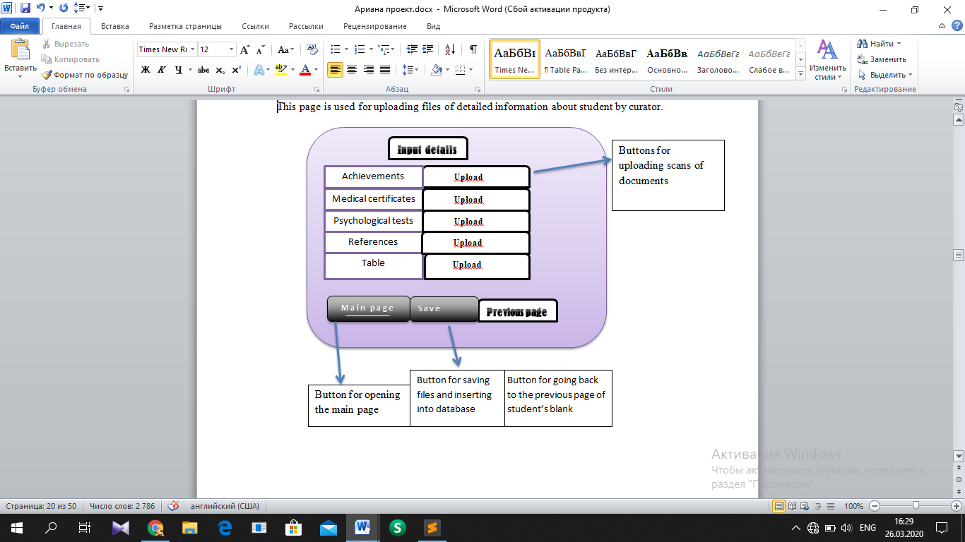

**Searching page:**

User can enter name or surname of student in space and pull the button search

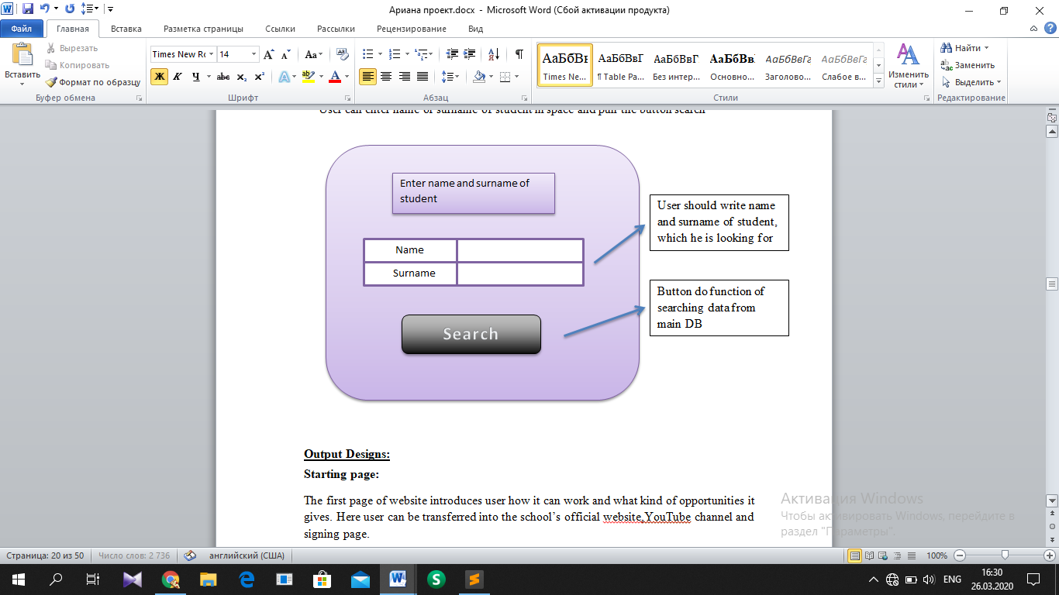

### Output Designs:

**Starting page:**

The first page of website introduces user how it can work and what kind of opportunities it gives. Here user can be transferred into the school’s official website,YouTube channel and signing page.

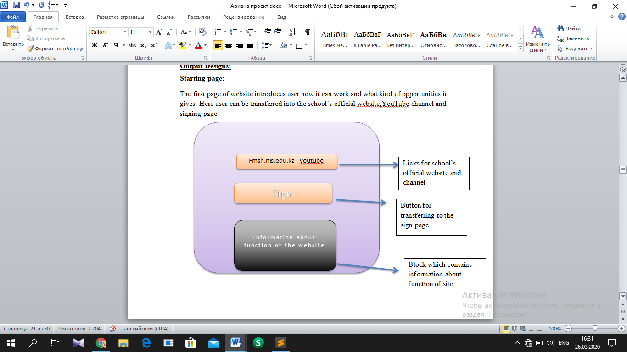

**Main page:**

This page can be opened after signing, if user is curator.

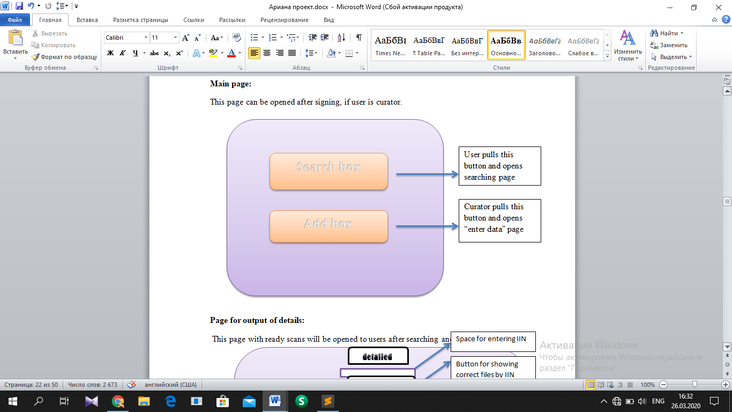

**Page for output of details:**

This page with ready scans will be opened to users after searching and viewing to the blank.

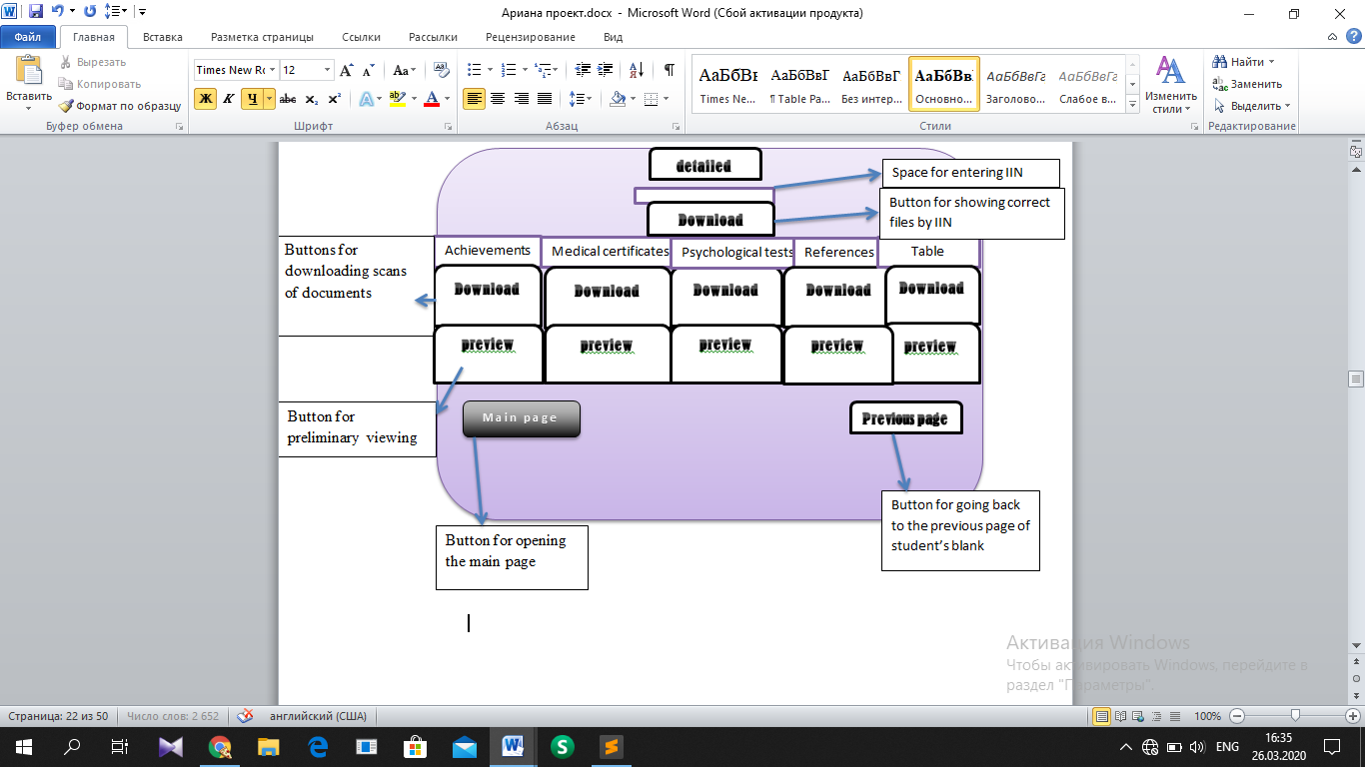

1. Intended benefits:

* This system solves the problem of time-consuming, as the function of searching for information about student quickly finds a particular student by name and surname
* It also allows administrators and teachers to access the database and view student’s documents
* The site is easy to use for everyone. Buttons and fields allow each user to perform operations and save everything
* High level of protection. When opening it, the site asks for a login and password, checks them from outer database of these details, and then displays specific pages by user status. Only curators can enter data into the form and other pages

1. Limits of the scope of the solution:

* This site cannot provide more opportunities for administrators and teachers, such as commenting behavior or predictions for exams
* Parents of students do not have access to the site
* Curators should be careful when entering data and loading the necessary documents into the correct boxes

1. Software development, programming, testing and installation
2. Development

* Draughts
  + Pages
    - * Starting
      * Signing
      * Main
      * Form entry
      * Photo upload
      * Page for input of details
      * Searching
      * Form output
      * Page for output of details
      * Photo show
  + Tables
    - * tblUsers
      * tblStudents
      * tblImages
      * tblFiles
  + Queries
    - * SELECT to check login details on pageSignIn
      * SELECT to list students name on frmProfile
      * INSERT to add data about new student on pageEnterdata

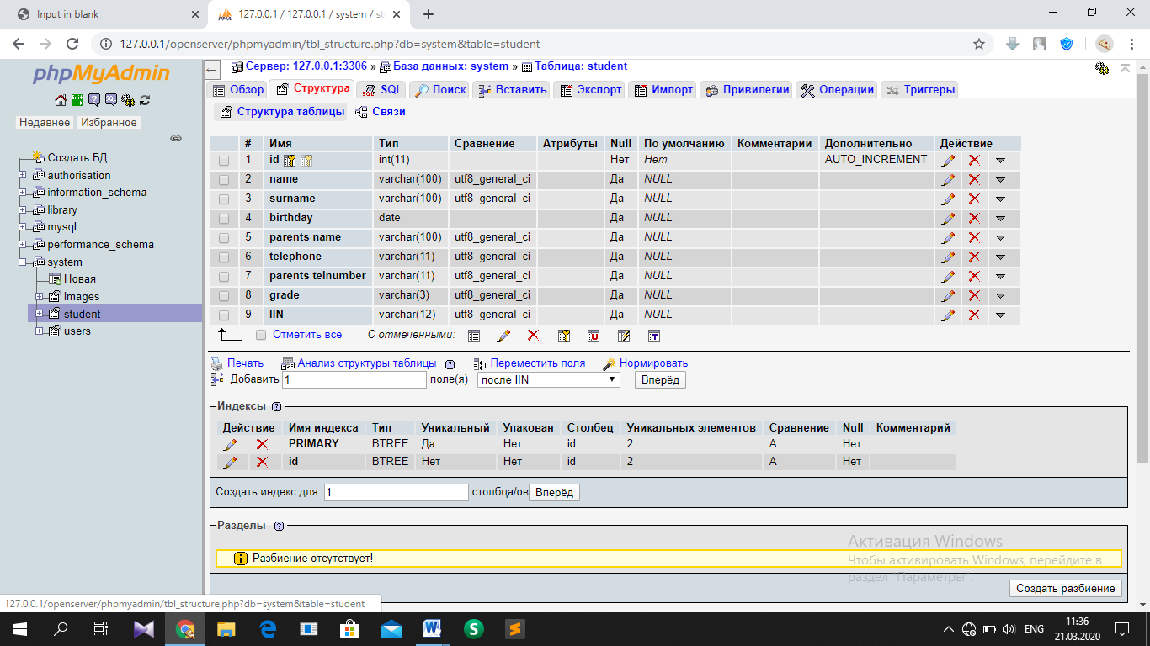

tblStudent

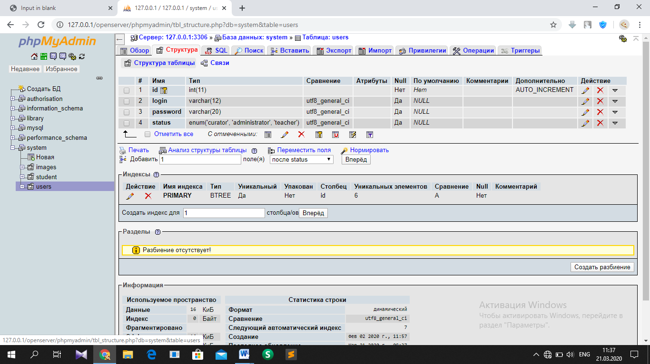

tblUsers

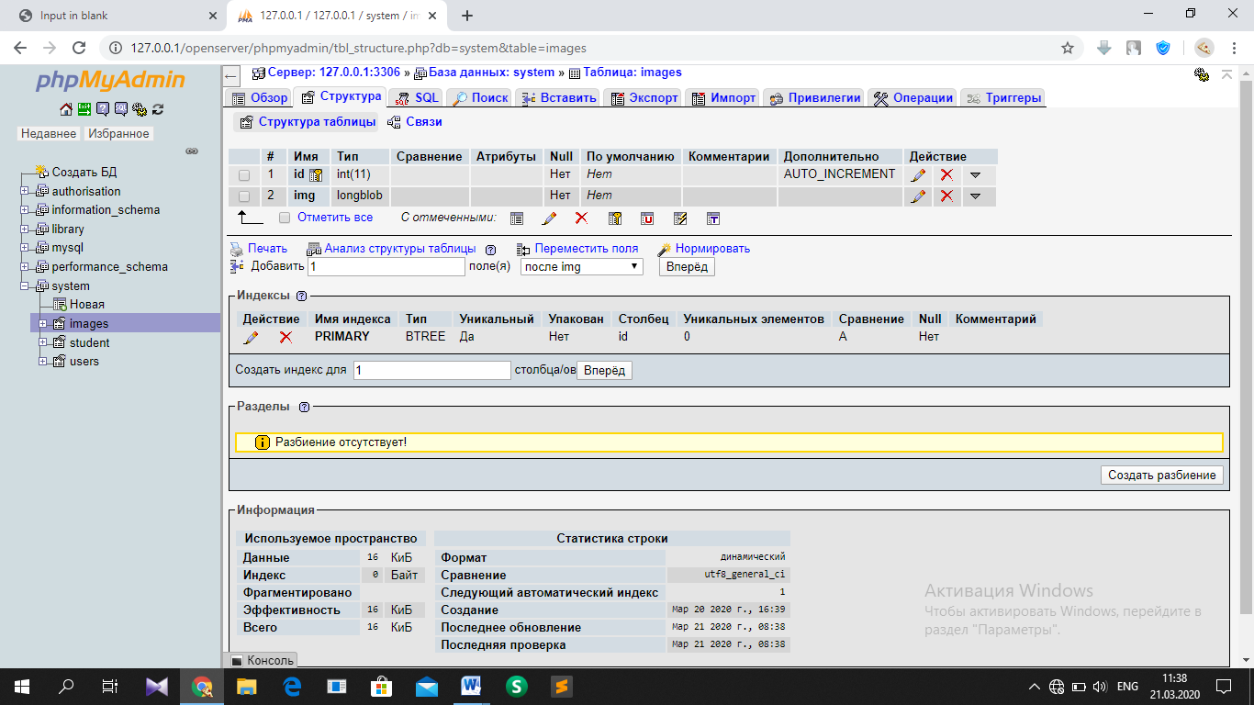

tblImages

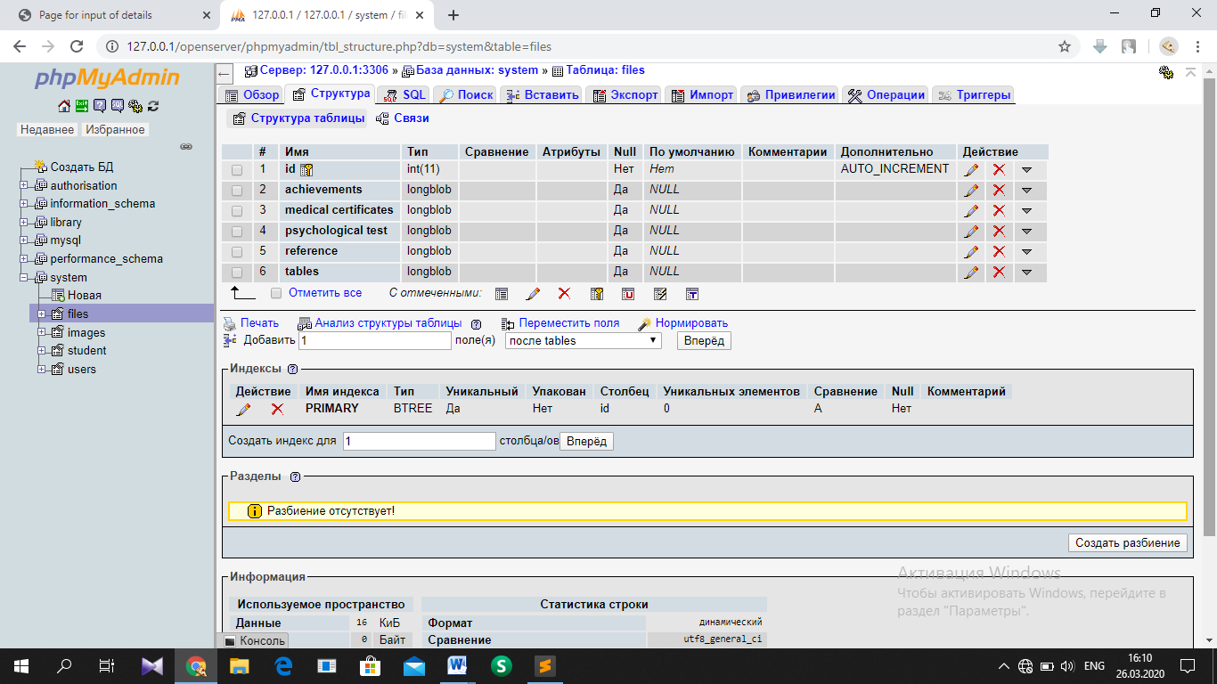

tblFiles

1. Programming

Starting page

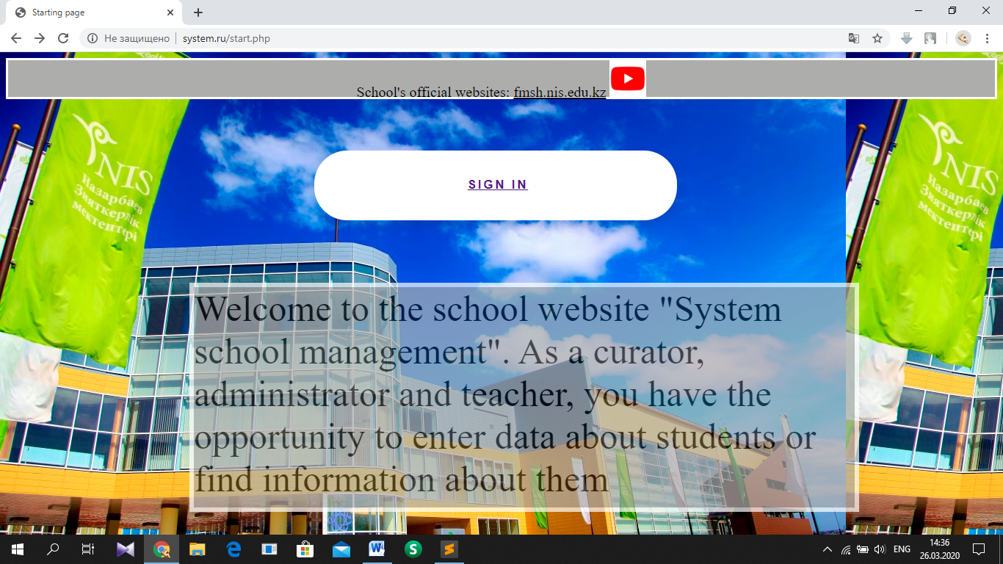

HTML part: ‘http://system.ru/start.php’

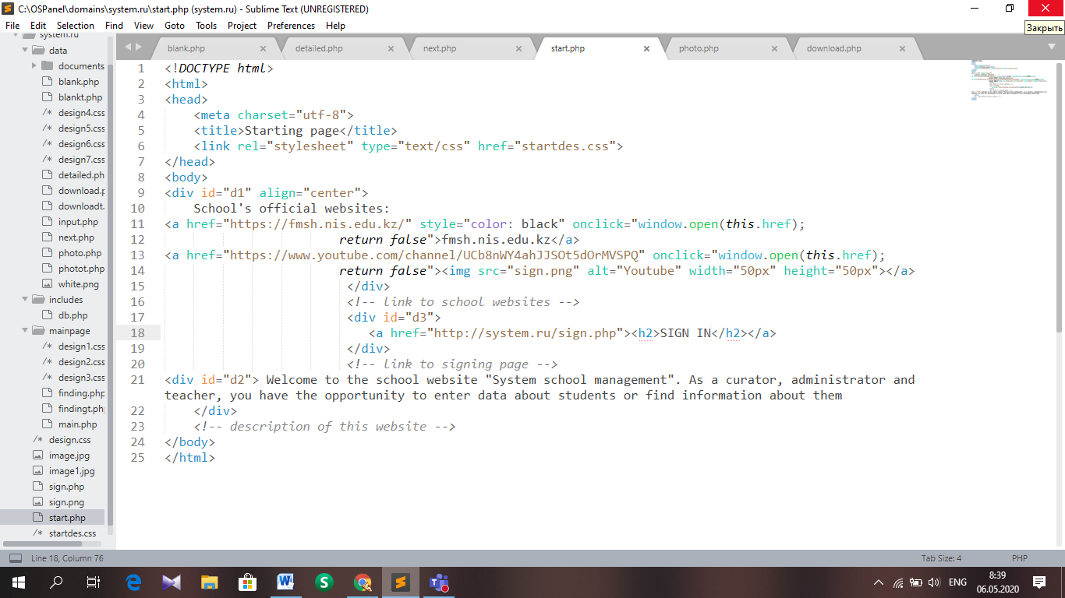

CSS part: ‘http://system.ru/startdes.css’

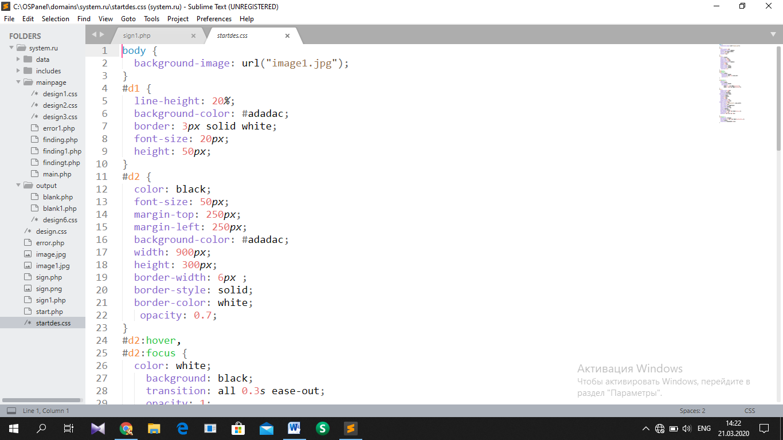

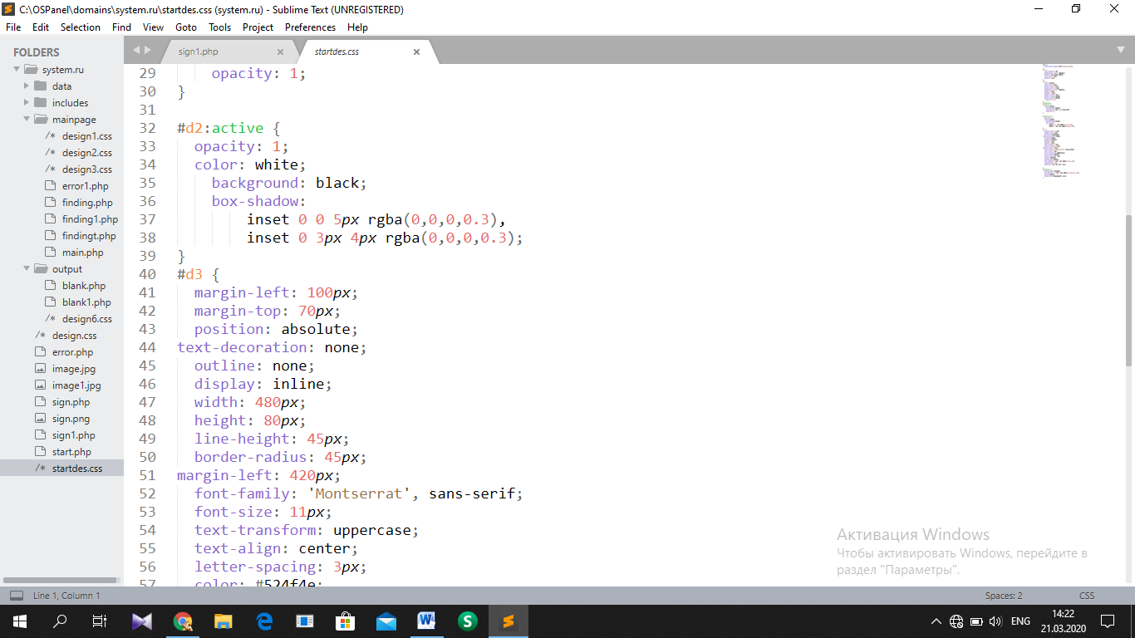

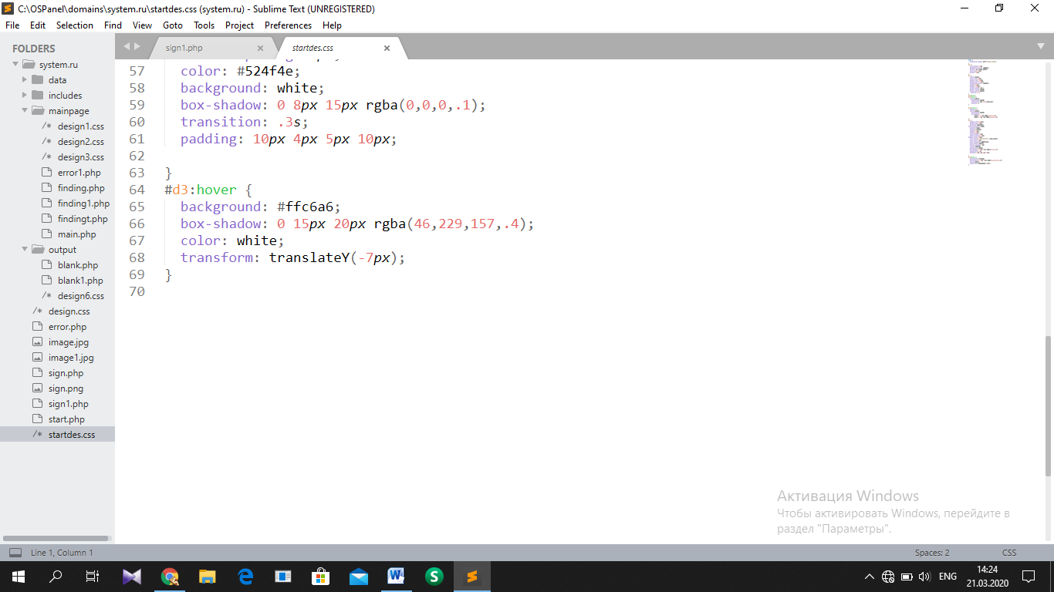

Signing page

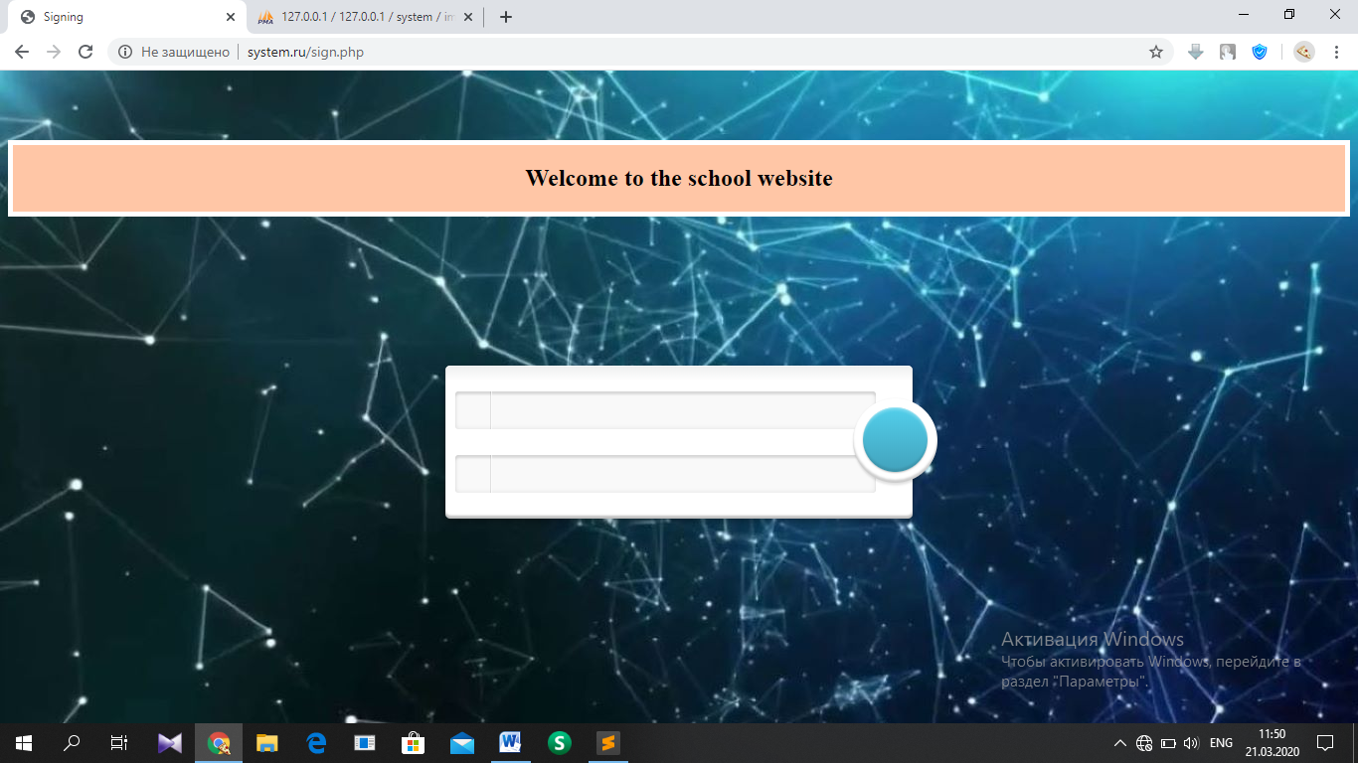

HTML, PHP part: ‘http://system.ru/sign.php’

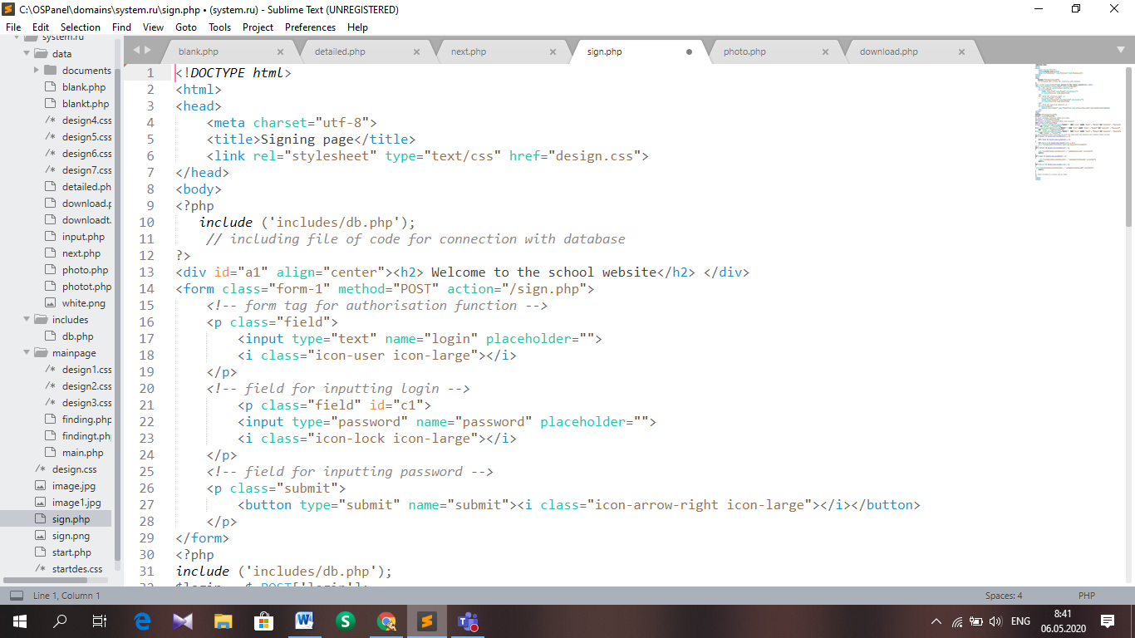

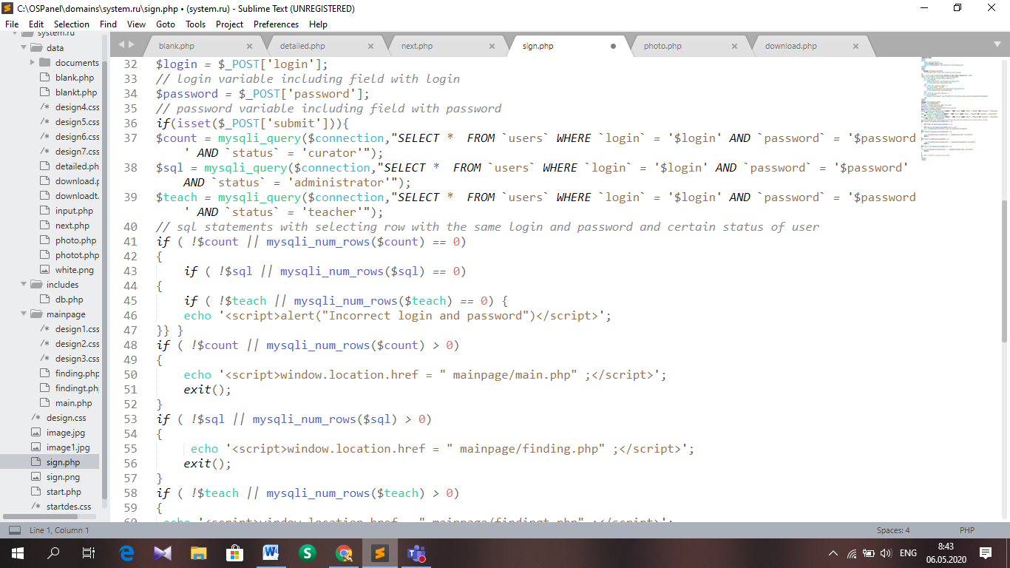

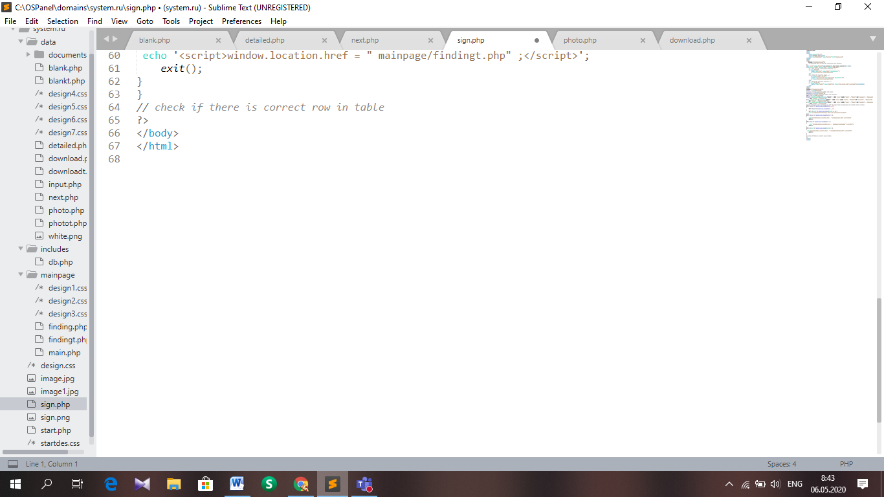

CSS part: ‘http://system.ru/design.css’

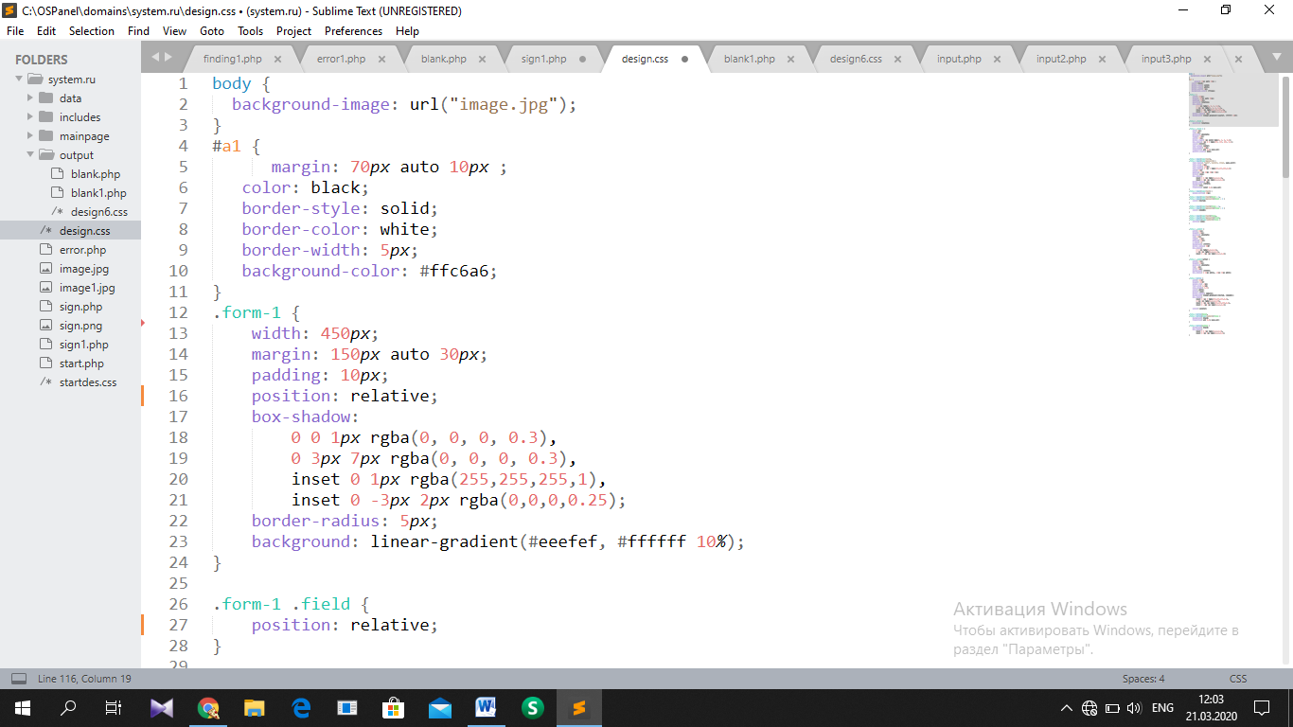

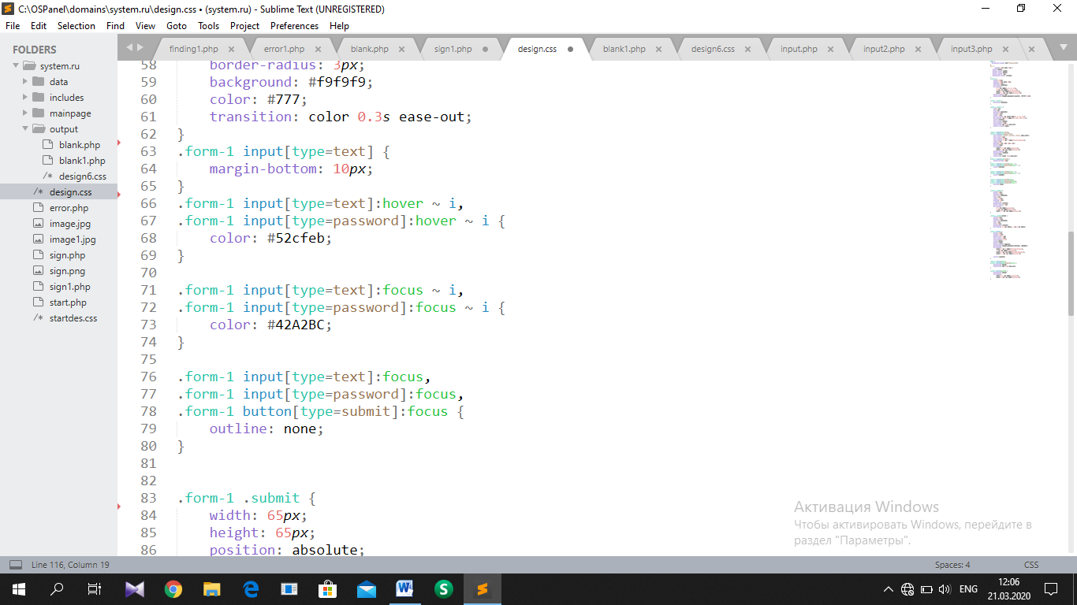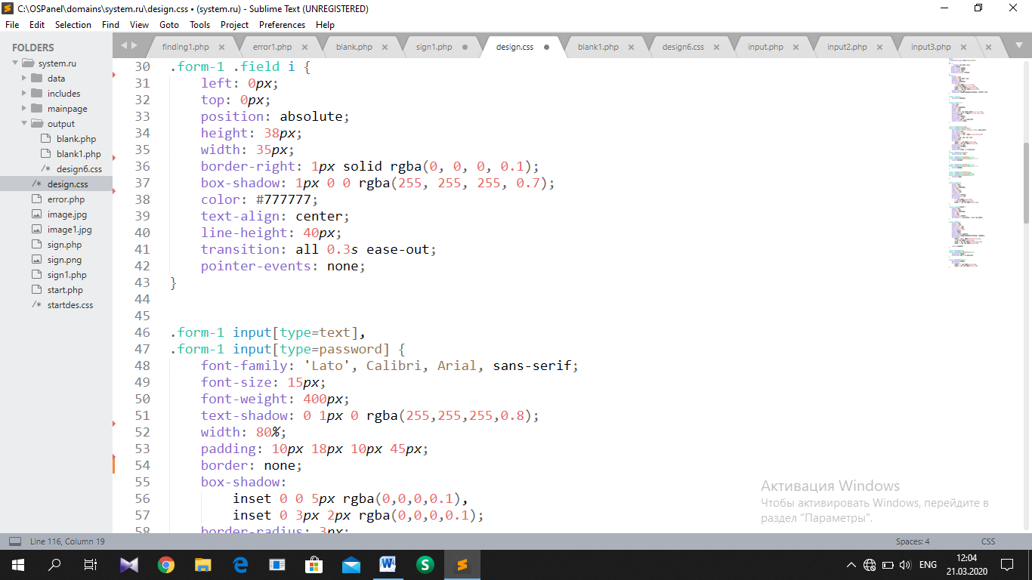

Main page

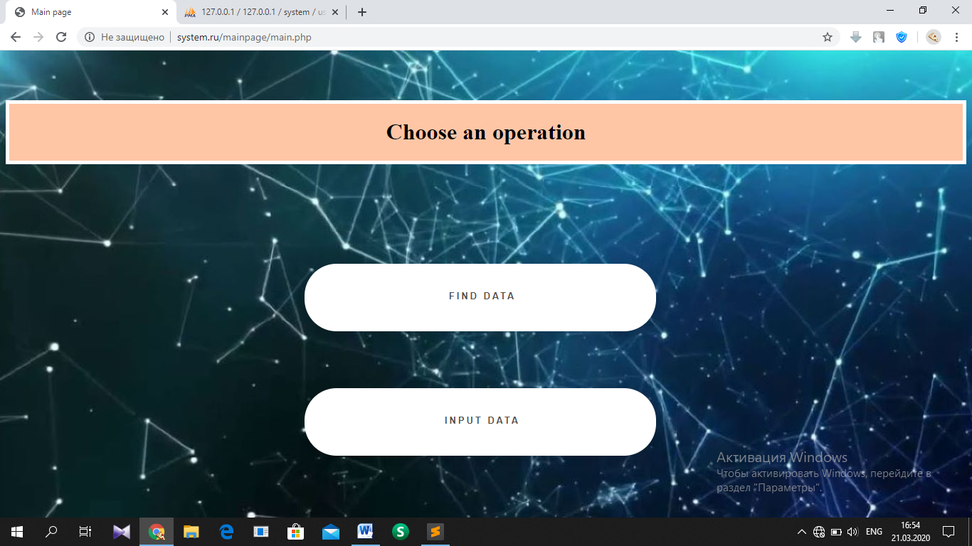

HTML part: ‘http://system.ru/mainpage/main.php’

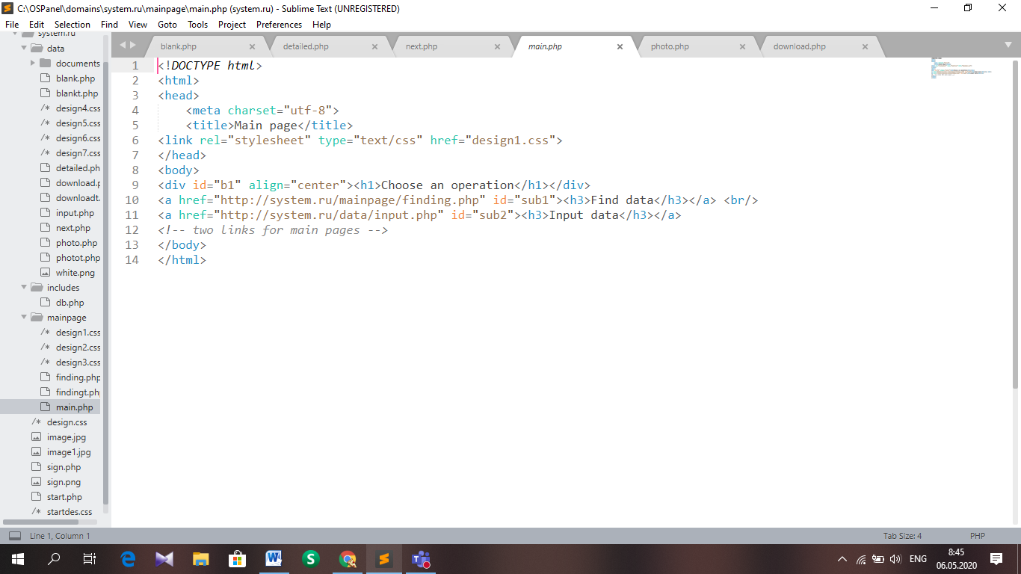

CSS part: ‘http://system.ru/mainpage/design1.css’

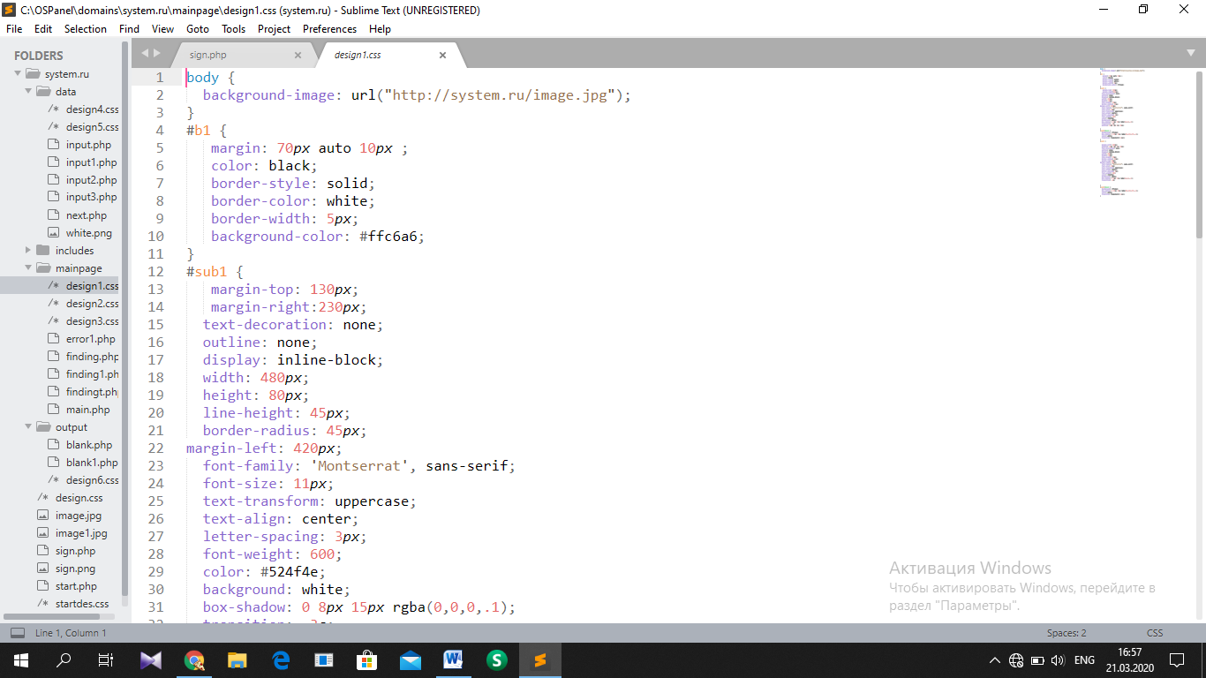

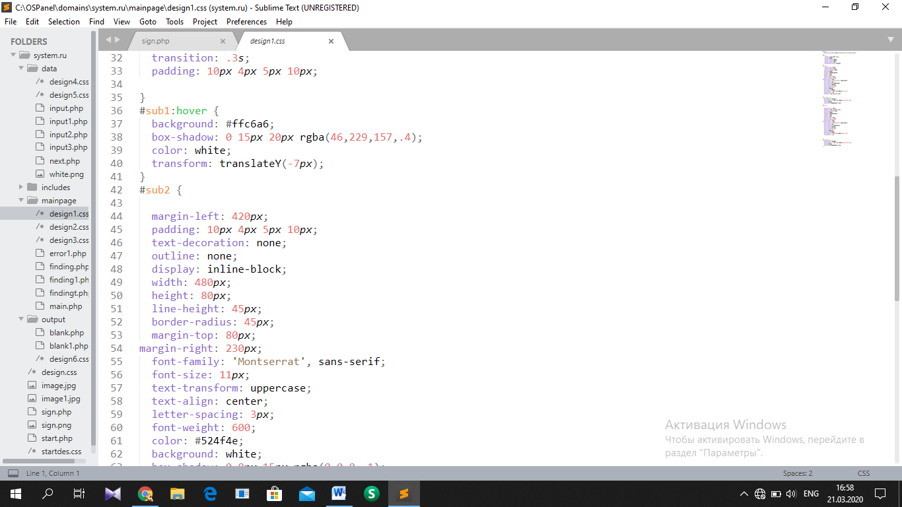

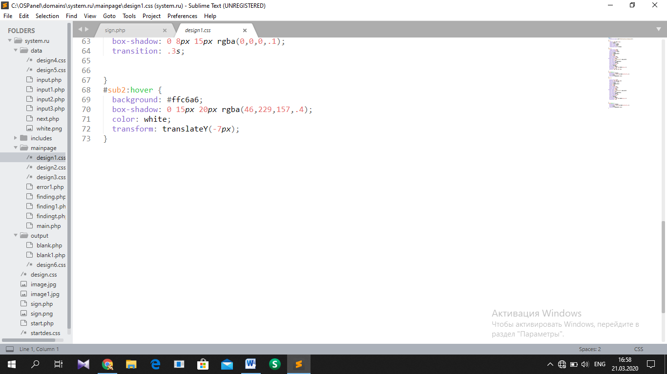

Form entry page

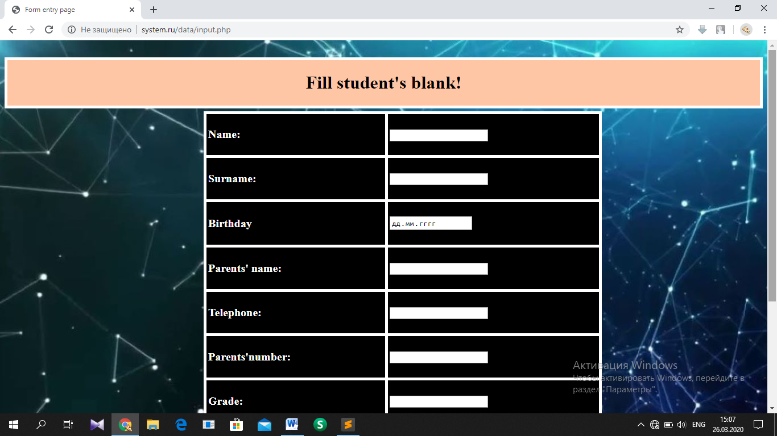

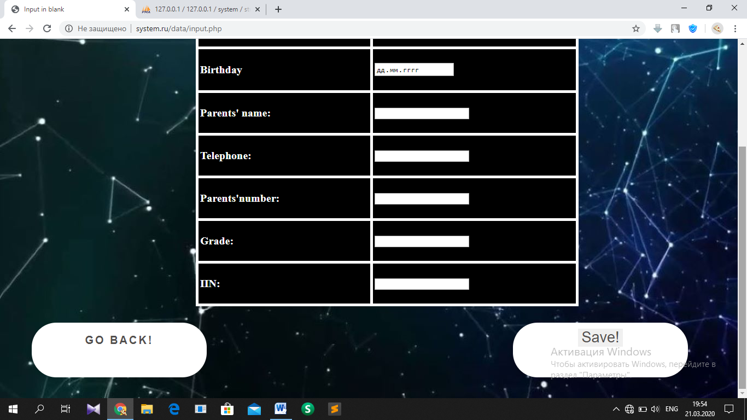

HTML, PHP part: ‘<http://system.ru/data/input.php>’

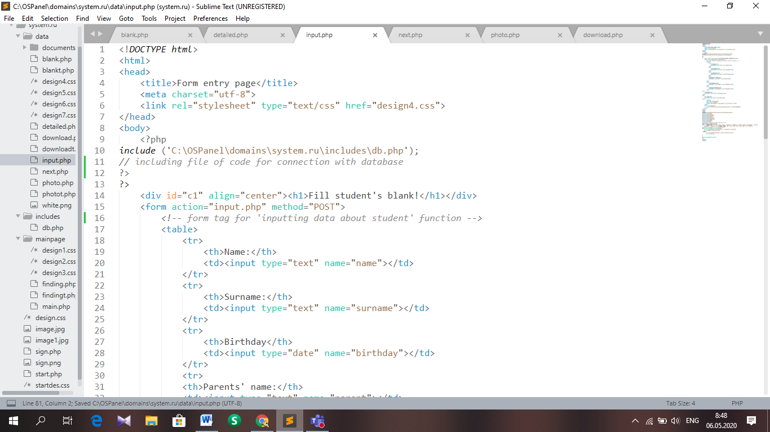

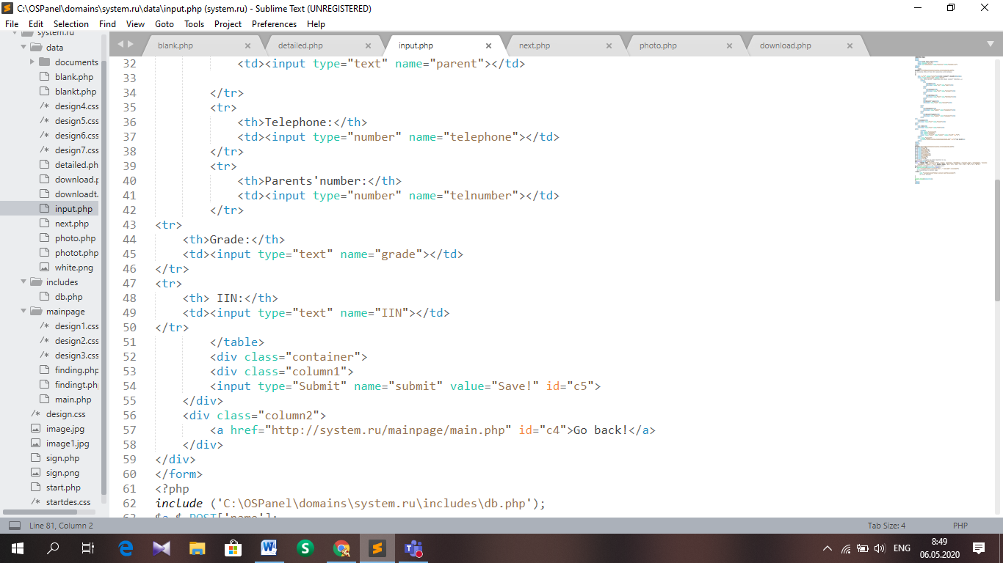

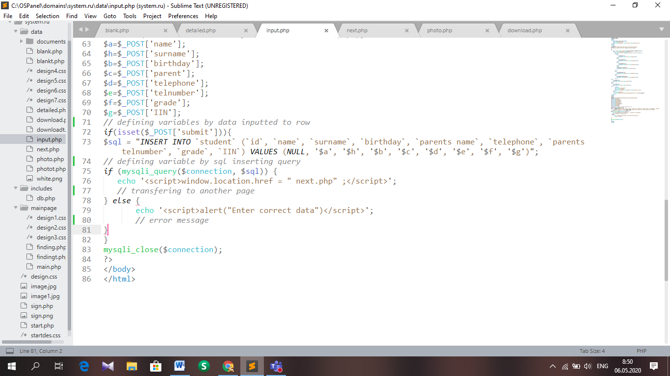

CSS part: ‘http://system.ru/data/design4.css’

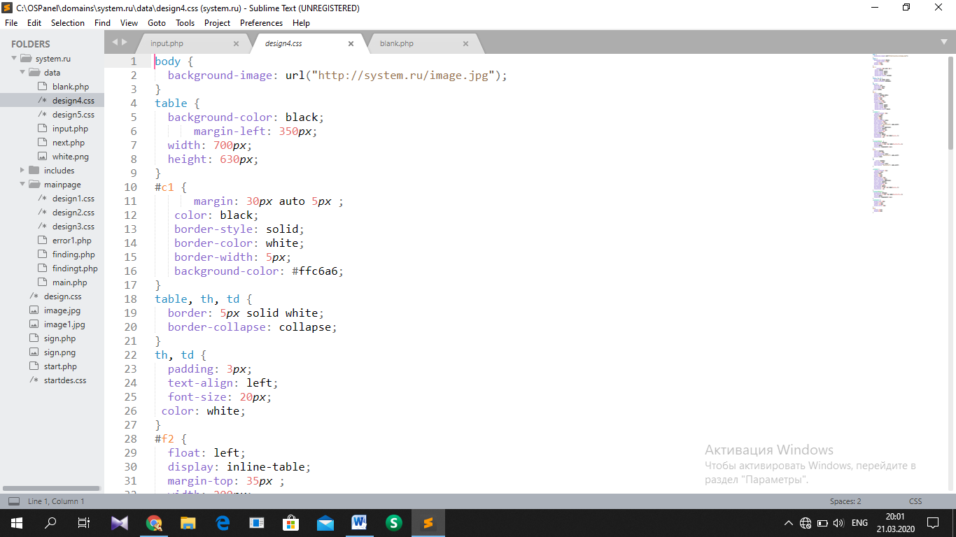

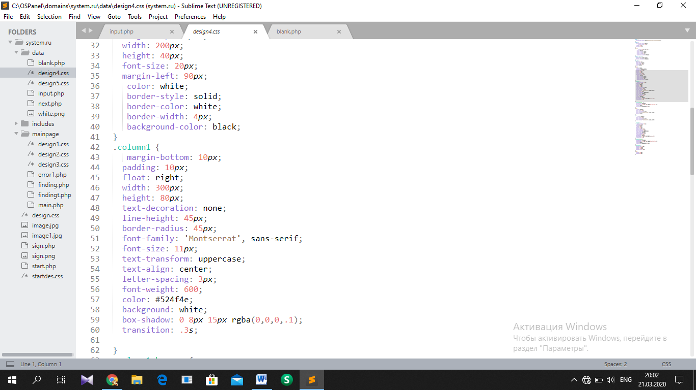

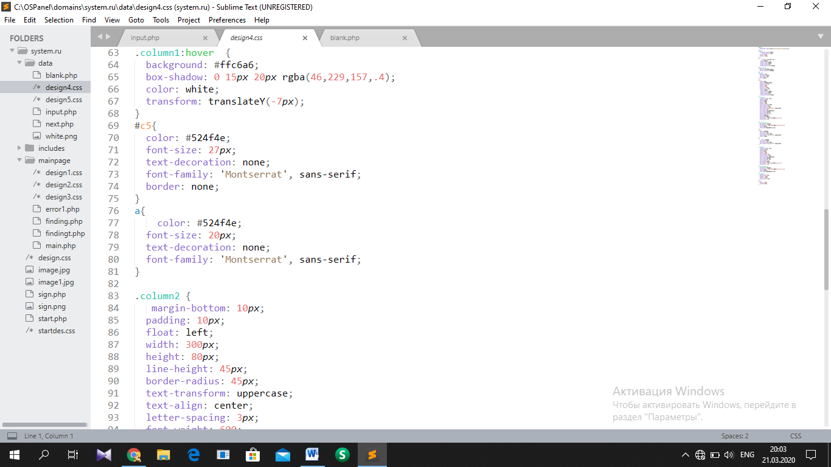

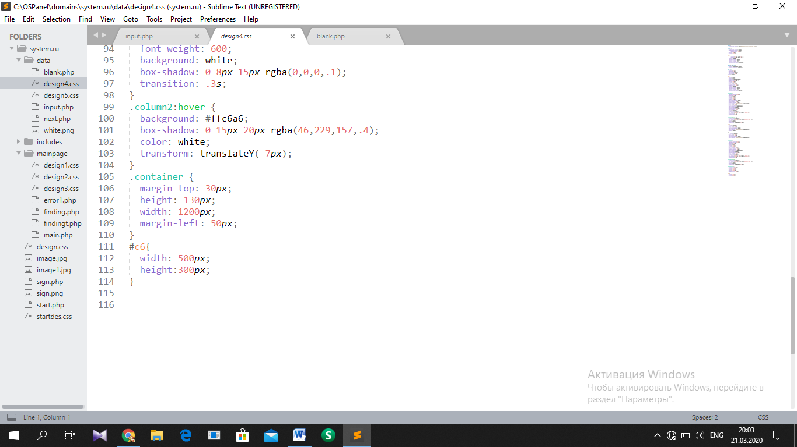

Photo upload page

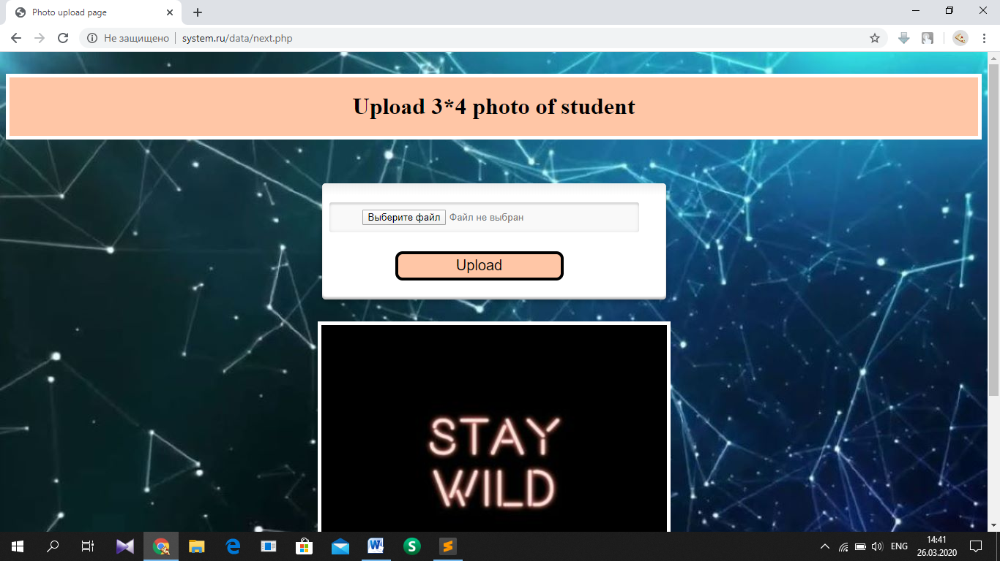

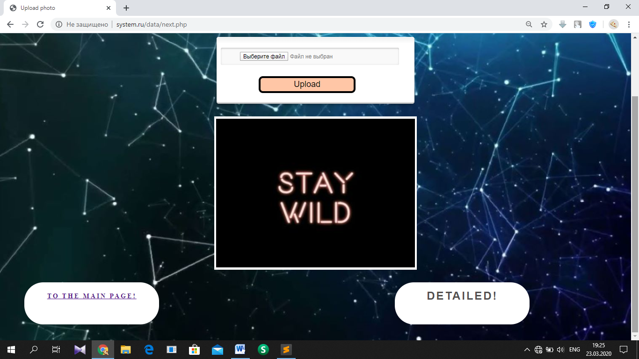

HTML, PHP part: ‘<http://system.ru/data/next.php>’

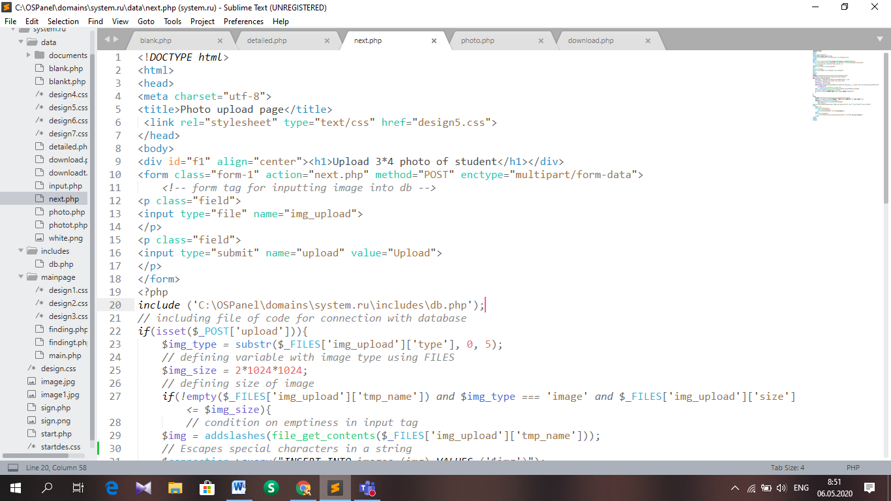

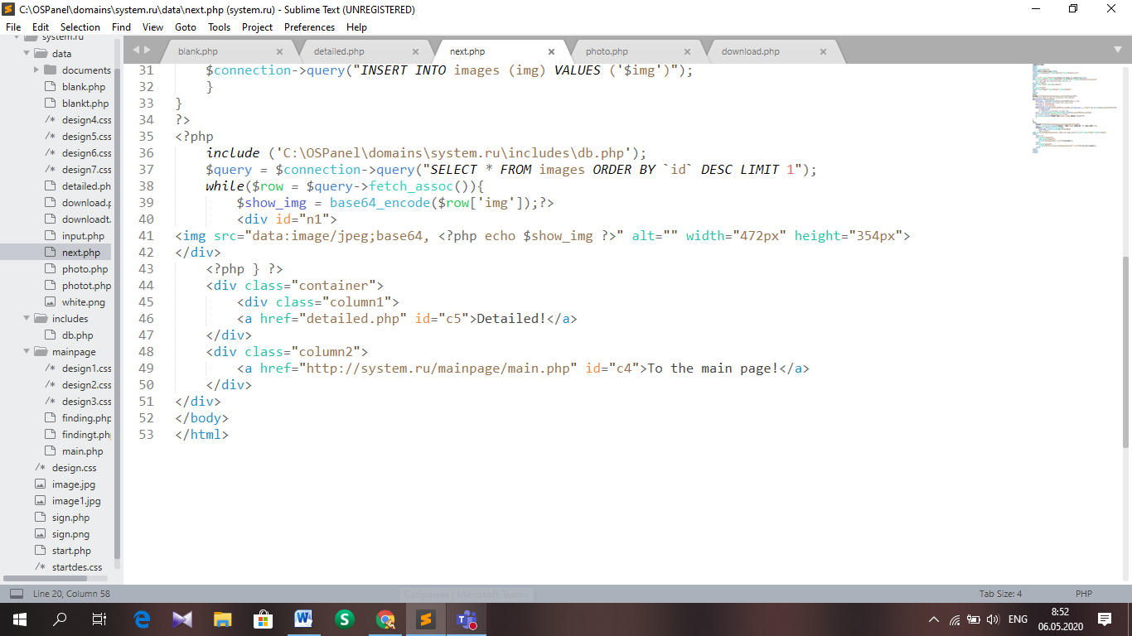

CSS part: <http://system.ru/data/design5.css>

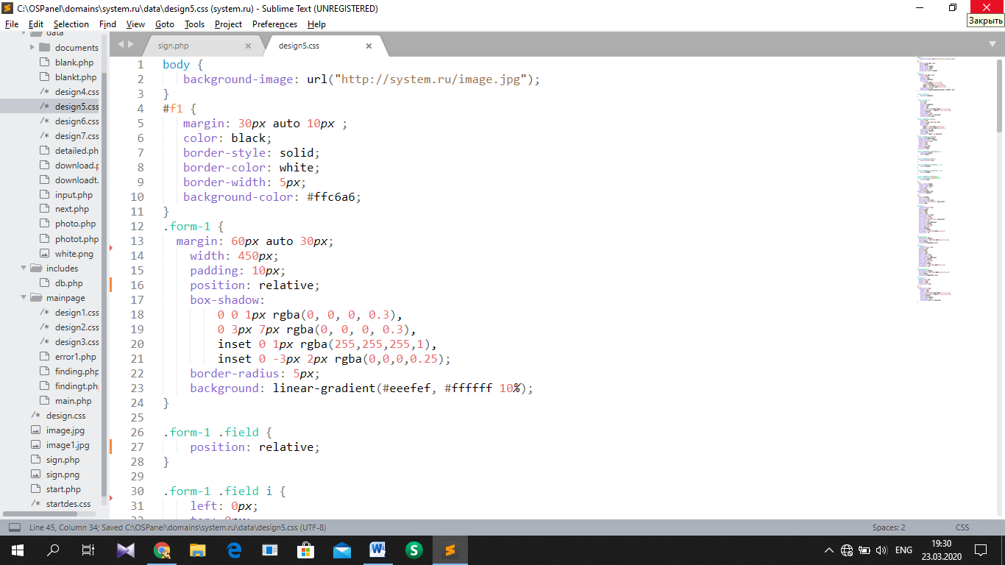

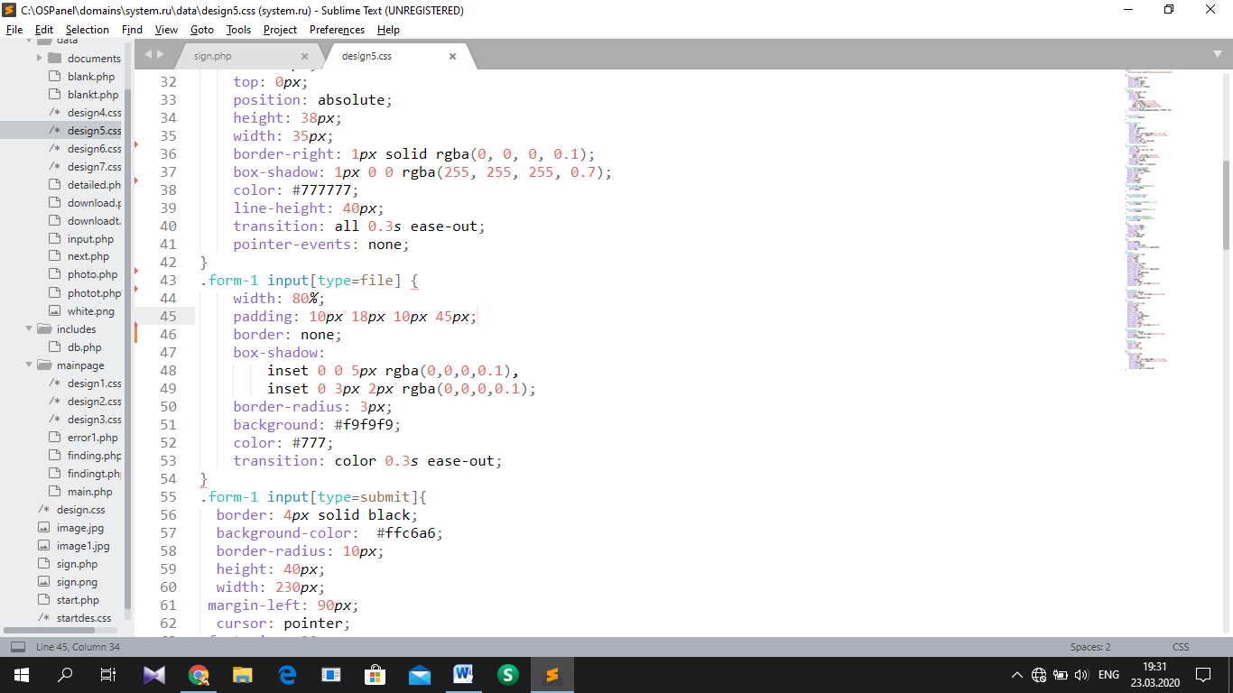

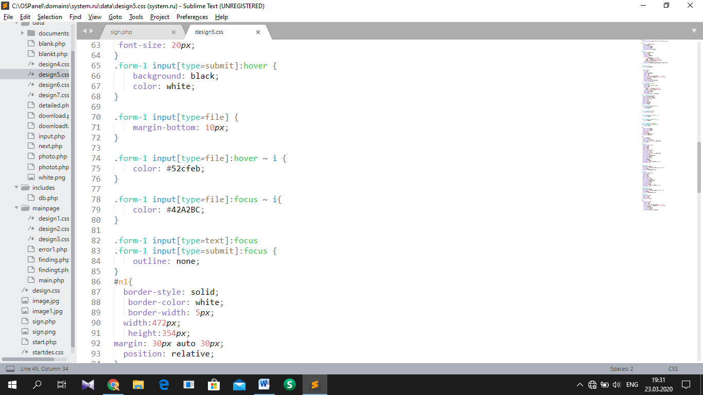

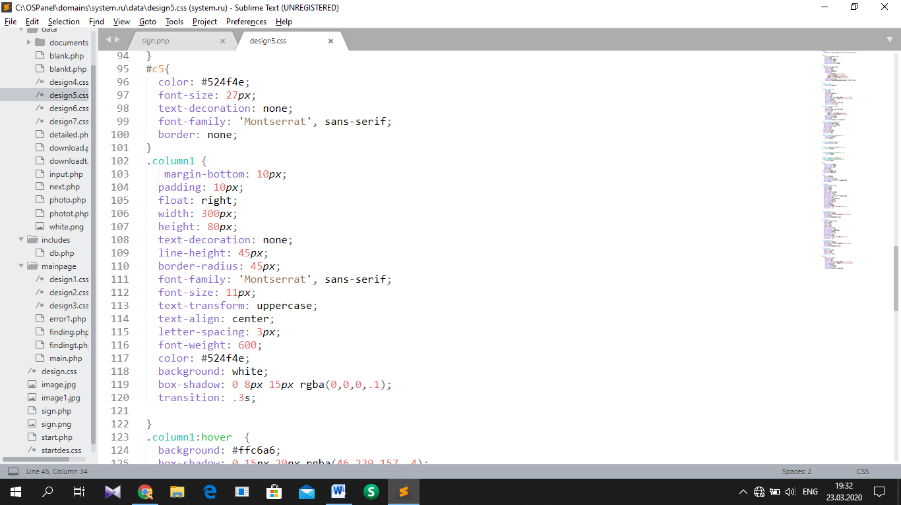

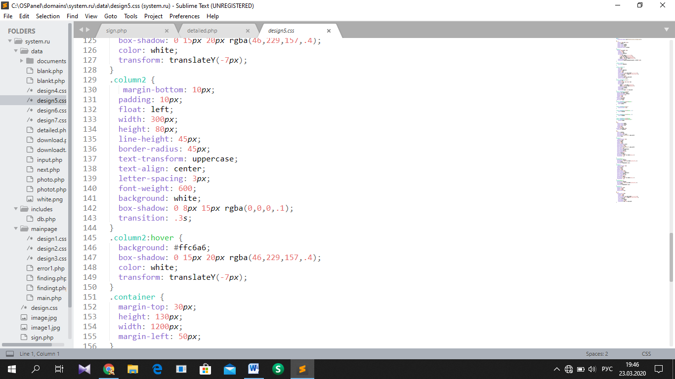

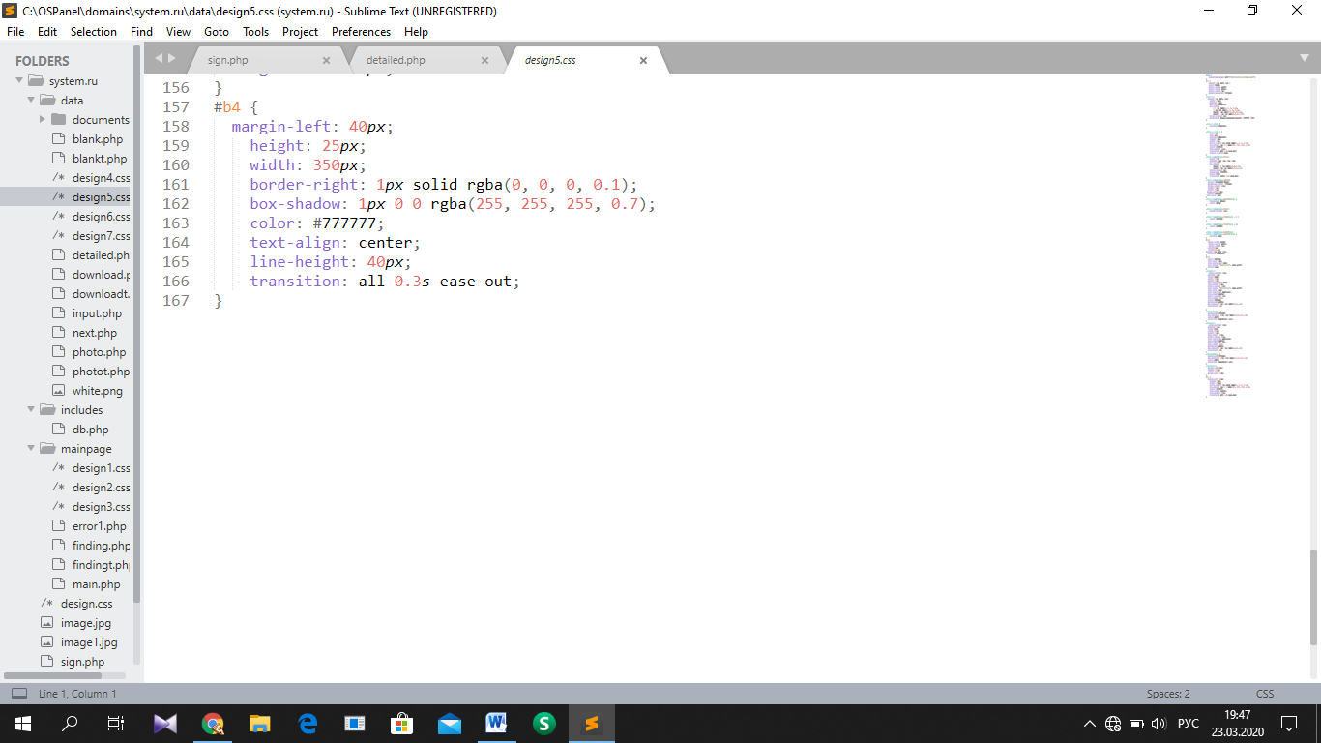

Page for input of details

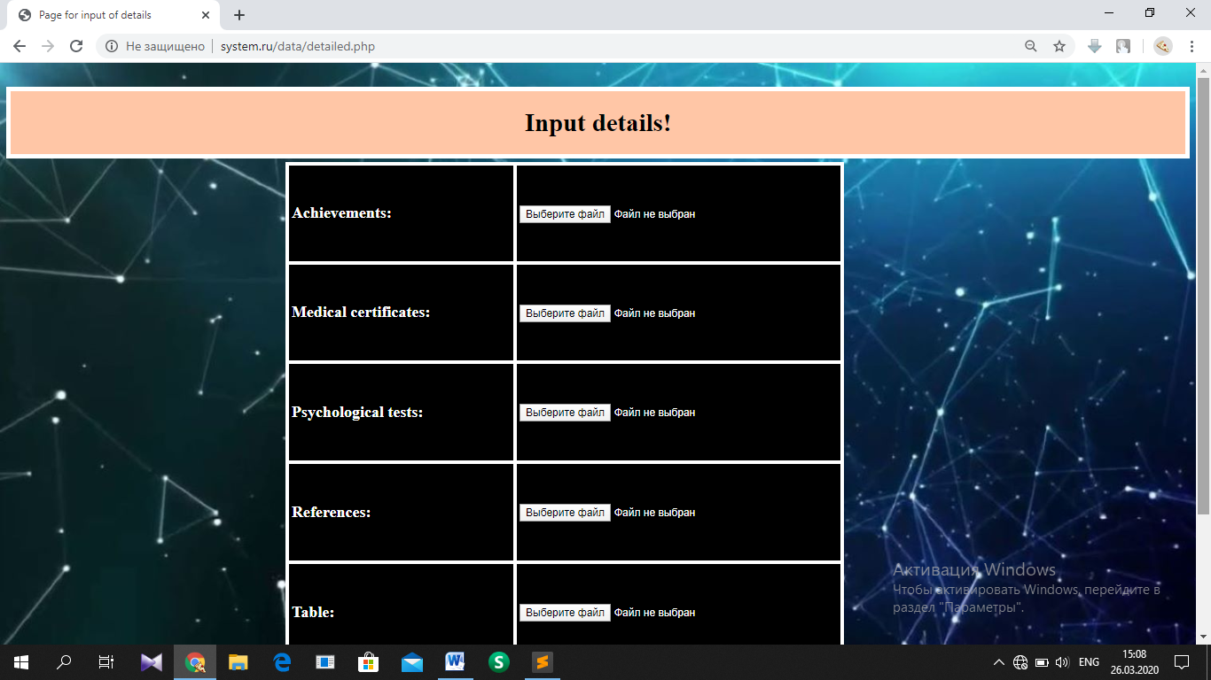

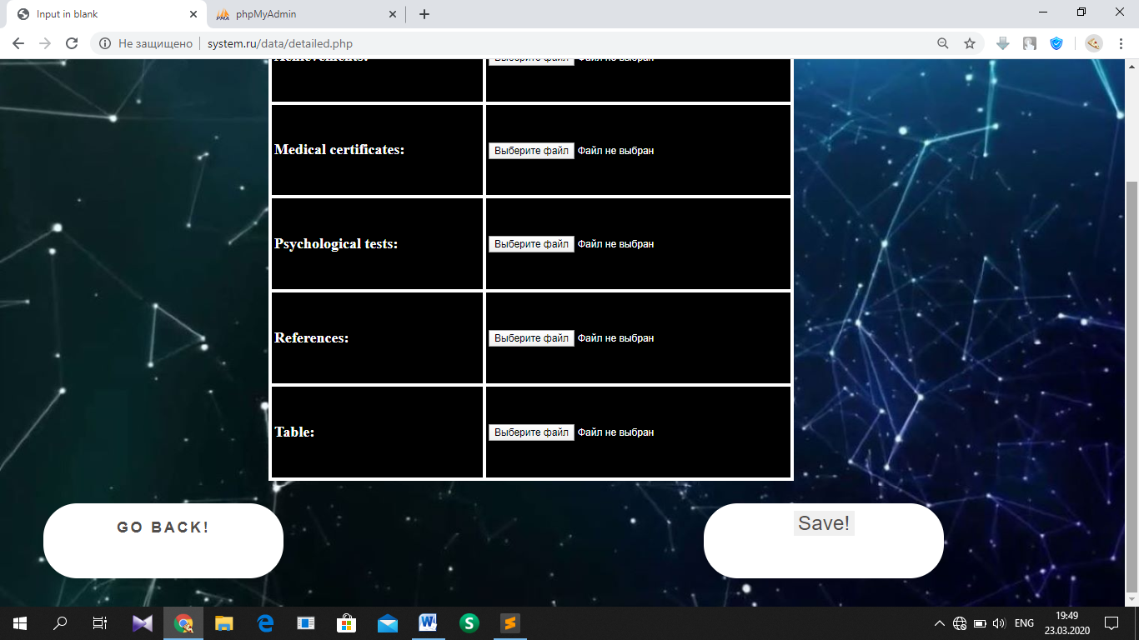

HTML, PHP part: <http://system.ru/data/detailed.php>

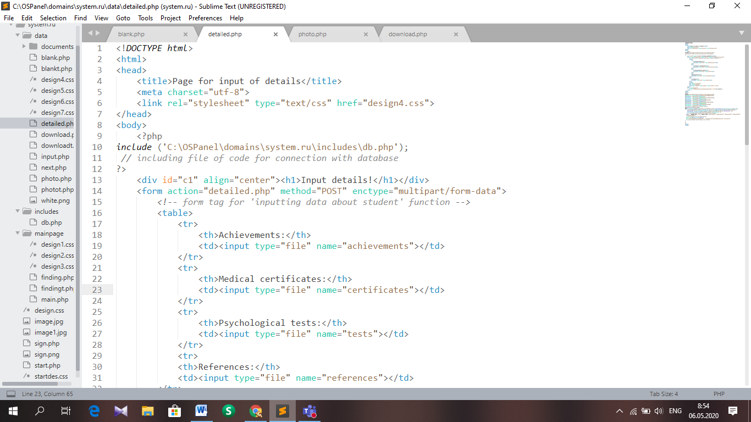

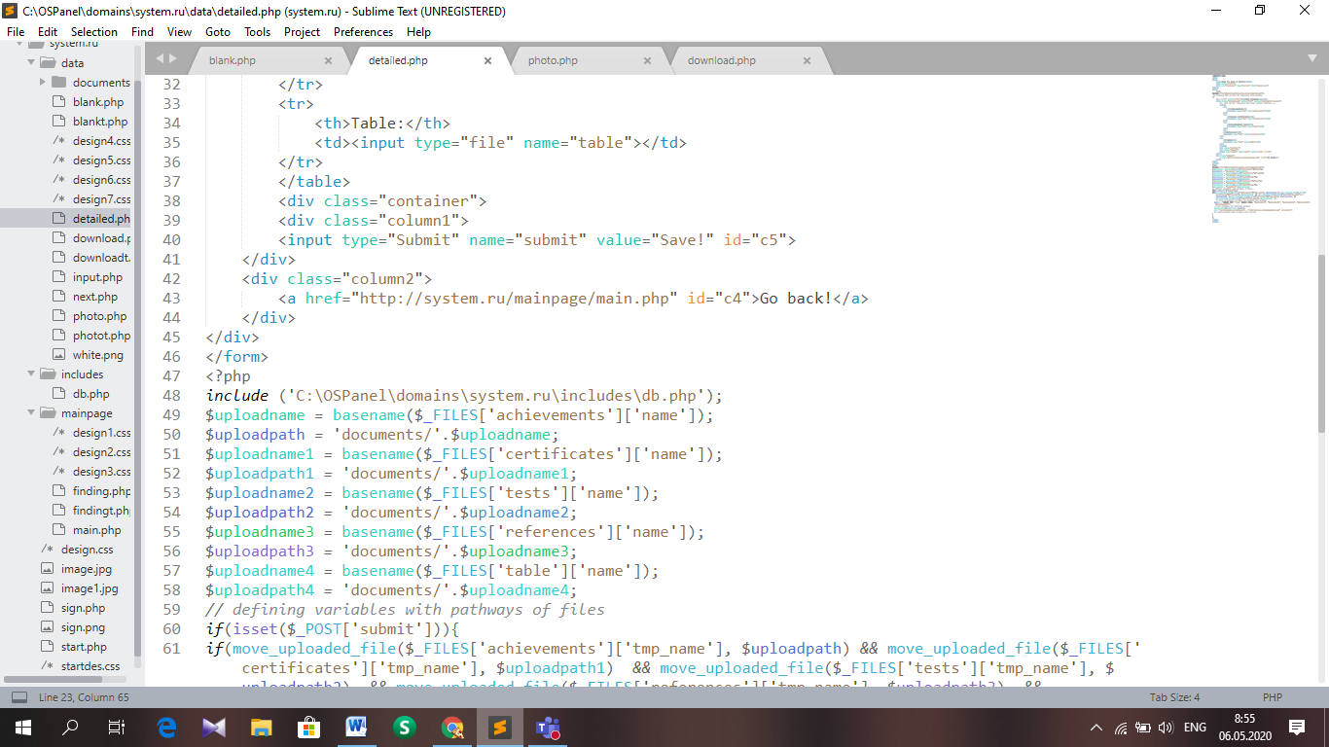

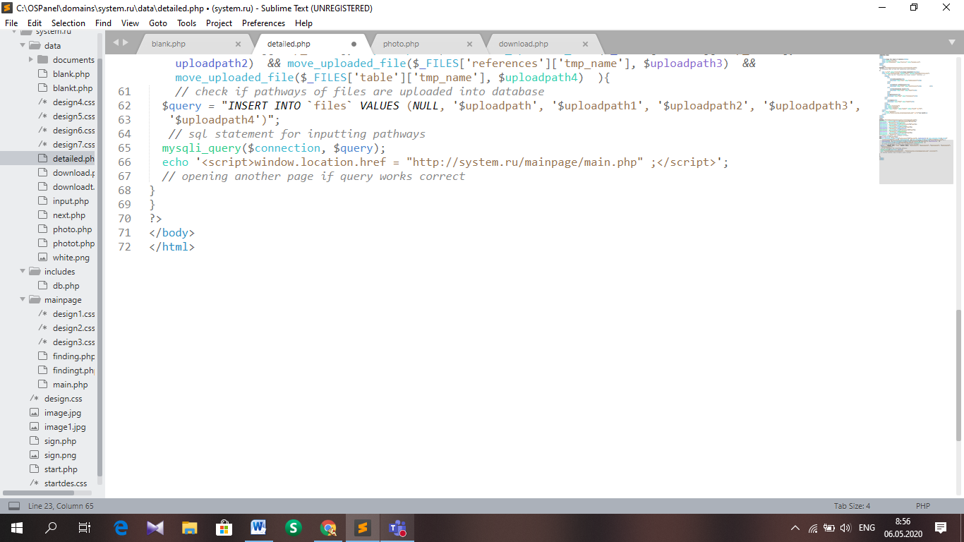

***CSS part:*** <http://system.ru/data/design4.css>

Searching page

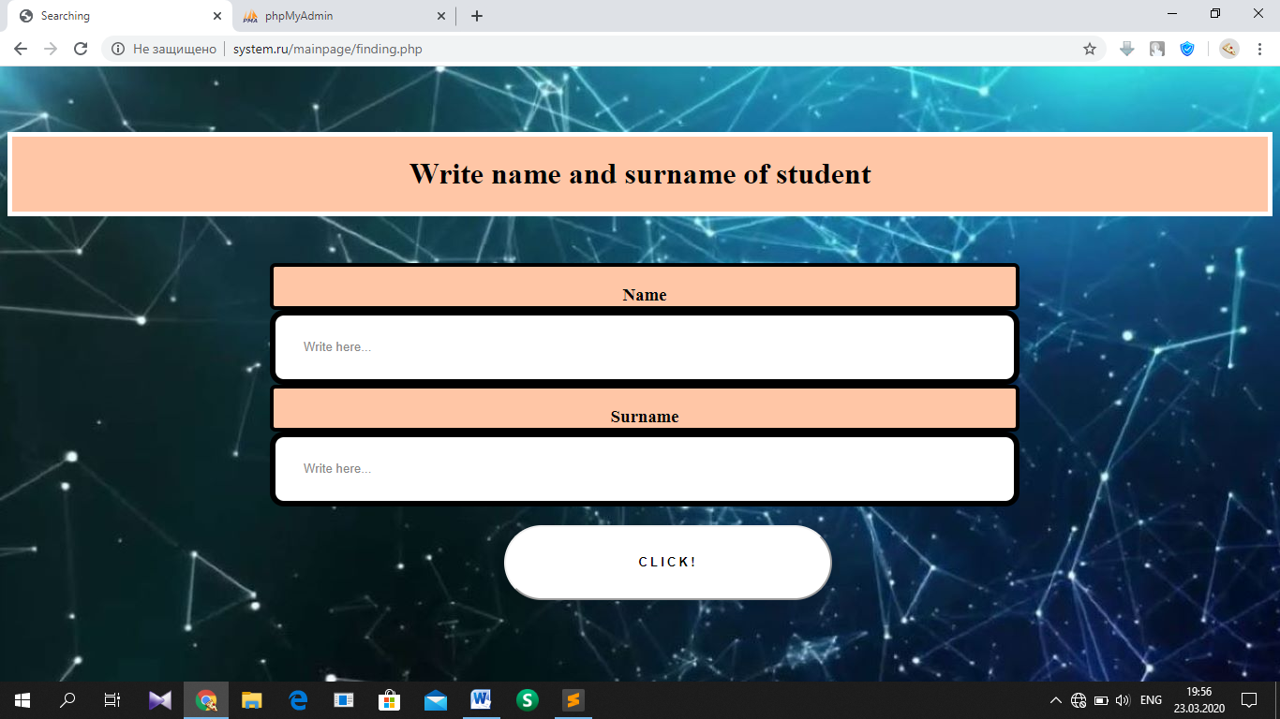

HTML, PHP part: <http://system.ru/mainpage/finding.php>, <http://system.ru/mainpage/findingt.php> (page for teachers)

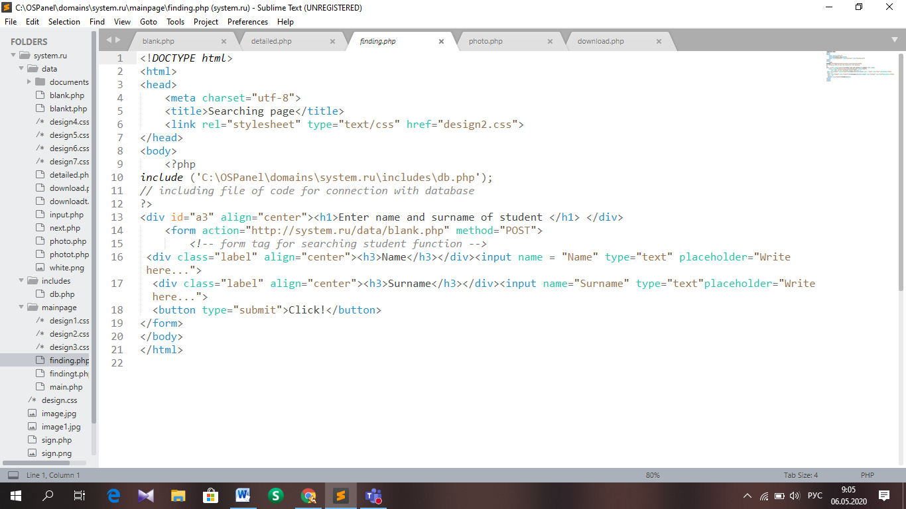

CSS part: <http://system.ru/mainpage/design2.css>

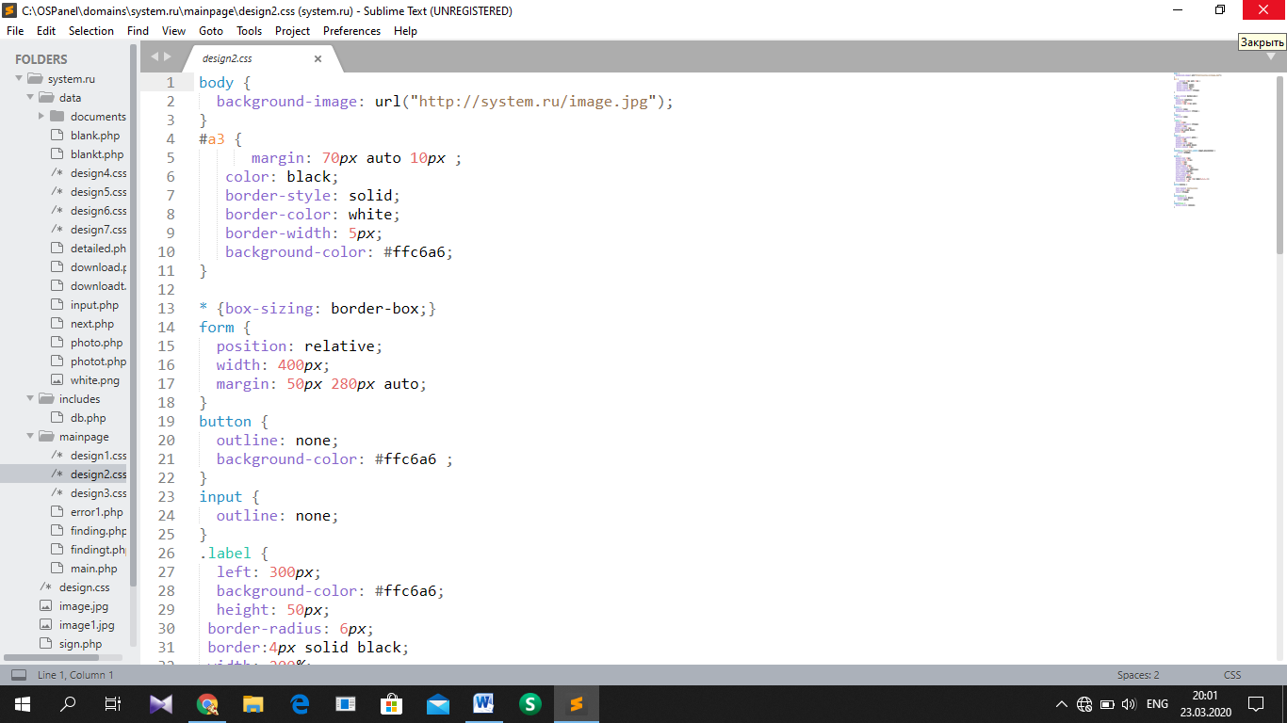

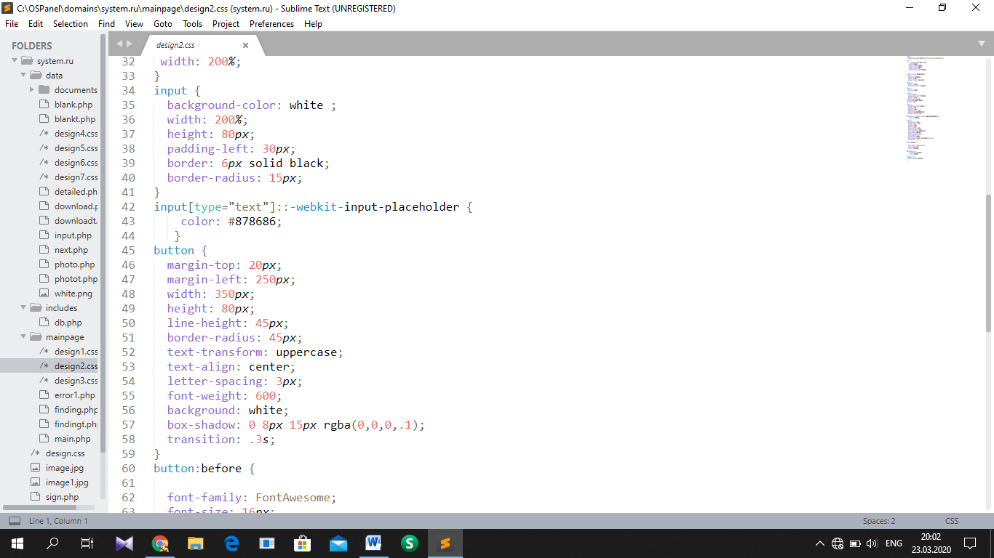

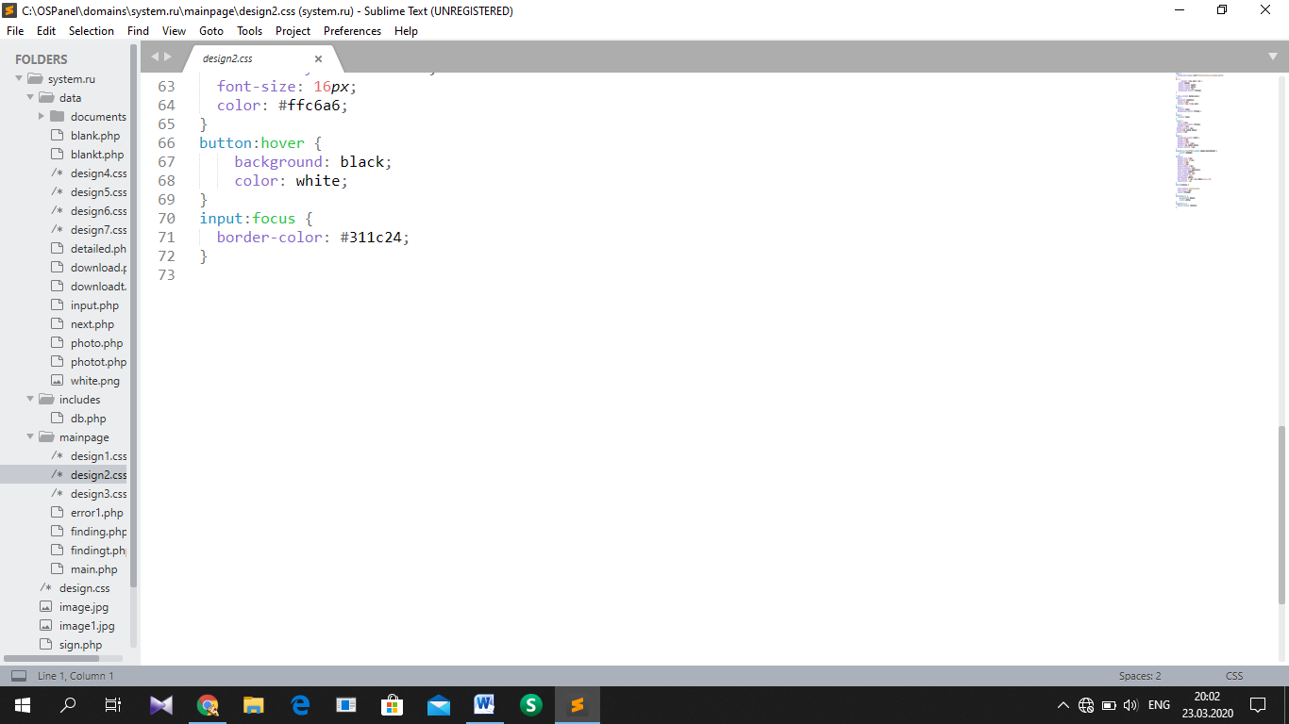

Form output page

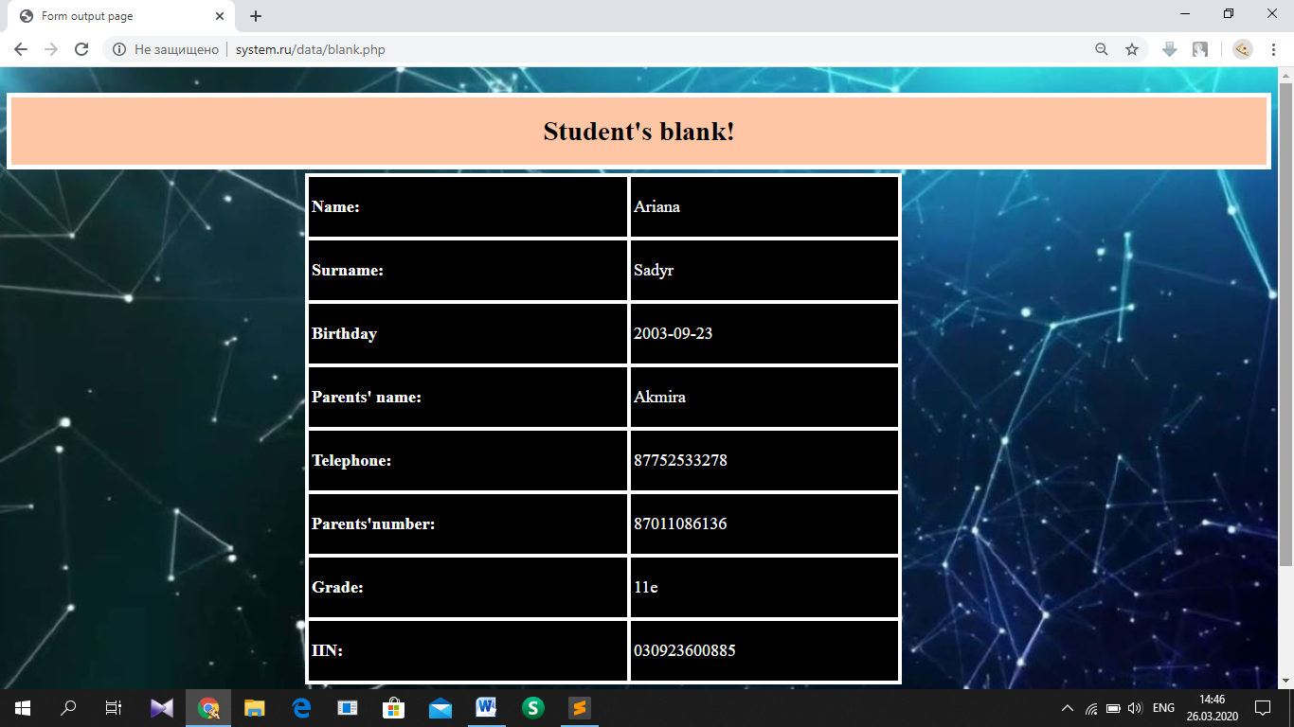

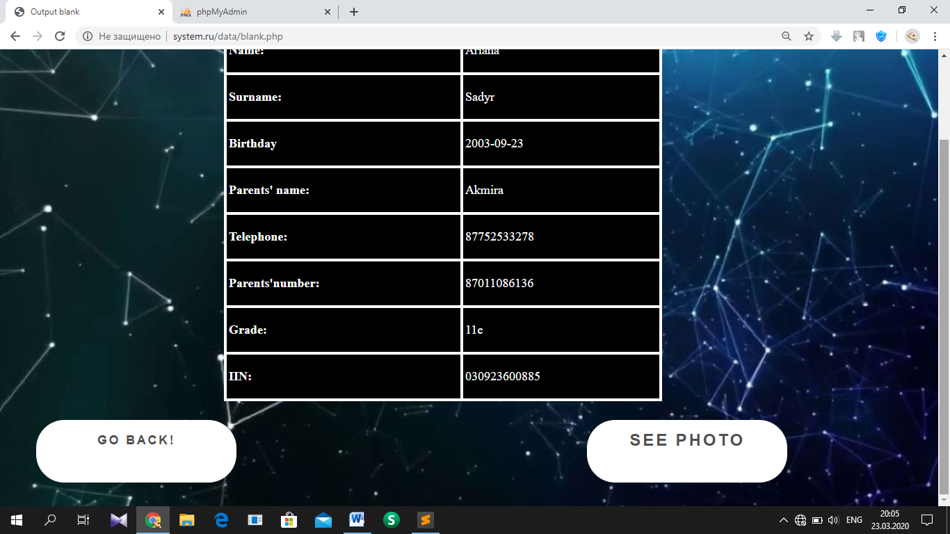

HTML, PHP part: <http://system.ru/data/blank.php>, <http://system.ru/data/blankt.php> (page for teachers)

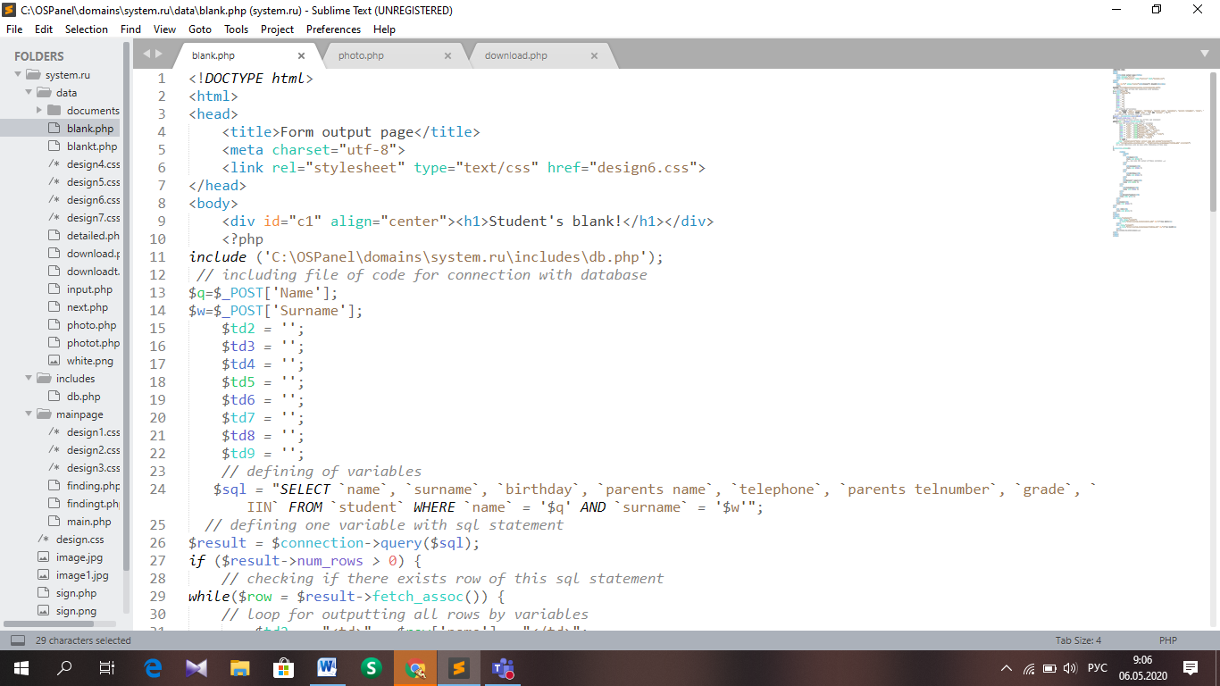

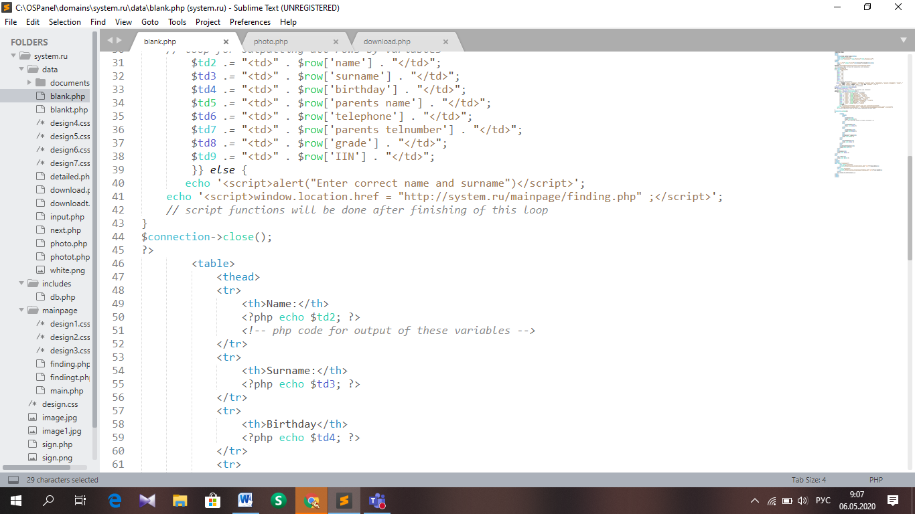

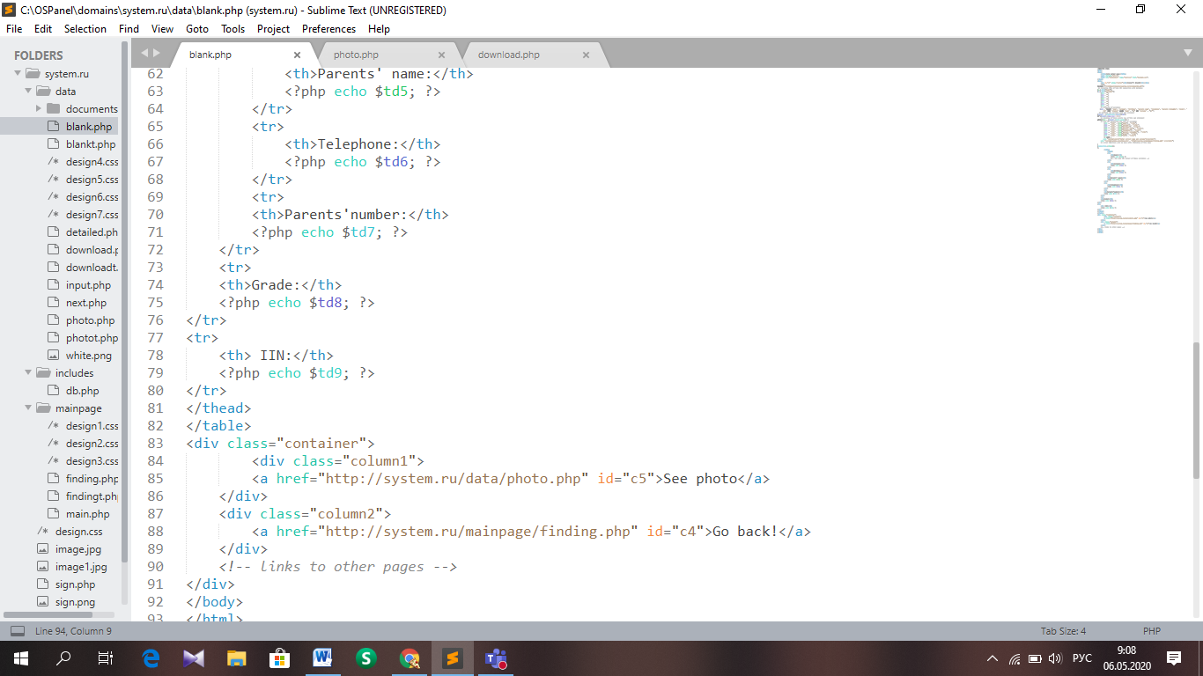

CSS part: <http://system.ru/data/design4.css>

Photo show page

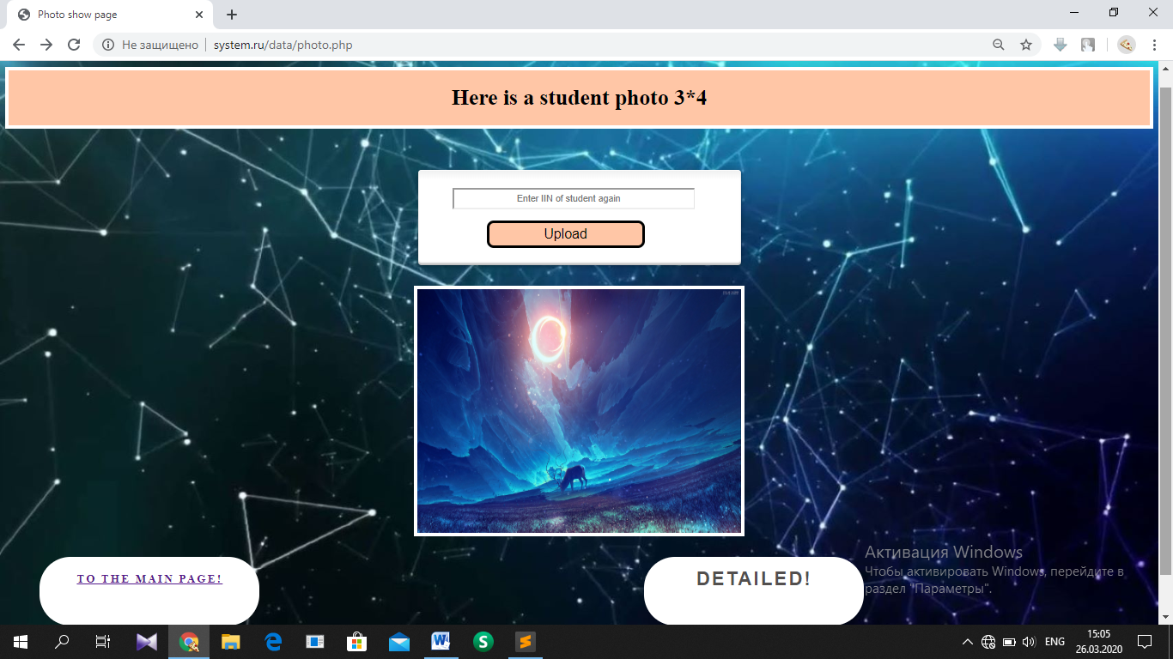

HTML, PHP part: <http://system.ru/data/photo.php>, <http://system.ru/data/photot.php> (page for teachers)

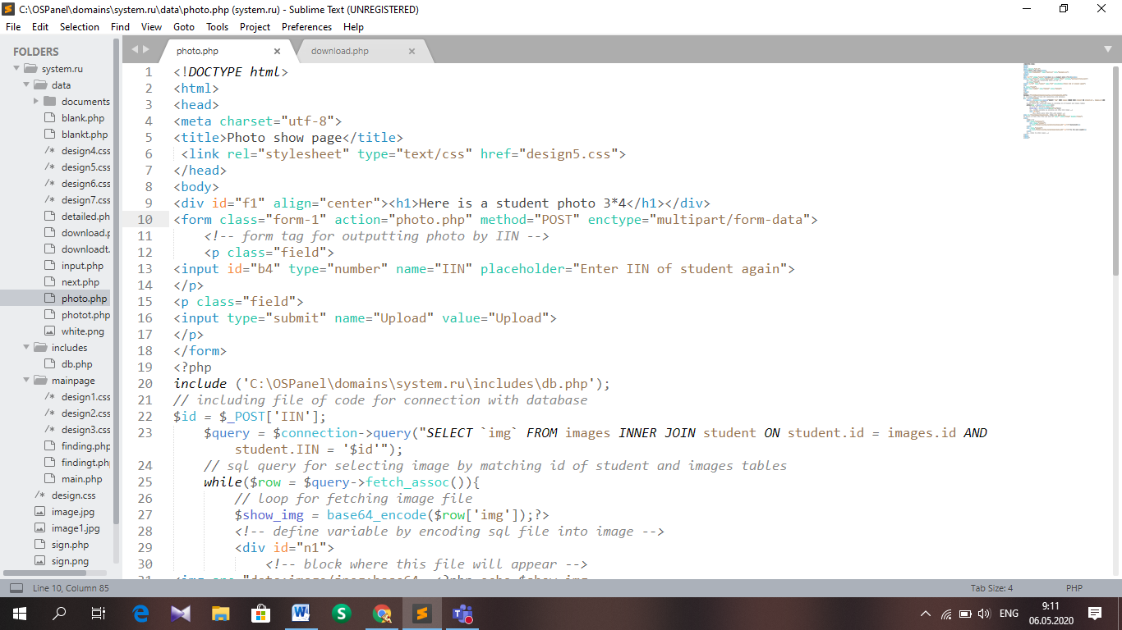

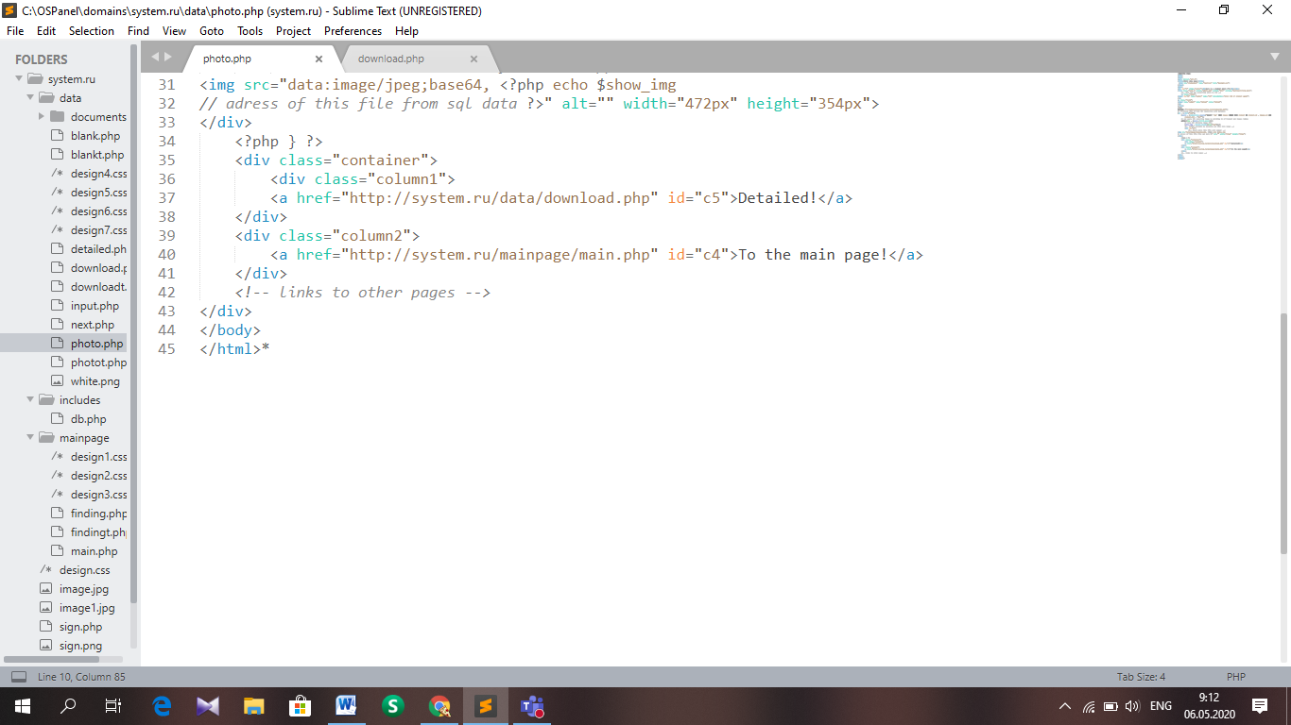

CSS part: <http://system.ru/data/design5.css>

Page for output of details

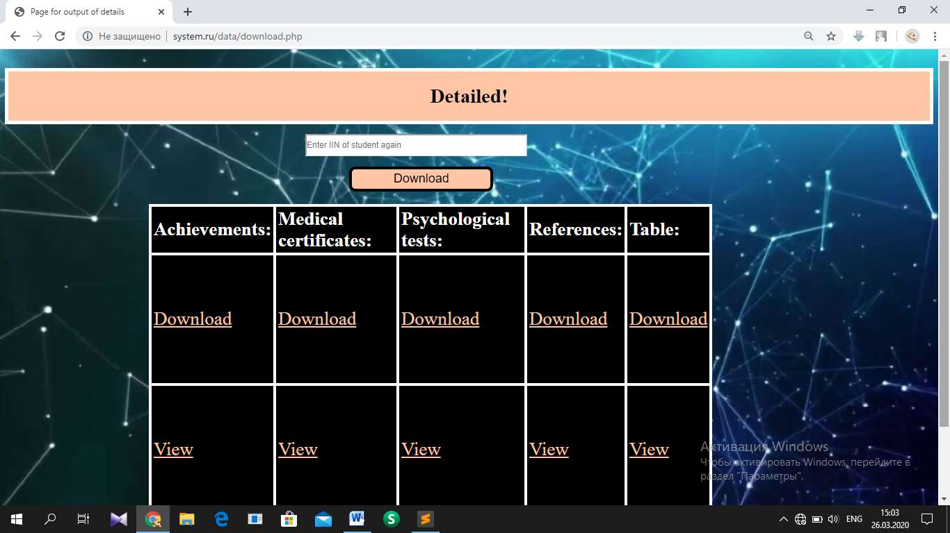

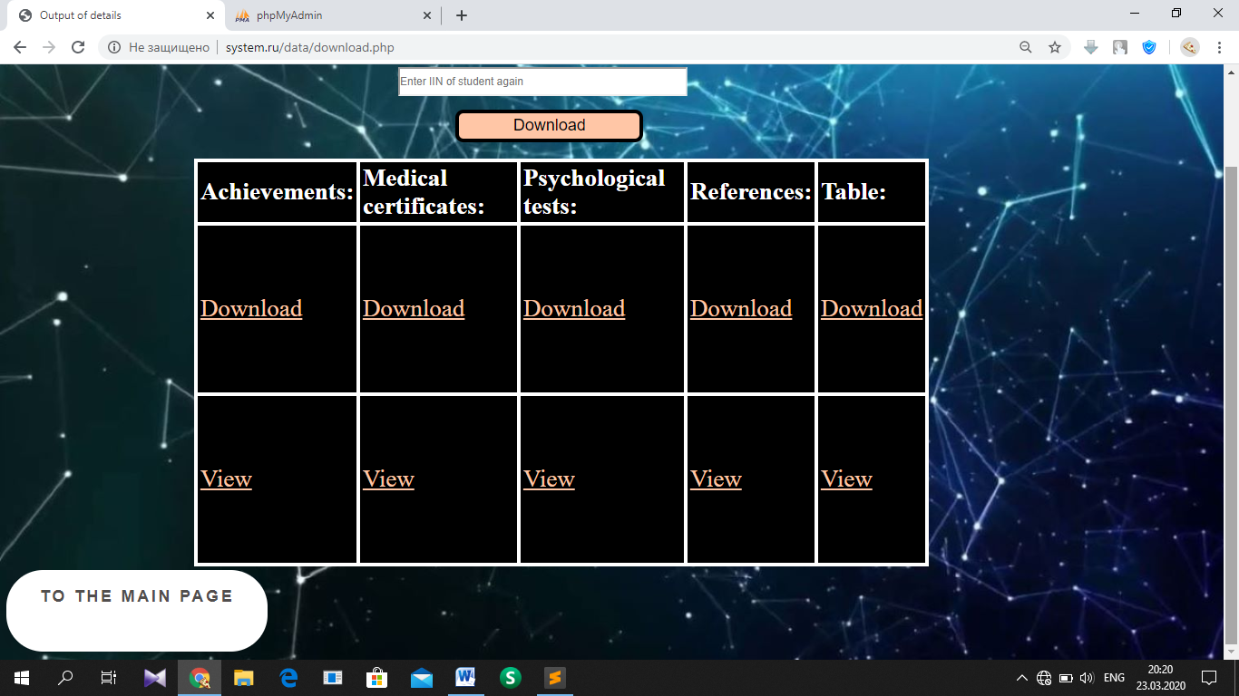

HTML, PHP part: <http://system.ru/data/download.php>

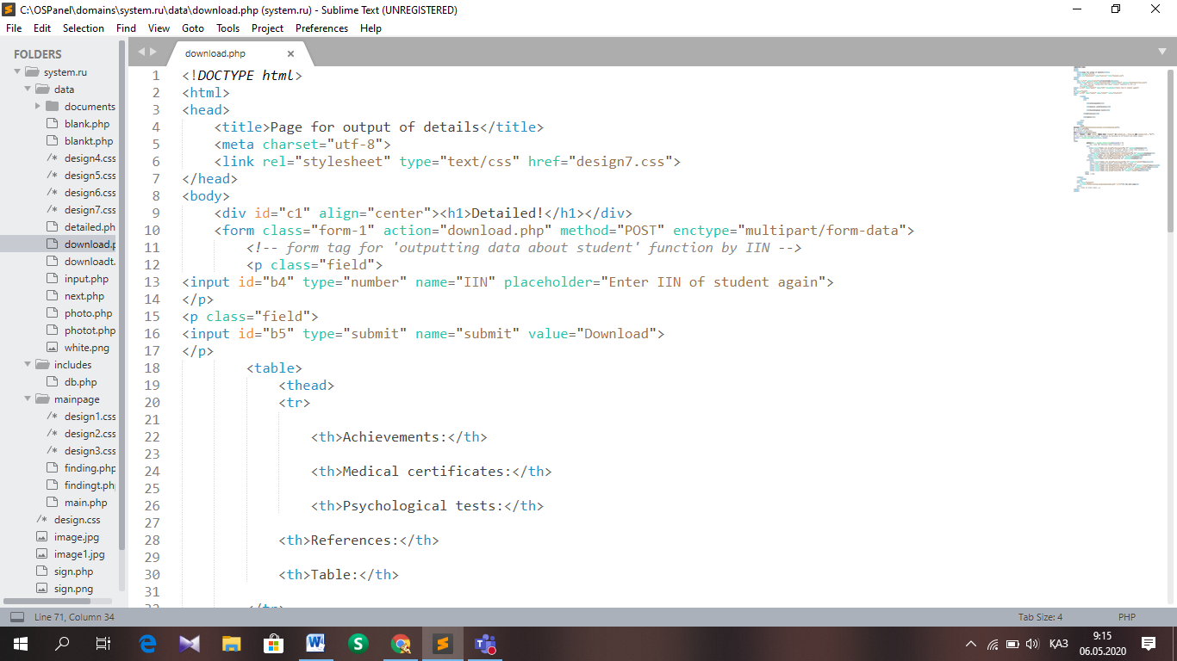

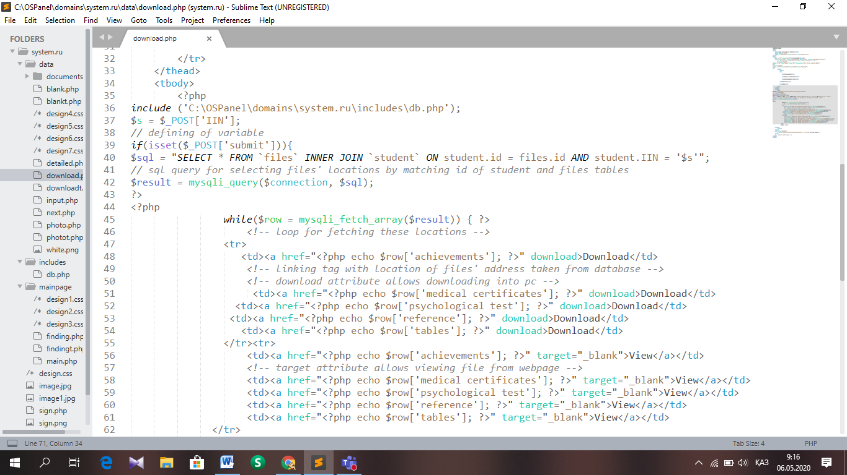

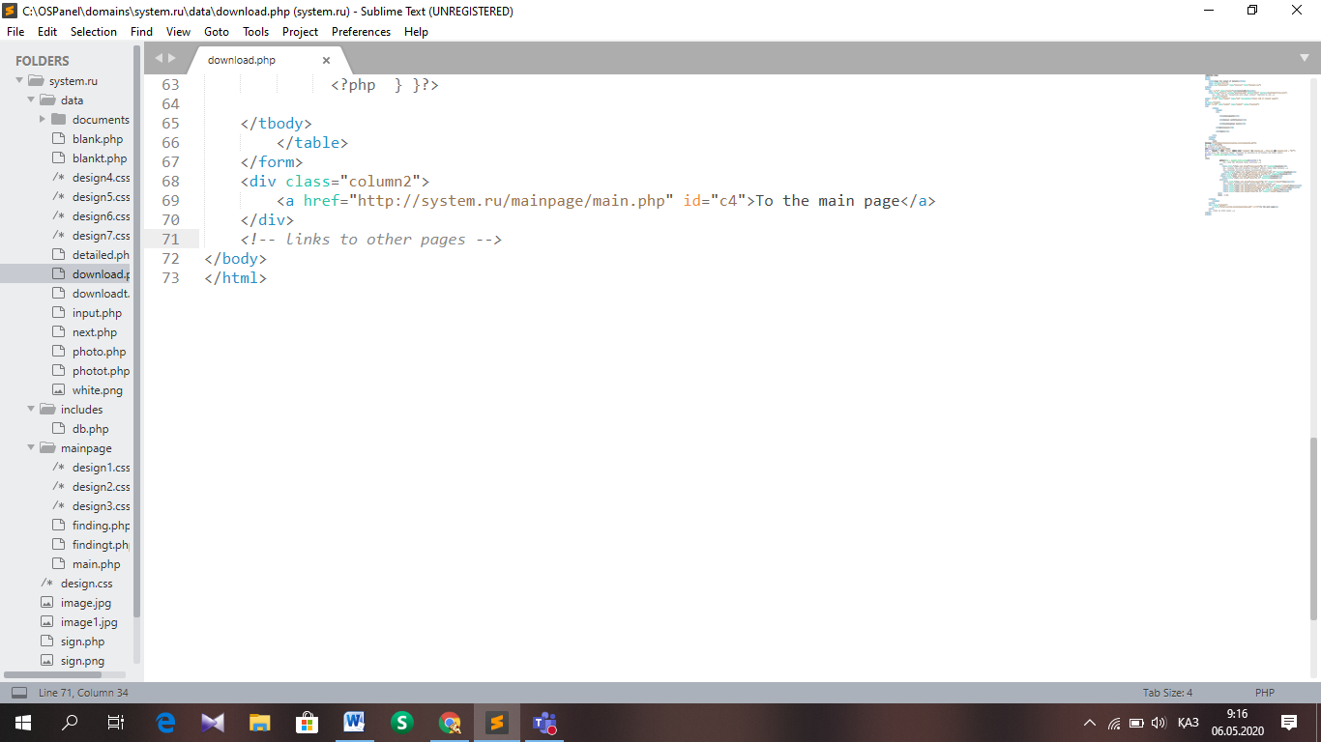

Page for output of details for teachers

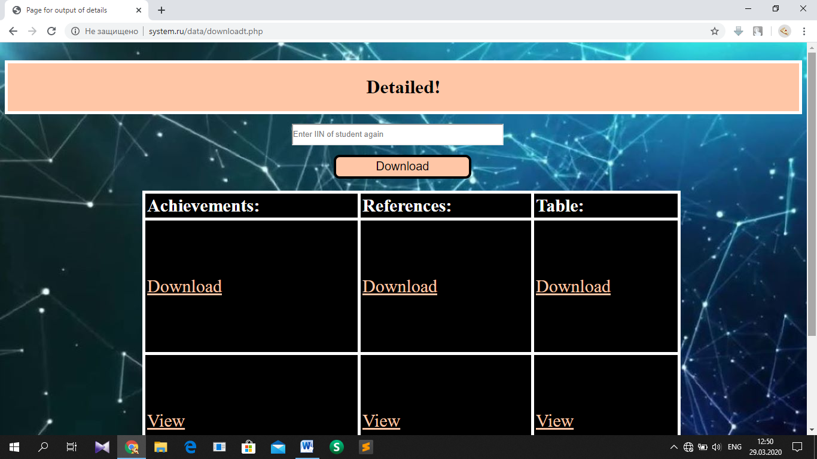

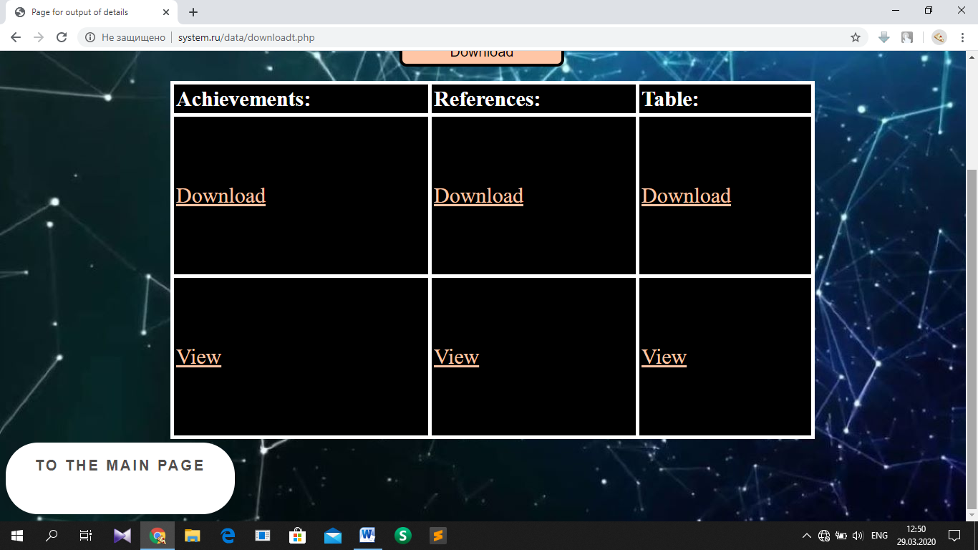

HTML, PHP part: <http://system.ru/data/downloadt.php>

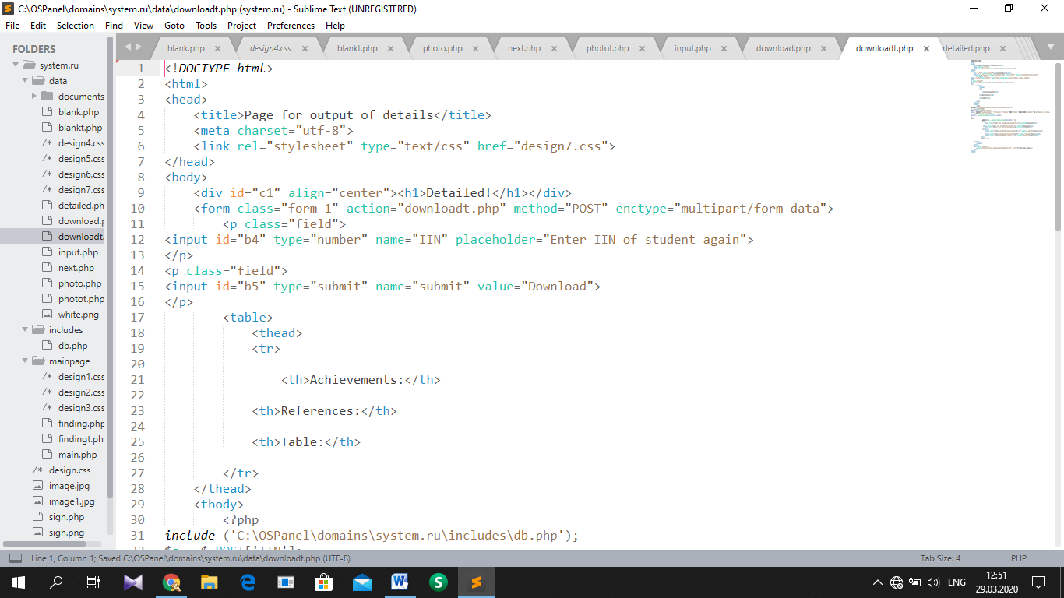

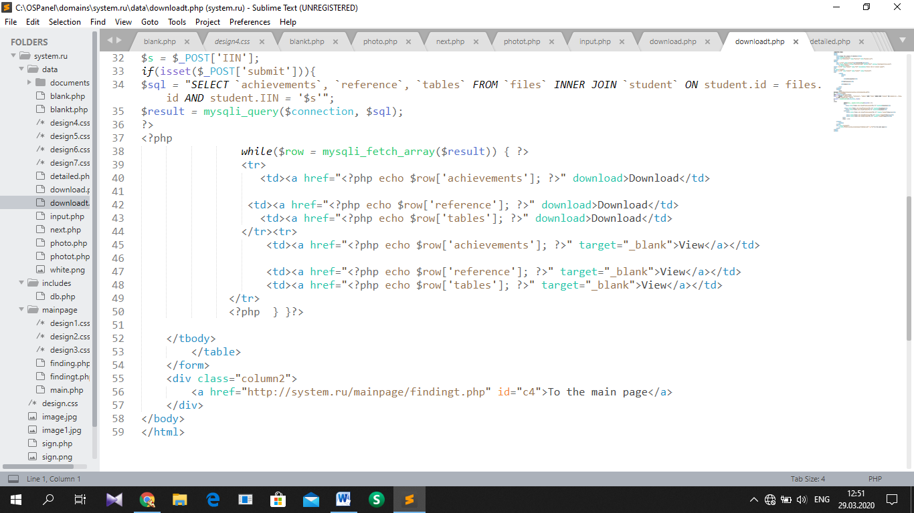

CSS part: <http://system.ru/data/design7.css>

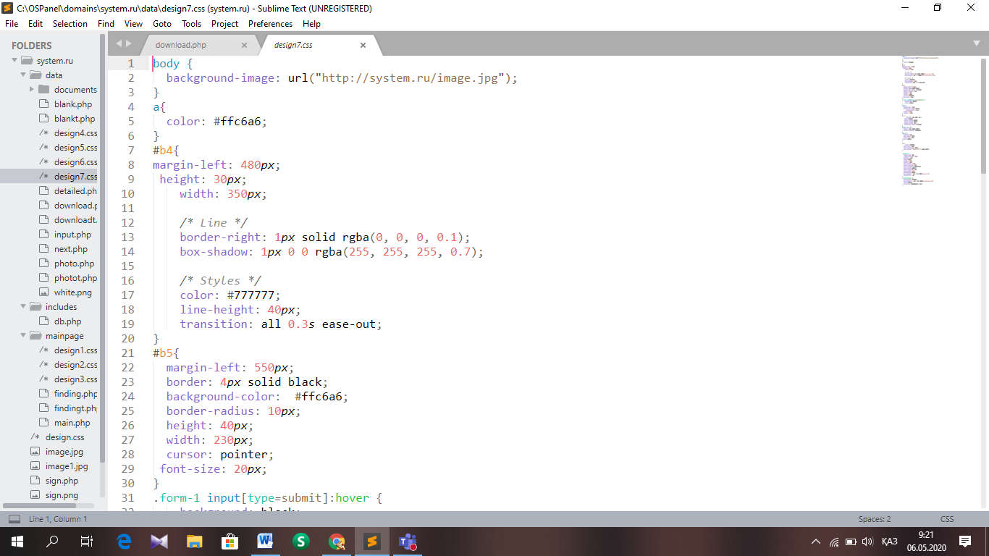

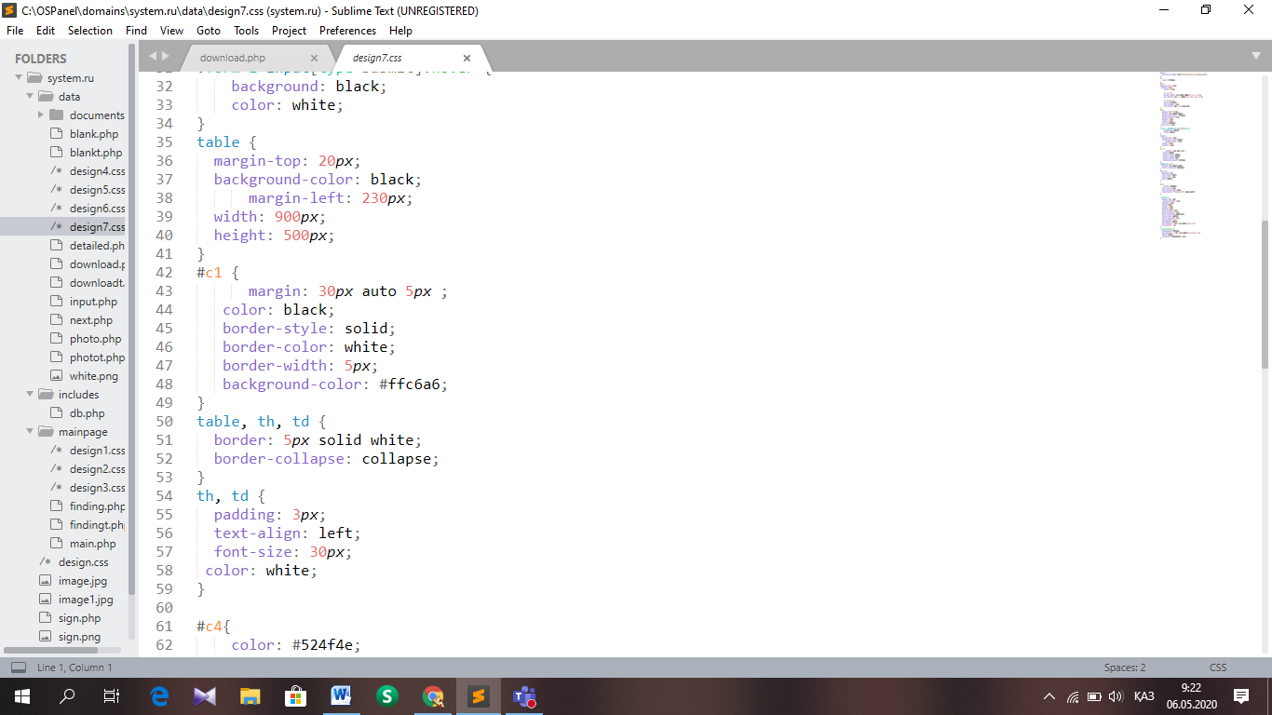

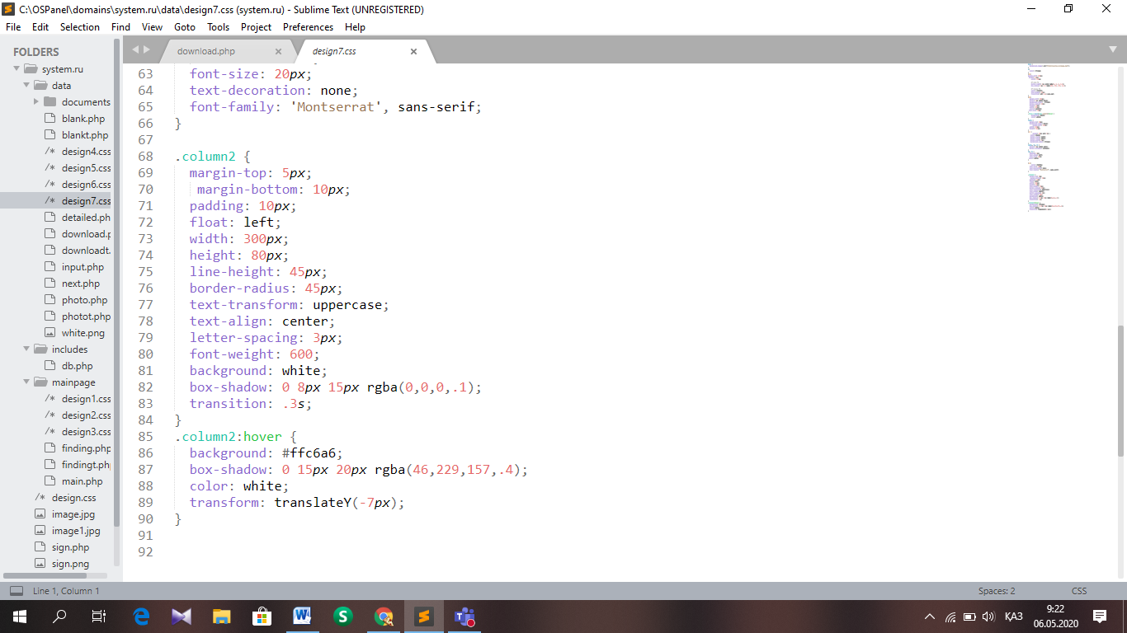

1. Testing

Test Strategy:

Testing is an important step before starting a site on the network. For the correct and effective work as a programmer, I will use various strategies to prevent errors in advance. At this stage, the expectations and actual operation of the system will be shown.

Test Plan:

|  |  |  |  |  |  |
| --- | --- | --- | --- | --- | --- |
| Test No. | Description | Data Type | Expected Result | Pass/Fail | Cross Reference |
| T1 | Links on the Starting Page | Typical – Correct domains of linking pages | 1. A new site (official website and YouTube channel of school) will be opened in a new tab | Pass | T1.1.1  T1.1.2 |
| T2 | Check the signing part | Typical –Correct user details    Erroneous – Incorrect username/password | 1.Displays Main Page, if login and password relates to Curator status  1.Displays Searching Page, if login and password relates to Administrator/Teacher status  2. Error message appears | Pass  Pass  Pass | T2.1.1  T2.1.2  T2.1.3  T2.1.4  T2.1.5  T2.2.1  T2.2.2 |
| T3 | Check the database work of Form entry page | Typical – Inserts a row of general information  Erroneous – Incorrectly filled form, which contains data does not relating to its type or rising maximum number of length | 1. There will be occurred new row with records in ‘student’ table, which are filled by curator in form  2. The records will not be saved in Student table and error message appears | Pass  Pass | T3.1.1  T3.1.2  T3.2.1  T3.2.2 |
| T4 | Check the photo uploading page | Typical – Double click to open File Dialog  Typical – Save uploaded picture  Erroneous – Upload the photo of another format | 1. Opens File Dialog with filter “*.jpeg”  2. Saves the photo in database with its pathway and shows in screen with 3*4 format  3. The site should open only JPEG photos. | Pass  Pass  Pass | T4.1.1  T4.1.2  T4.1.3  T4.2.1  T4.2.2  T4.3.1  T4.3.2  T4.3.3 |
| T5 | Check the database work of Page for input of details | Typical – Uploads files one by one into every row  Erroneous – Empty rows are left | 1. Saves pathways of files in database  2. There is no recently added row | Pass  Pass | T5.1.1  T5.1.2  T5.1.3  T5.2.1  T5.2.2  T5.2.3 |
| T6 | Check the Searching page | Erroneous – Search for not existing name and surname  Erroneous – Search for only name or surname  Typical – Search for name and surname of student | 1. Doesn’t provide any records. Error message appears  2. Doesn’t provide any records. Error message appears  3. Finds the correct record by his name and surname from Student table | Pass  Pass  Pass | T6.1.1  T6.1.2  T6.2.1  T6.2.2  T6.3.1  T7.1.1 |
| T7 | Check the database work of Form output page | Typical – Load the table into page, like in Form entry page  Typical – Select the student by name and surname, which was written in the Searching page | 1. The table and its values are shown in the page  2. Shows records belong to selected student from Student table | Pass  Pass | T7.1.1  T7.1.1 |
| T8 | Check the database work of Photo show page | Typical – Select student’s photo by IIN written by user  Erroneous– Incorrect IIN of student | 1. Loads photo of certain student in 3*4 format  2. Does not show anything. There no such IIN in database | Pass  Pass | T8.1.1  T8.1.2  T8.2.1  T8.2.2  T8.2.3  T8.2.4 |
| T9 | Check the database work of Page for output of details | Typical – Load the horizontal table into page  Typical – Select the student IIN written by user in the field  Erroneous – Incorrect or not existing IIN is written by user | 1. The table is shown in the page with links  2.Shows records belong to selected student from Files table  3. Does not provide any records | Pass  Pass  Pass | T9.1.1  T9.1.1  T9.2.1  T9.3.1  T9.3.2 |
| T10 | Check the work of links in Page for output of details | Typical – Clicks Download link  Typical – Clicks View link | 1. Certain file, which belongs to the attribute about student’s details, automatically is downloaded to the user’s PC  2. There will be opened new tab with electronic variant of the file | Pass  Pass | T10.1.1  T10.2.1 |
| T11 | Check the database work of Page for output of details for teachers | Typical – Load the horizontal table into page  Typical – Select the student IIN written by user in the field  Erroneous – Incorrect or not existing IIN is written by user | 1. The table with 3 attributes is shown in the page with links  2.Shows records belong to selected student from Files table  3. Does not provide any records | Pass  Pass  Pass | T11.1.1  T11.1.1  T11.2.1  T11.3.1  T11.3.2 |

### Test №1

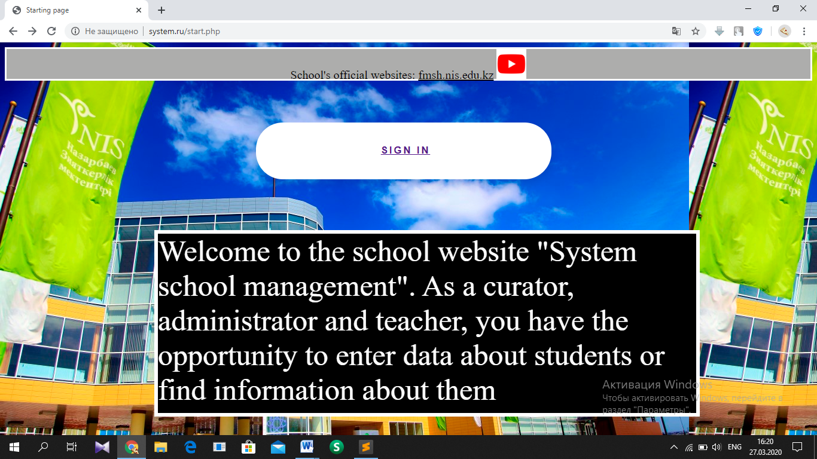

T1.1.1 Starting page with the link of school’s official website and YouTube sign in the top.

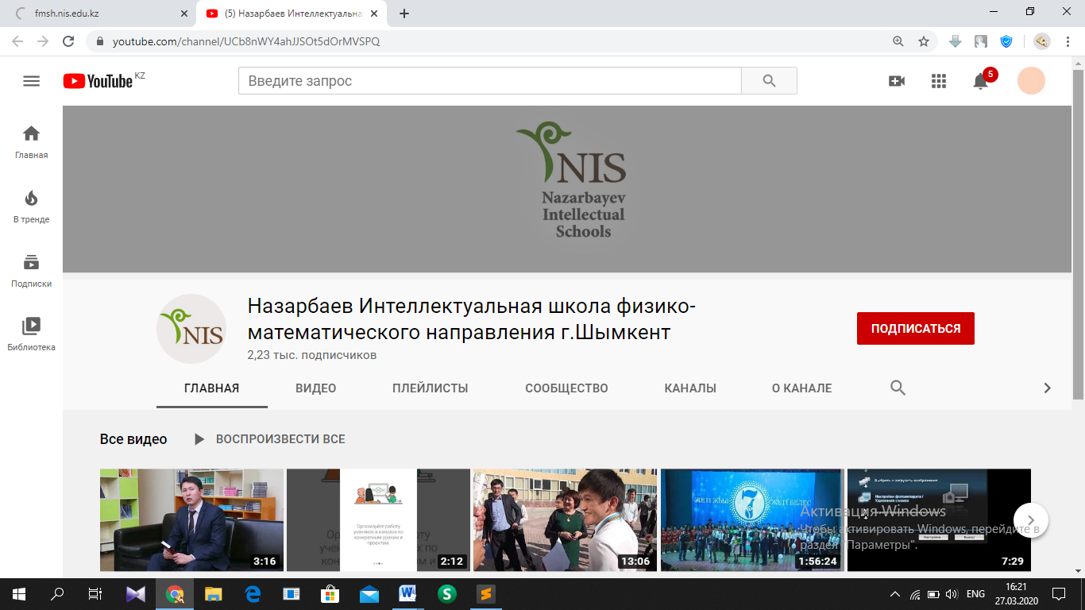

T1.1.2. Loaded websites from the links

### Test №2

The user’s account already has registered and set by mutual agreement with client. The following pictures show that user can enter only if his account details are correct.

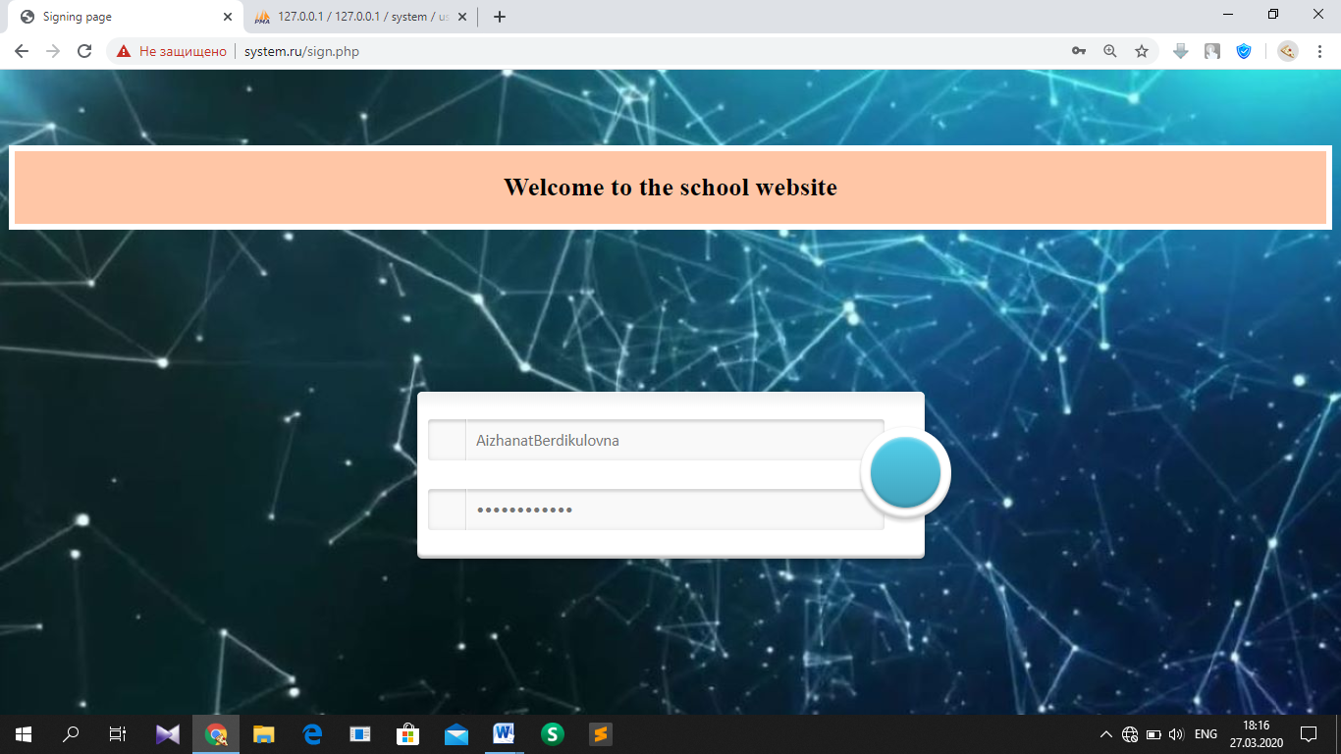

T2.1.1. Signing page, where correct login and password of curator is written

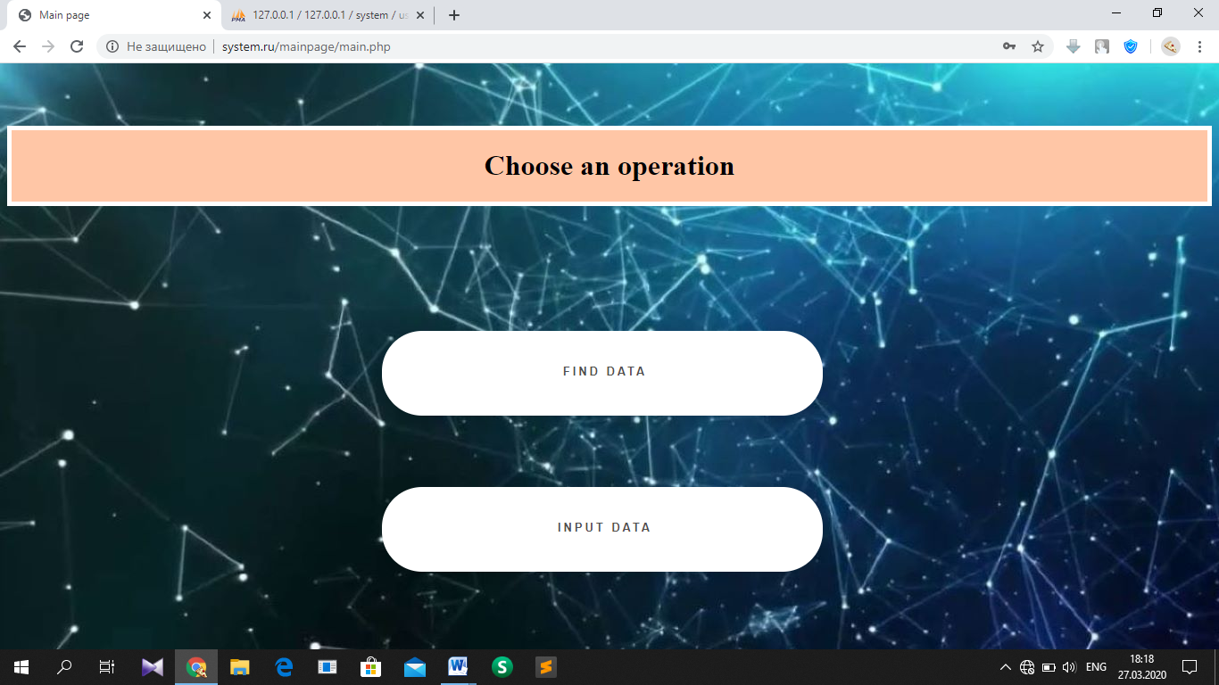

T2.1.2. Main page is opened after curator’s signing

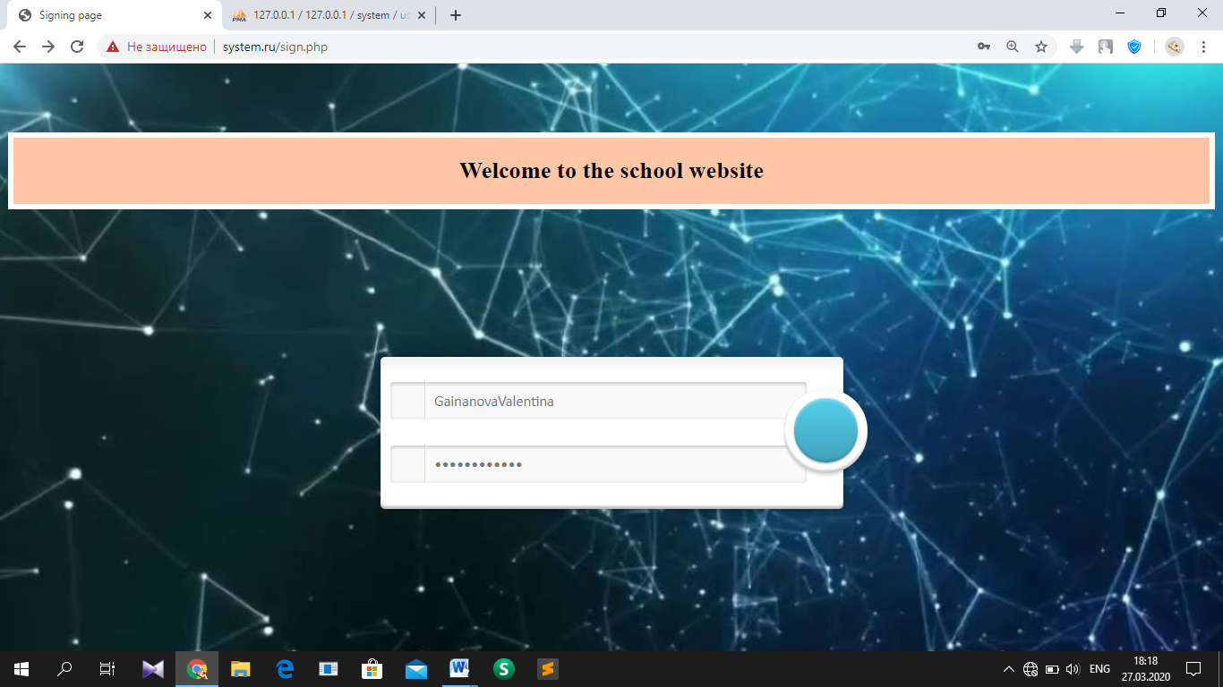

T2.1.3. Signing page, where correct login and password of teacher is written

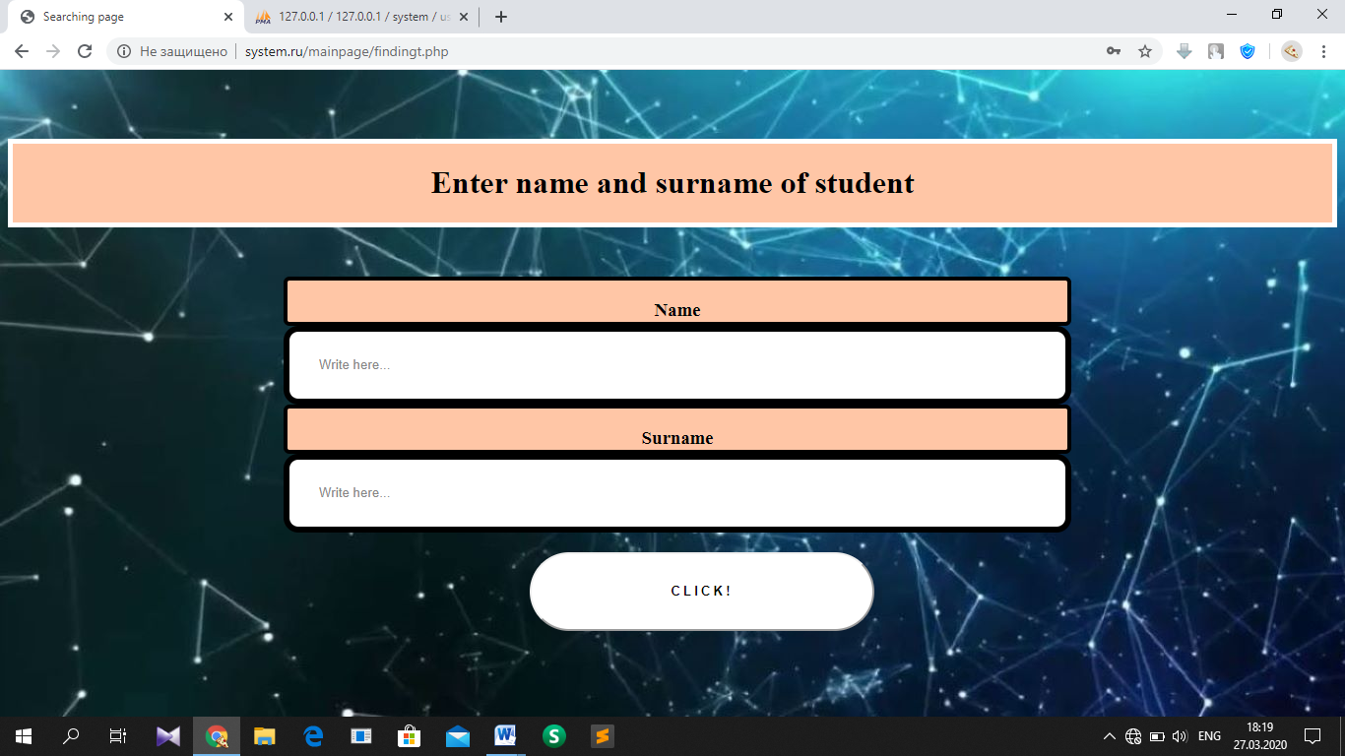

T2.1.4. Searching page is opened after teacher’s signing

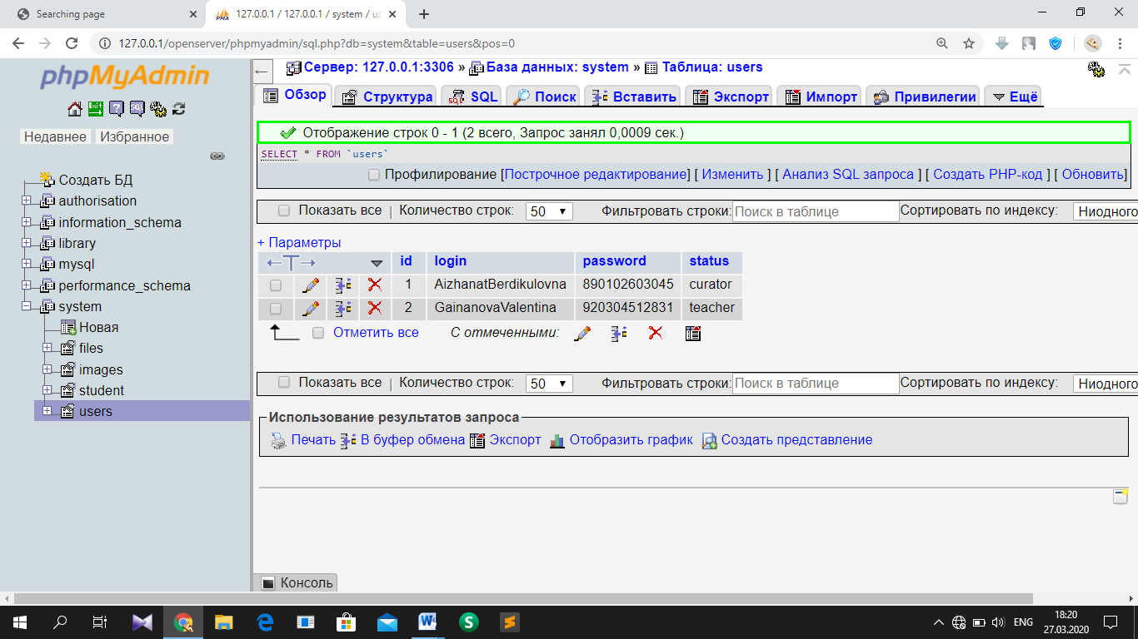

T2.1.5. ‘System’ database, ‘Users’ table which contains correct details

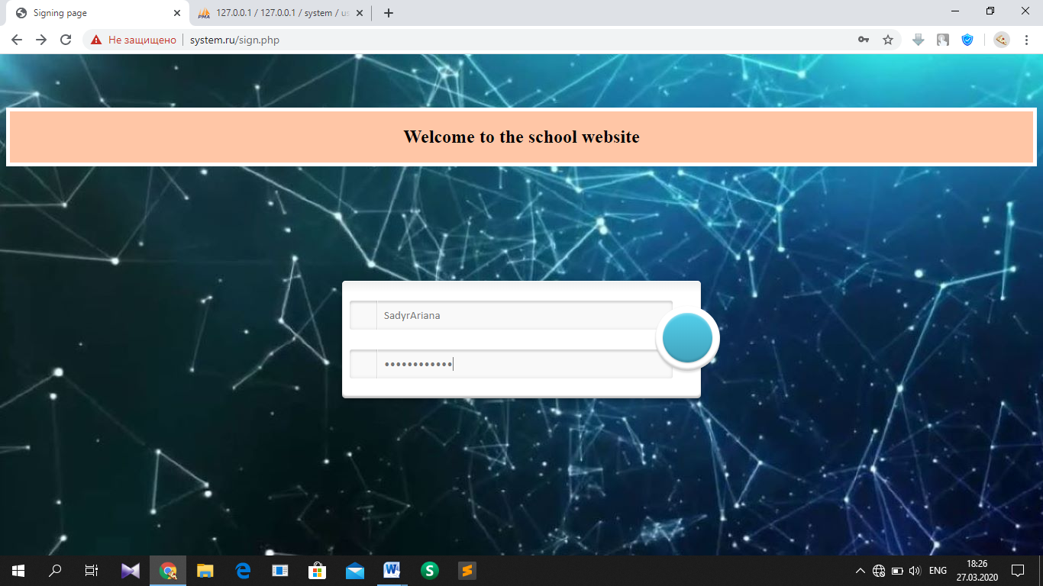

T2.2.1. Signing page, where incorrect and not existing login and password is written

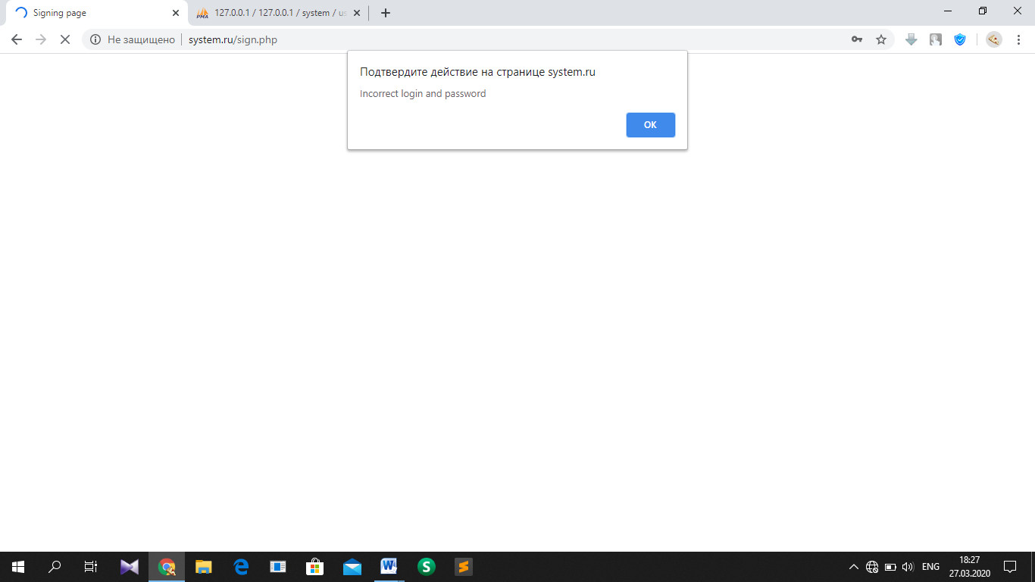

T2.2.2. Error message

### Test №3

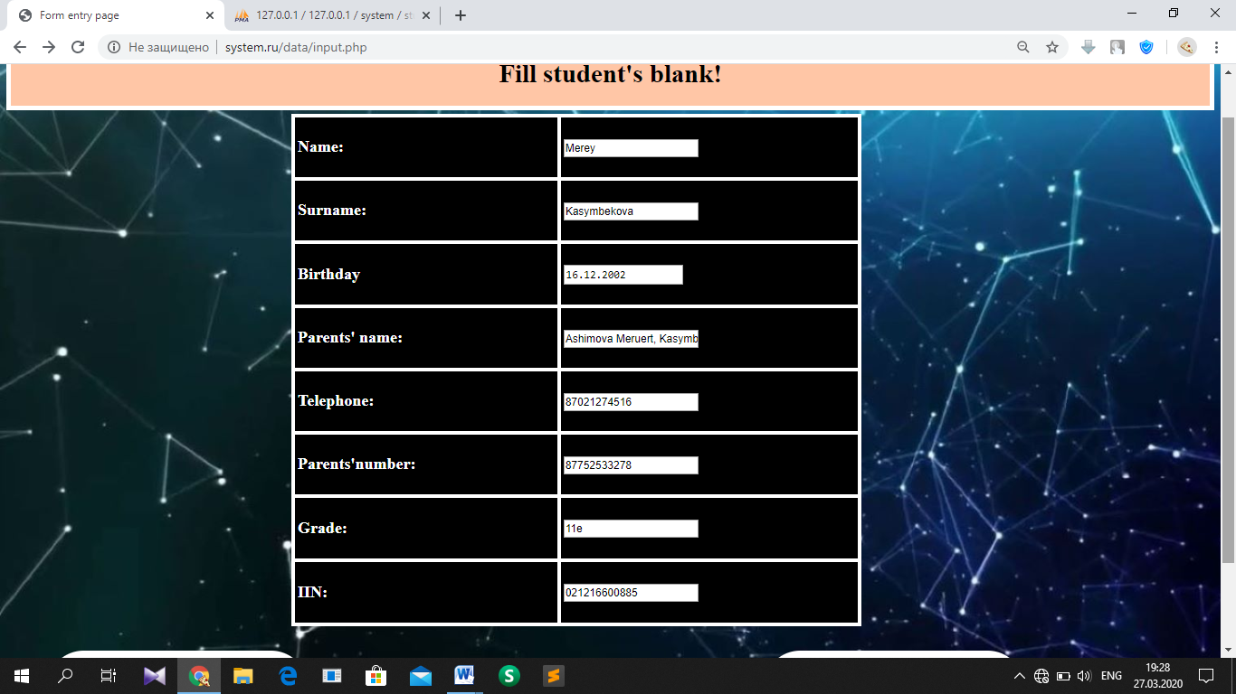

T3.1.1. Form entry page with general data about student in table

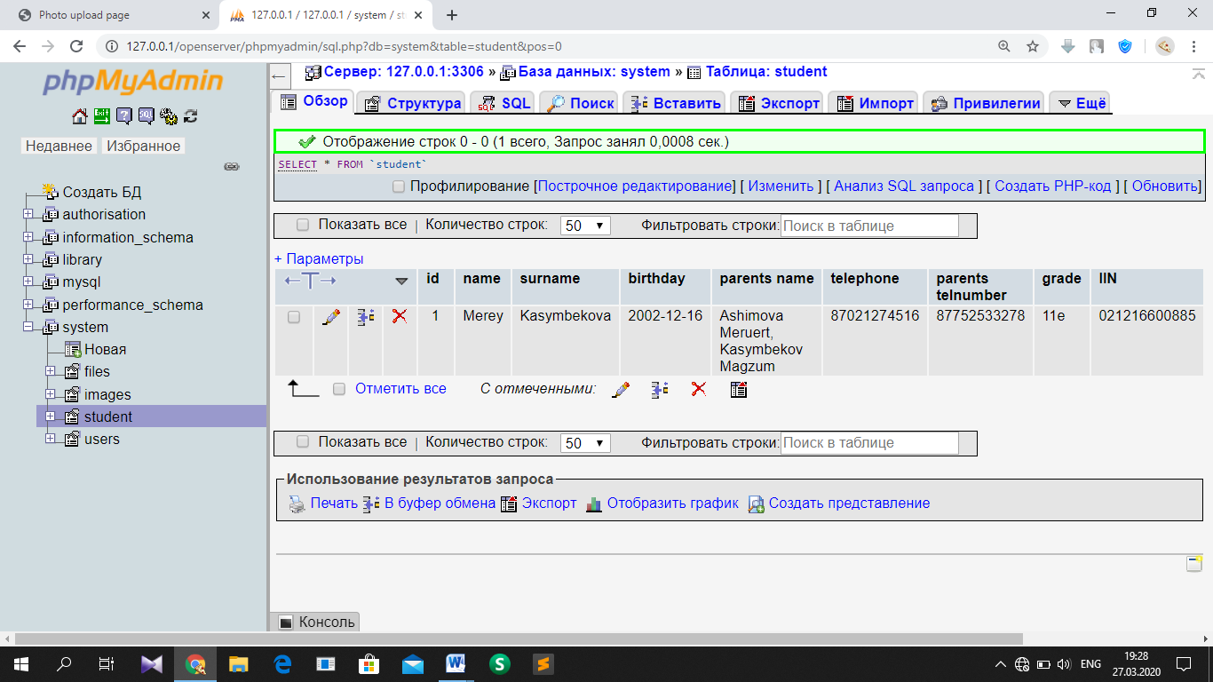

T3.1.2 Database, ‘student’ table with new row about this student

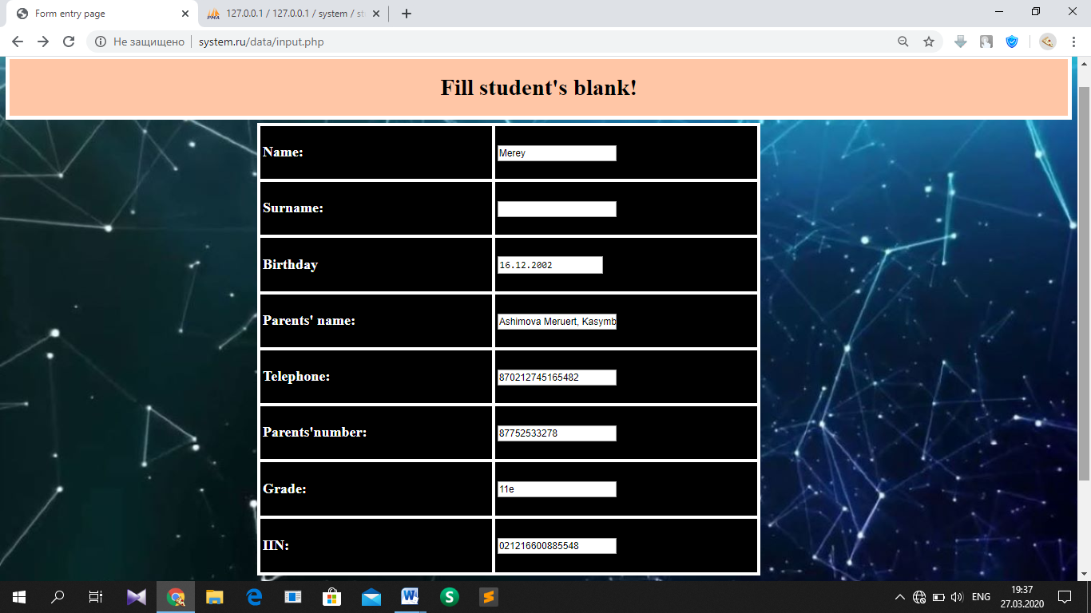

T3.2.1. Form entry page with incorrect data (empty cell is left, length is over maximum size) about student in table

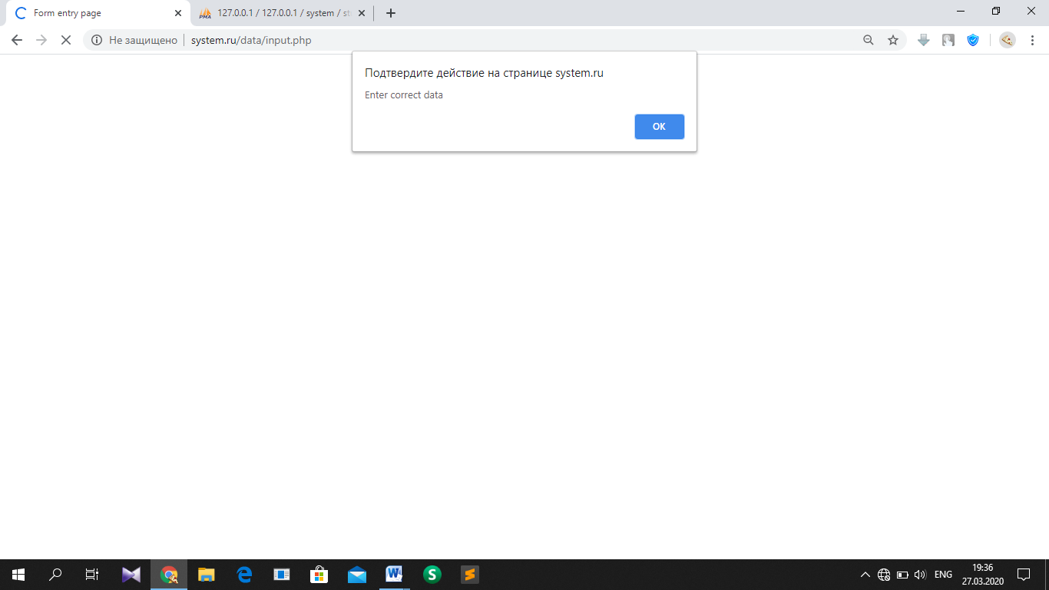

T3.2.2. Error message

### Test №4

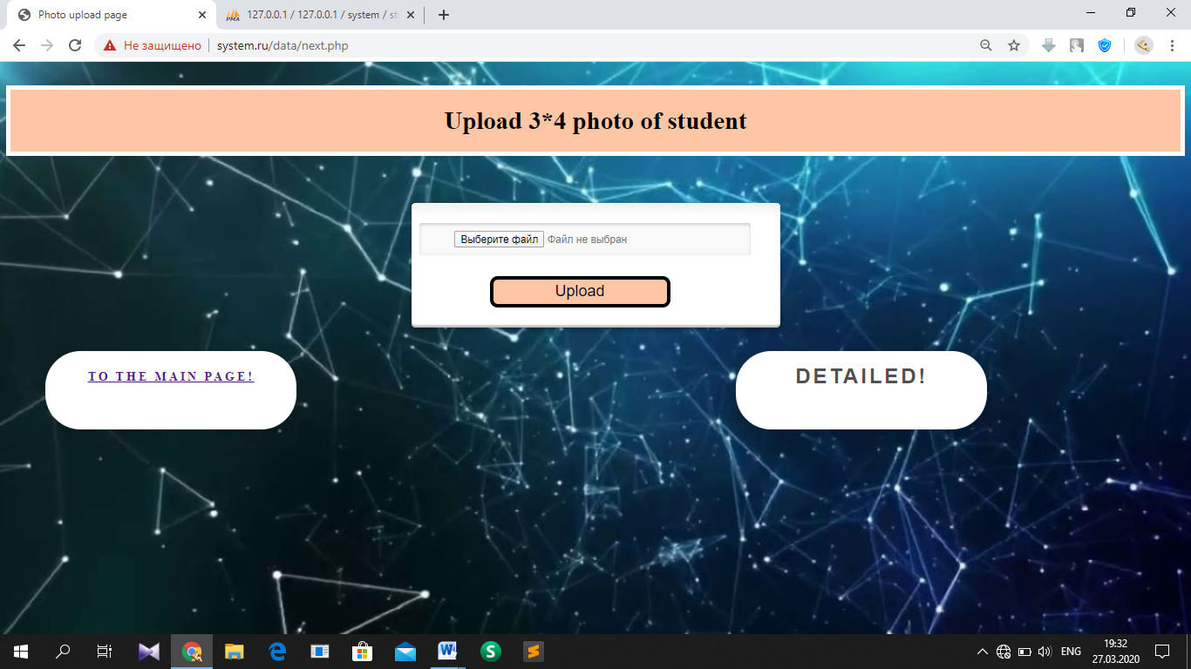

T4.1.1. Photo upload page

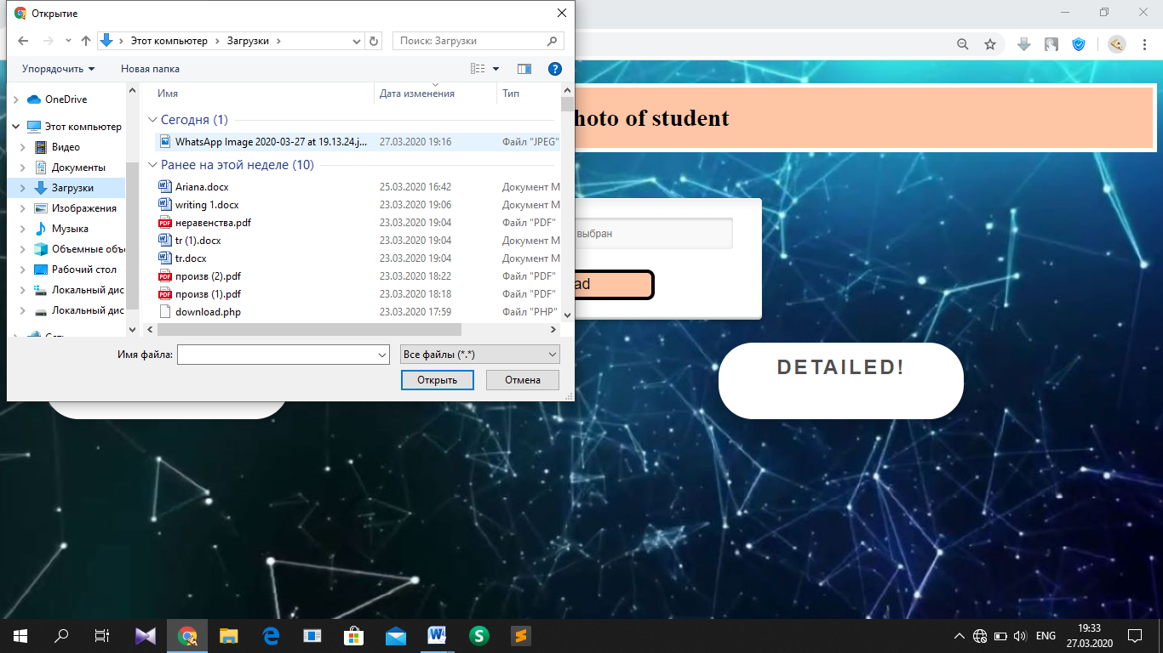

T4.1.2. Photo upload page where File Dialog appears in clicking the button ‘Choose file’

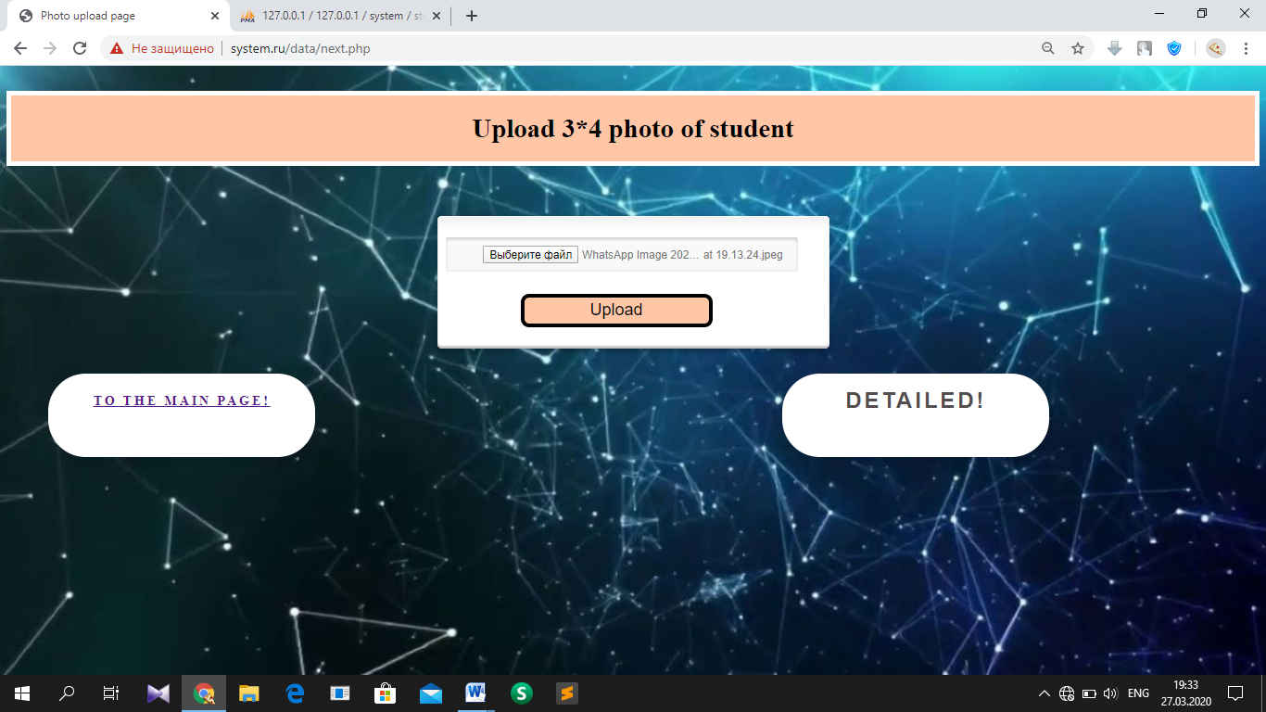

T4.1.3. Photo upload page where pathway to .jpeg file have been uploaded to the field

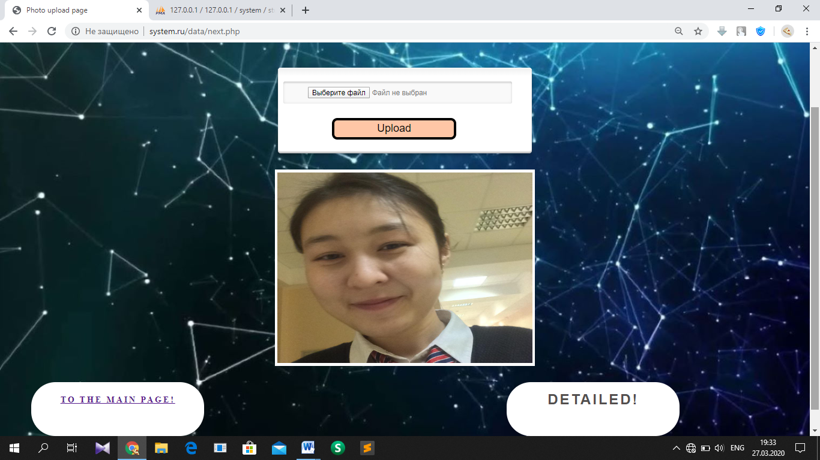

T4.2.1. Photo upload page where image has been appeared in block with 3*4 format

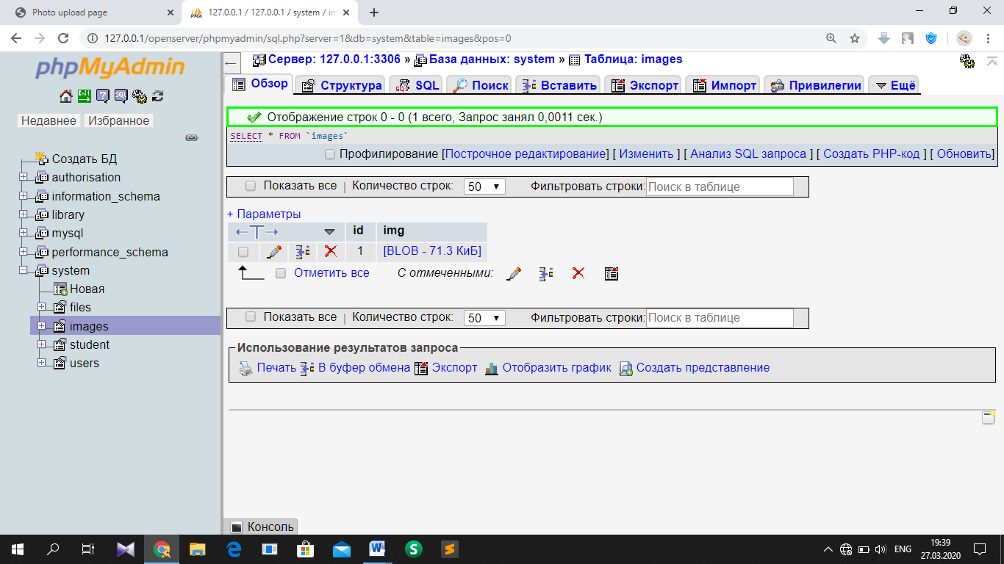

T4.2.2. Database, ‘images’ table where Jpeg file is uploaded with ID ‘1’

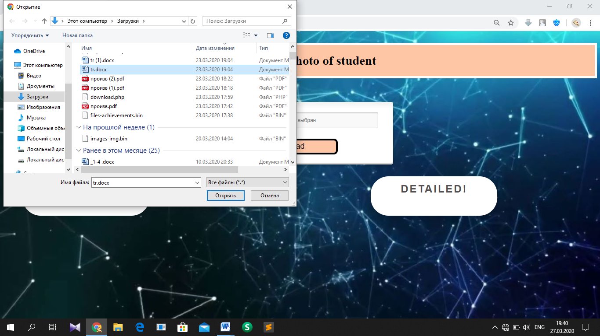

T4.3.1. Photo upload page where user is choosing file with .docx format

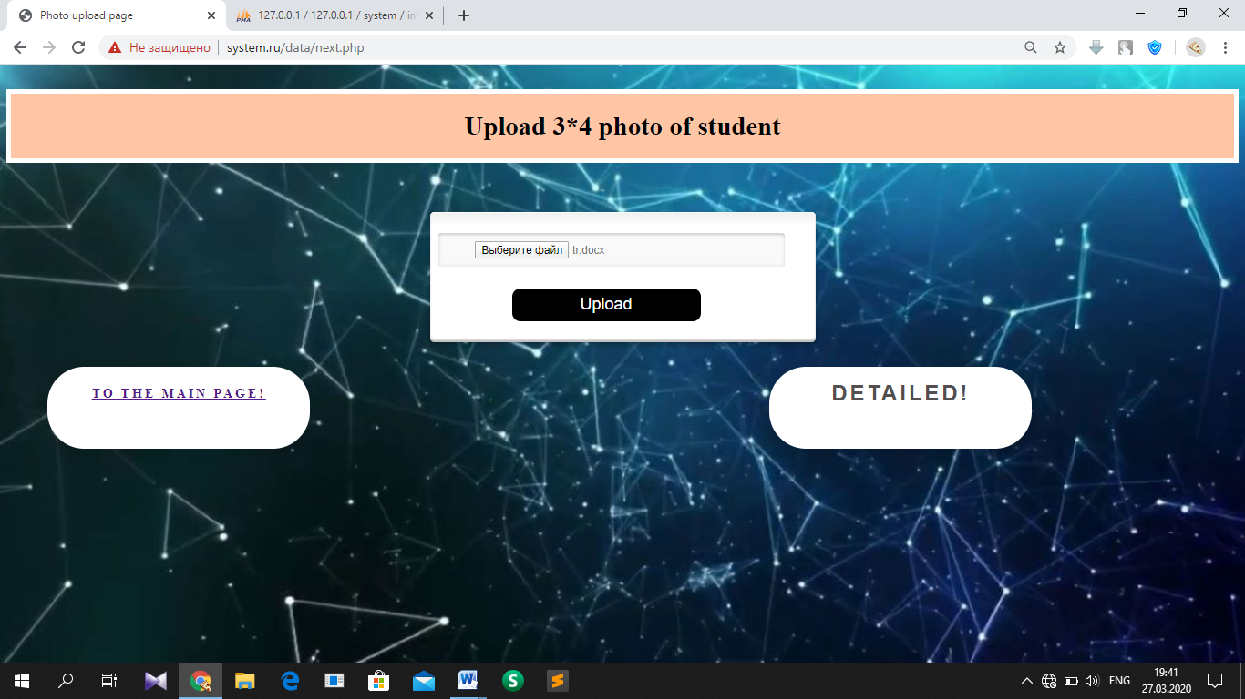

T4.3.2. Photo upload page where pathway to .docx file have been uploaded to field

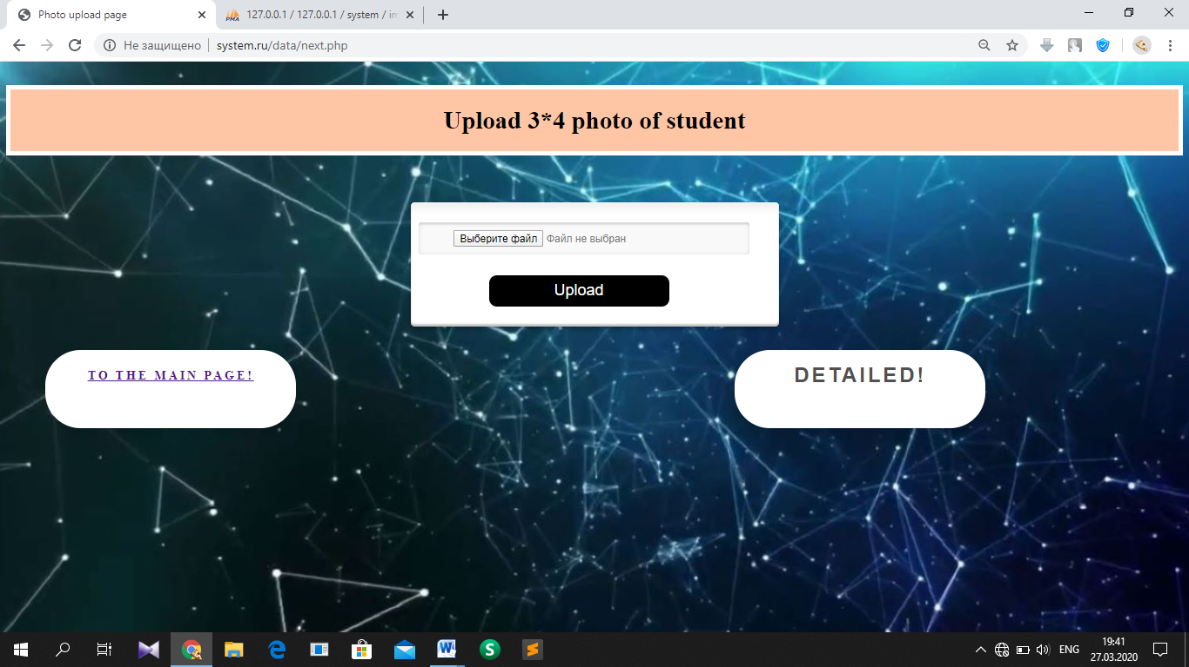

T4.3.3 Photo upload page which have been refreshed after uploading incorrect file (Database did not save this file)

### Test №5

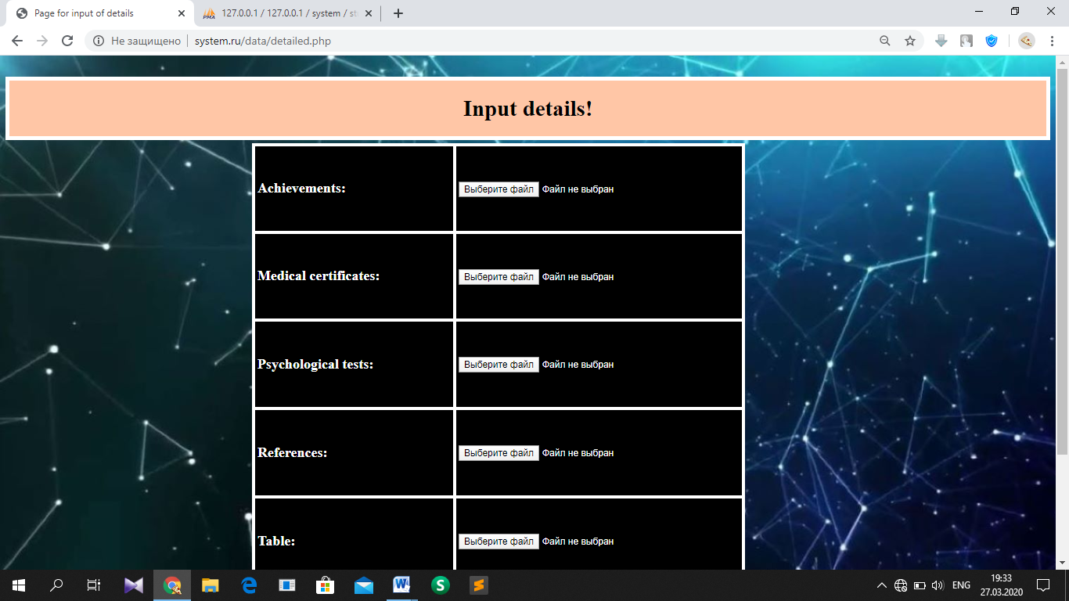

T5.1.1. Page for input of details

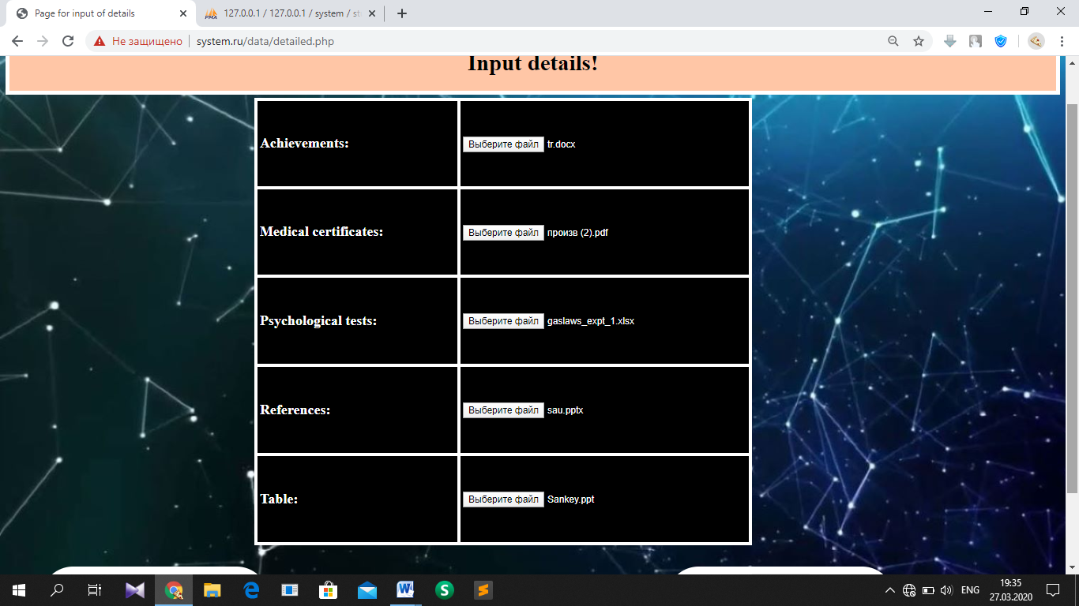

T5.1.2. User uploaded pathways to different files into table of Page for input of details

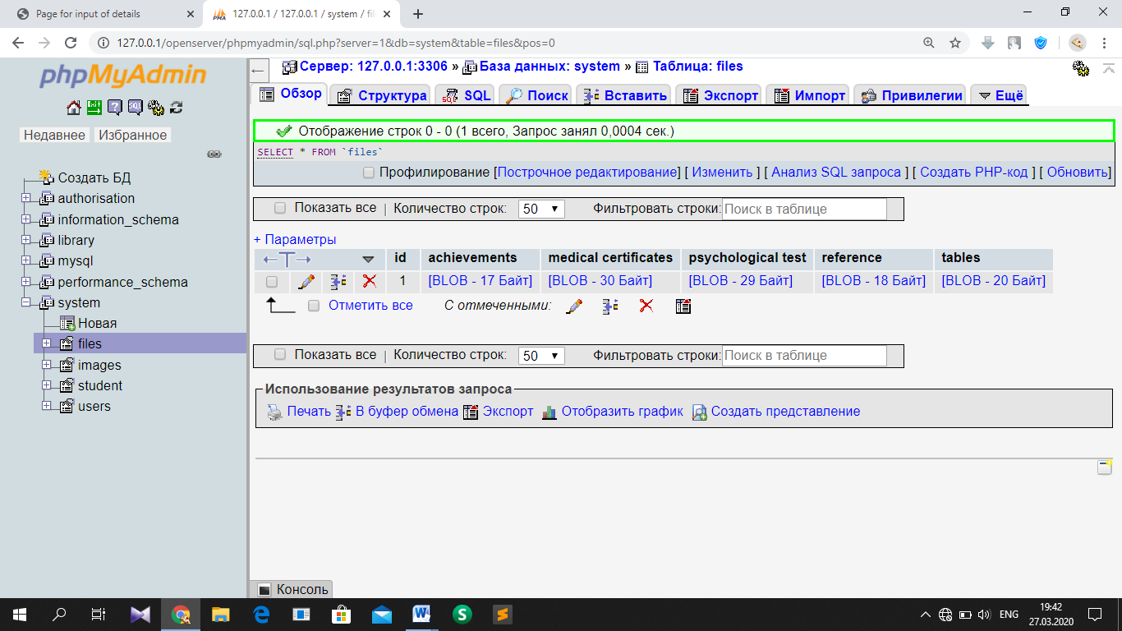

T5.1.3. Database, ‘files’ table which contains files uploaded by user

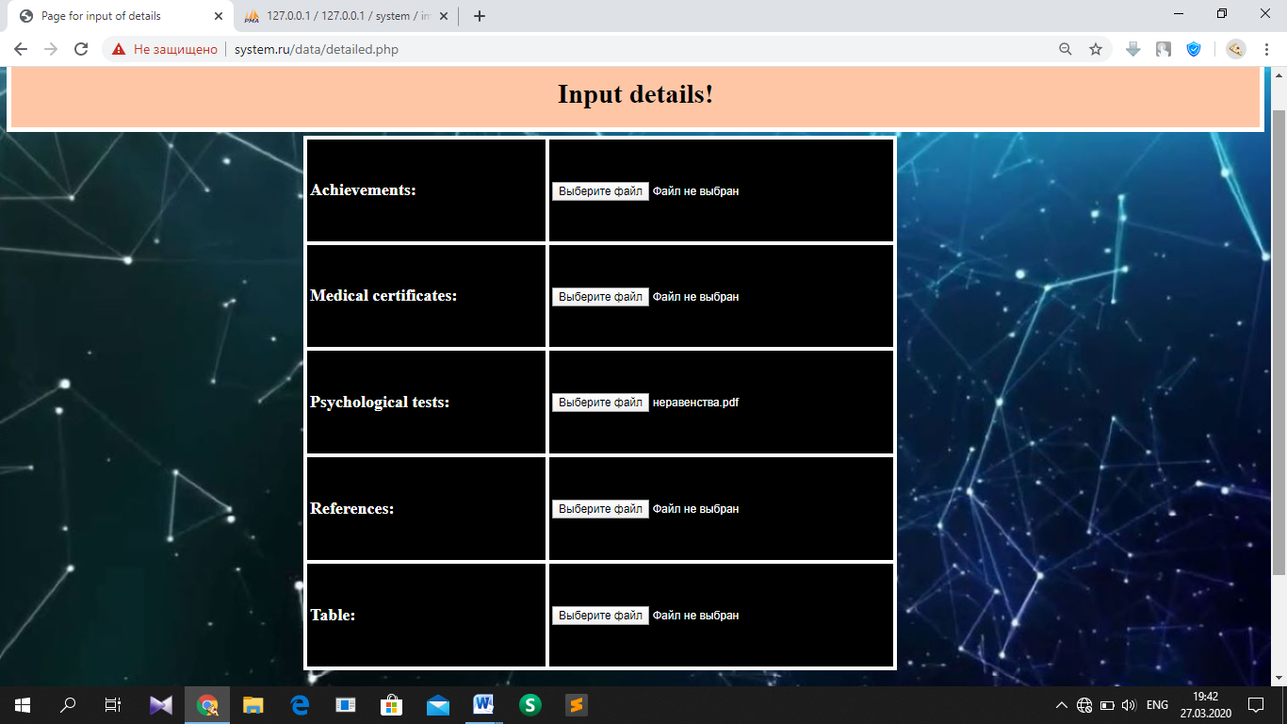

T5.2.1. Page for input of details, which have been filled incorrectly (empty cells are left) and there are no new rows in table ‘files’

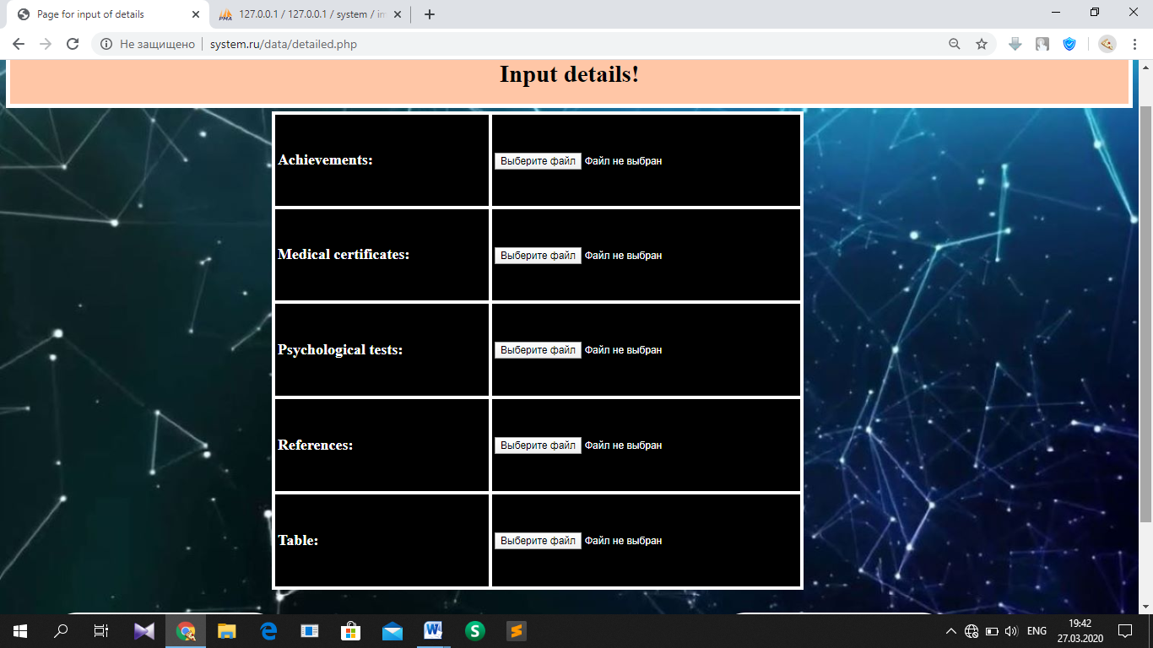

T5.2.2. After clicking ‘Save’ button, page have been refreshed, because of incorrect filling

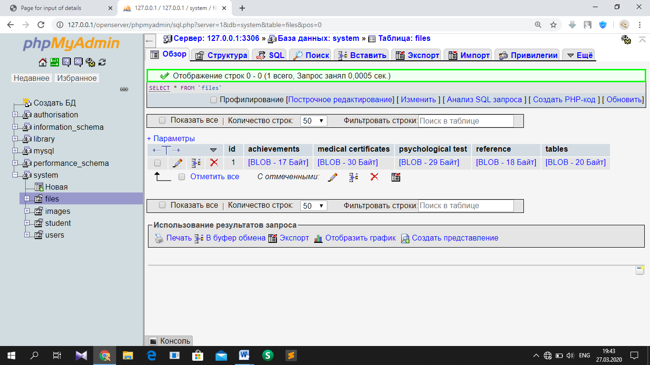

T5.2.3. Database, ‘files’ table has no new row

### Test №6

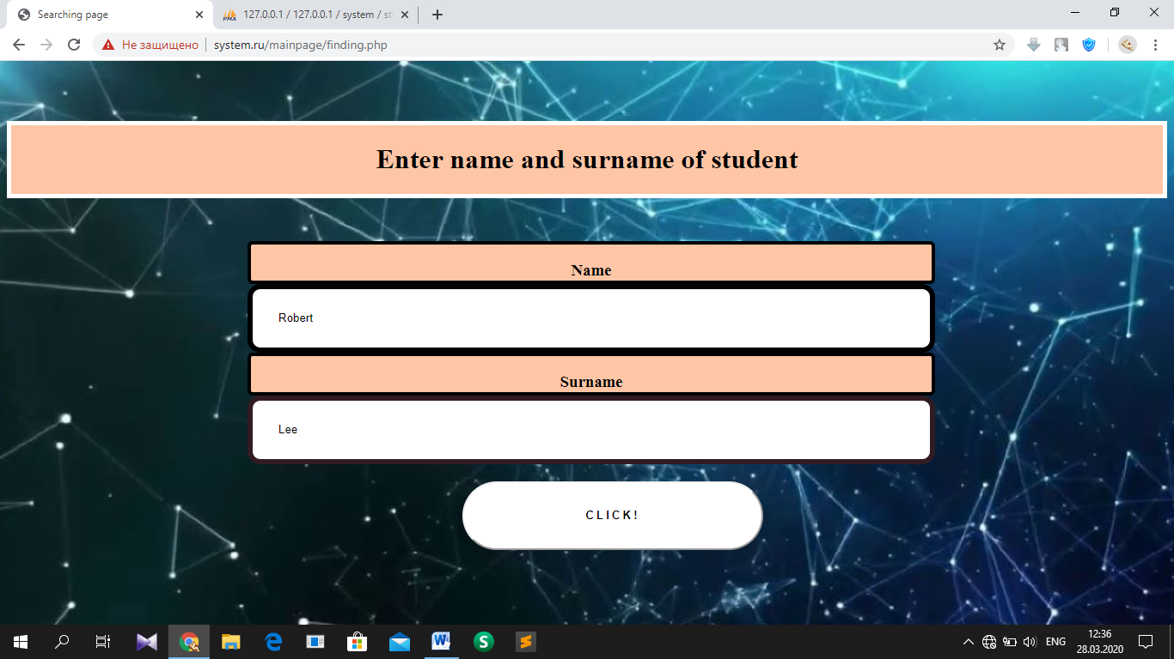

T6.1.1. Searching page where user wrote name and surname of student, whom information has not been entered to database

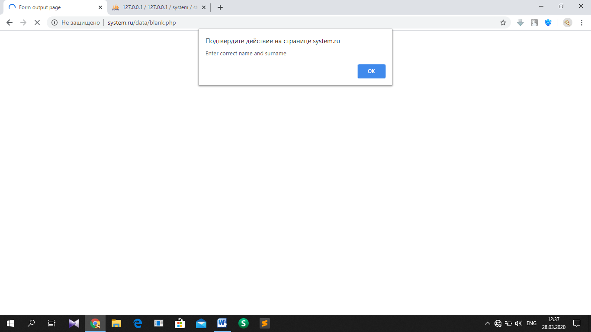

T6.1.2. Error message

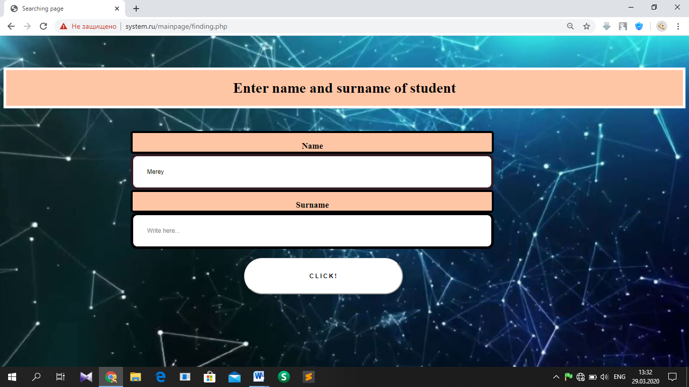

T6.2.1. Searching page where user wrote only name of student

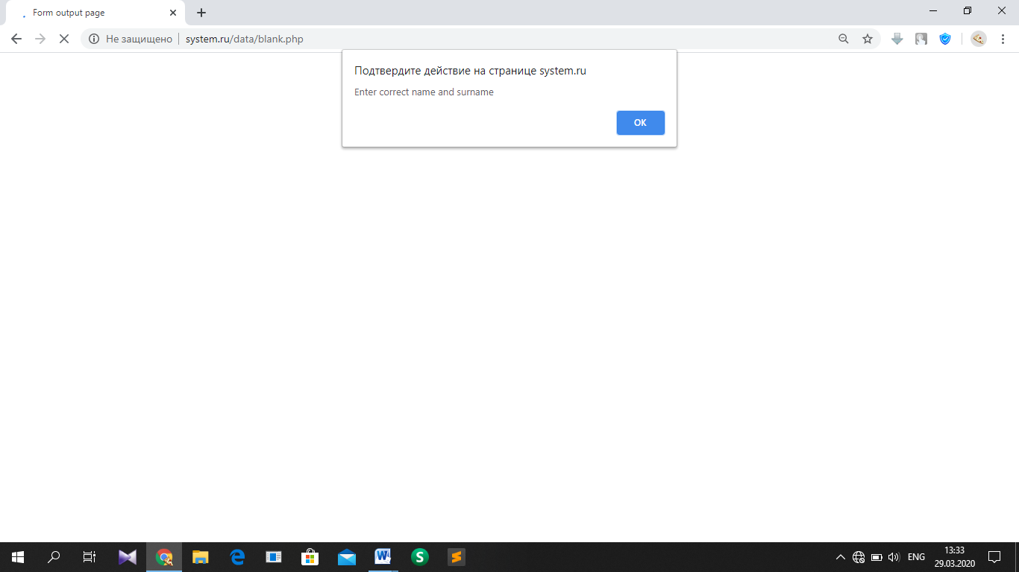

T6.2.2. Error message

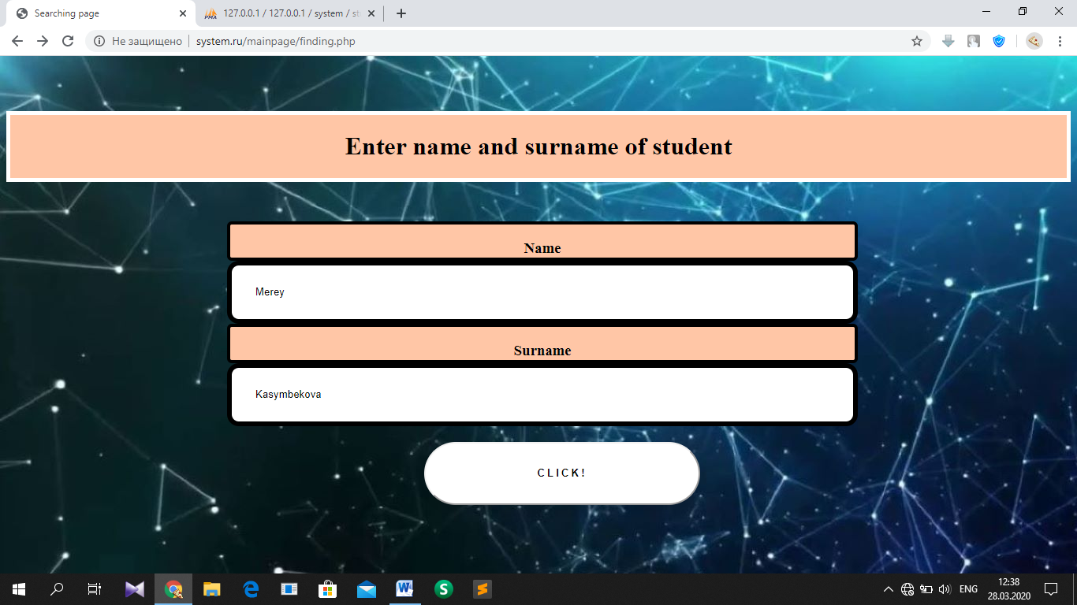

T6.3.1. Searching page where user wrote correct name and surname of student who has data in database

### Test №7

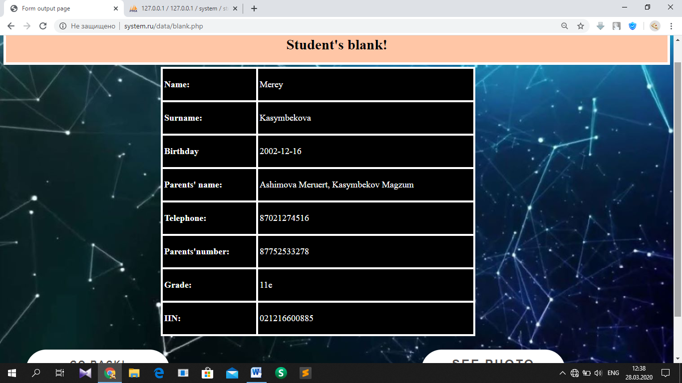

T7.1.1. Form output page where data about student (whom name and surname was written in the searching page) has appeared

### Test №8

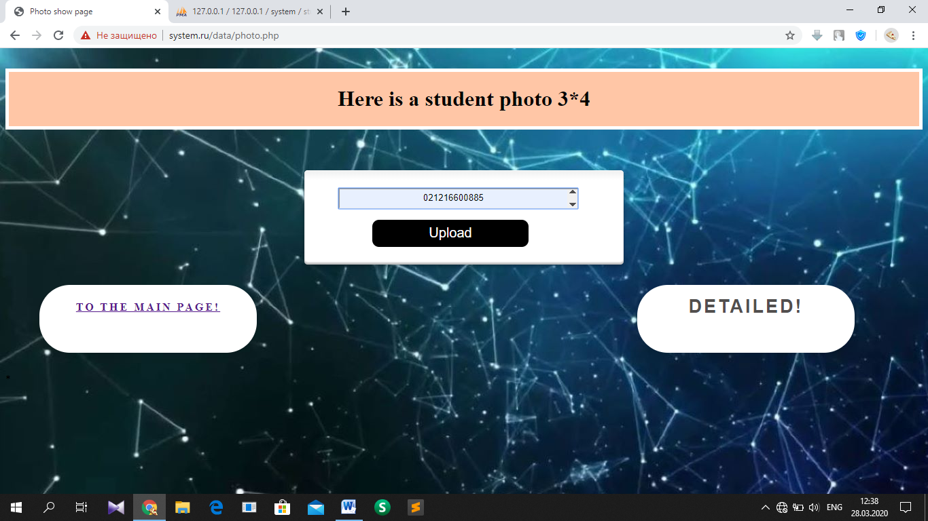

T8.1.1. Photo upload page where user wrote IIN of searching student

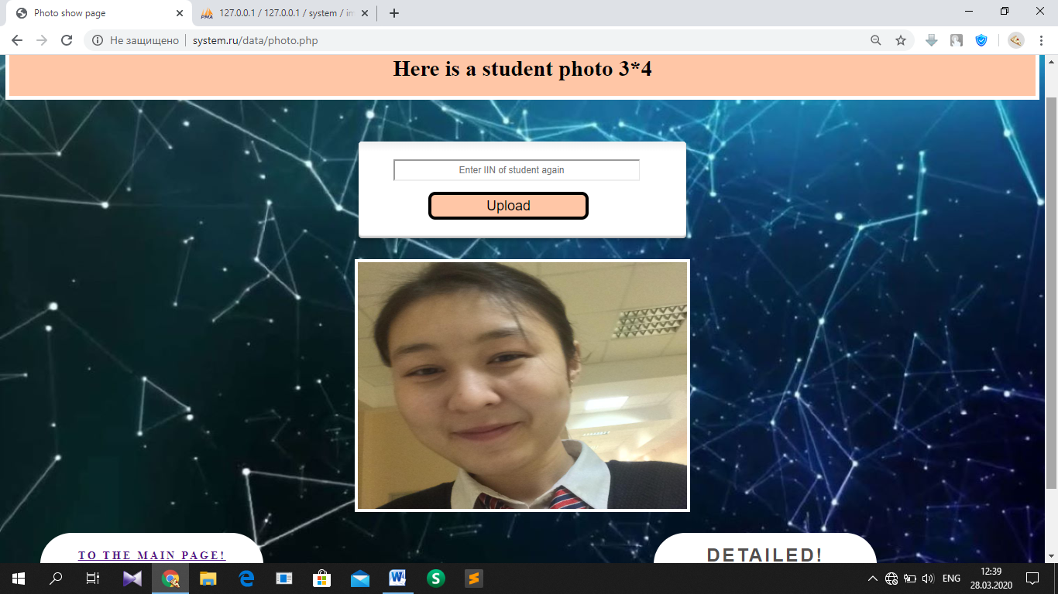

T8.1.2. After writing correct IIN and clicking button ‘upload’, photo of student has appeared

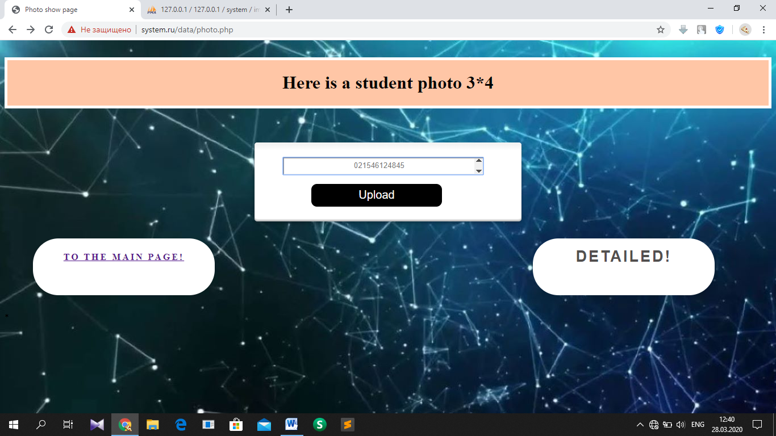

T8.2.1. Photo show page where user wrote IIN of student whom data has not been registered in database

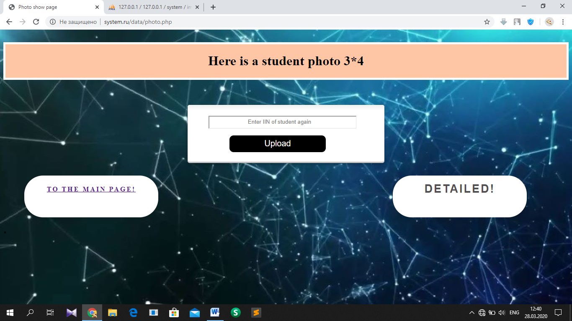

T8.2.2. Photo show page has been refreshed after incorrect IIN

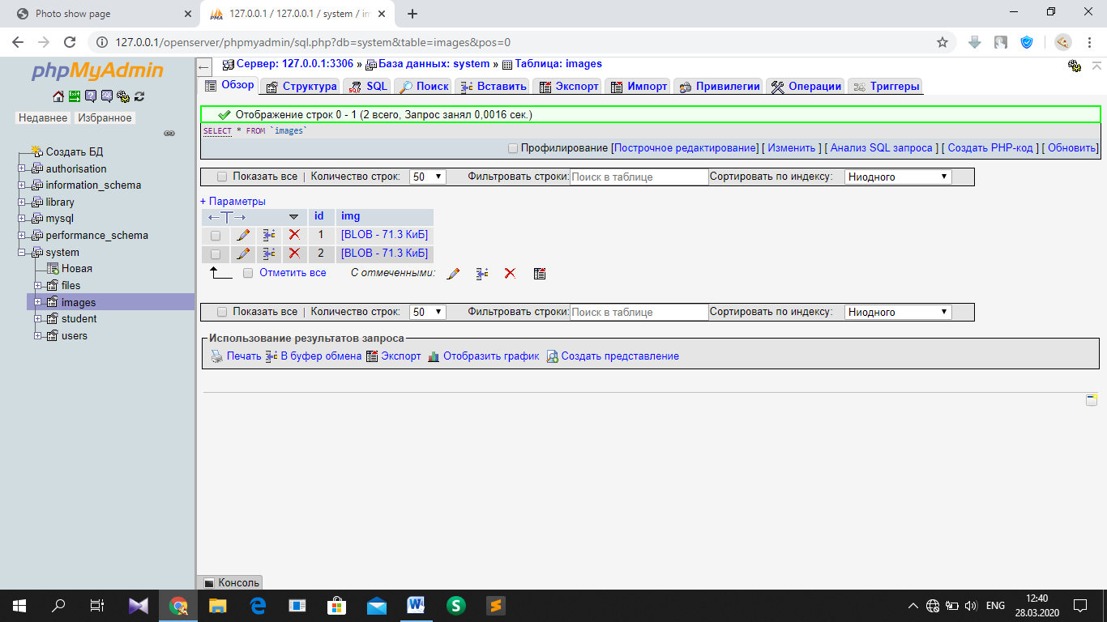

T8.2.3. Database, ‘images’ table where image of id ‘1’ has been appeared in photo show page.

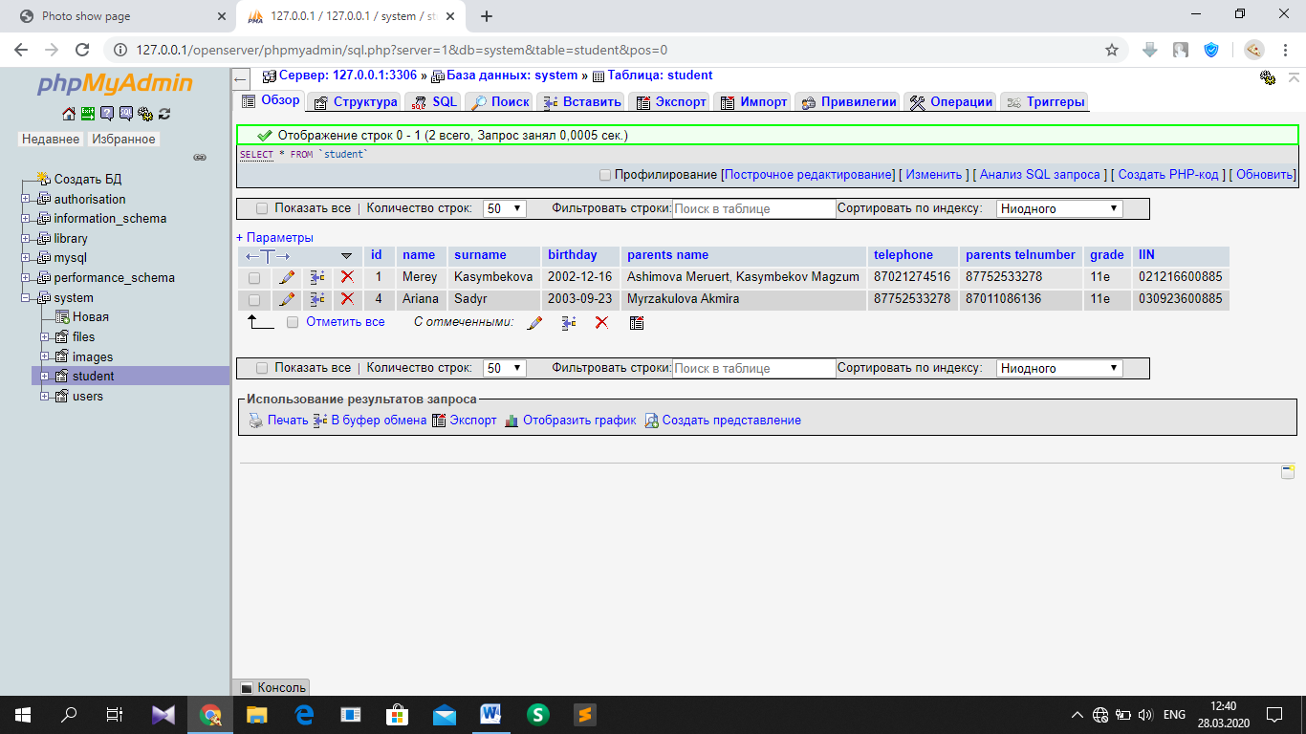

T8.2.4. Database, ‘student’ table where id ‘1’ has IIN written in the field of photo show page. Table does not contain incorrect IIN written in T8.2.1

### Test №9

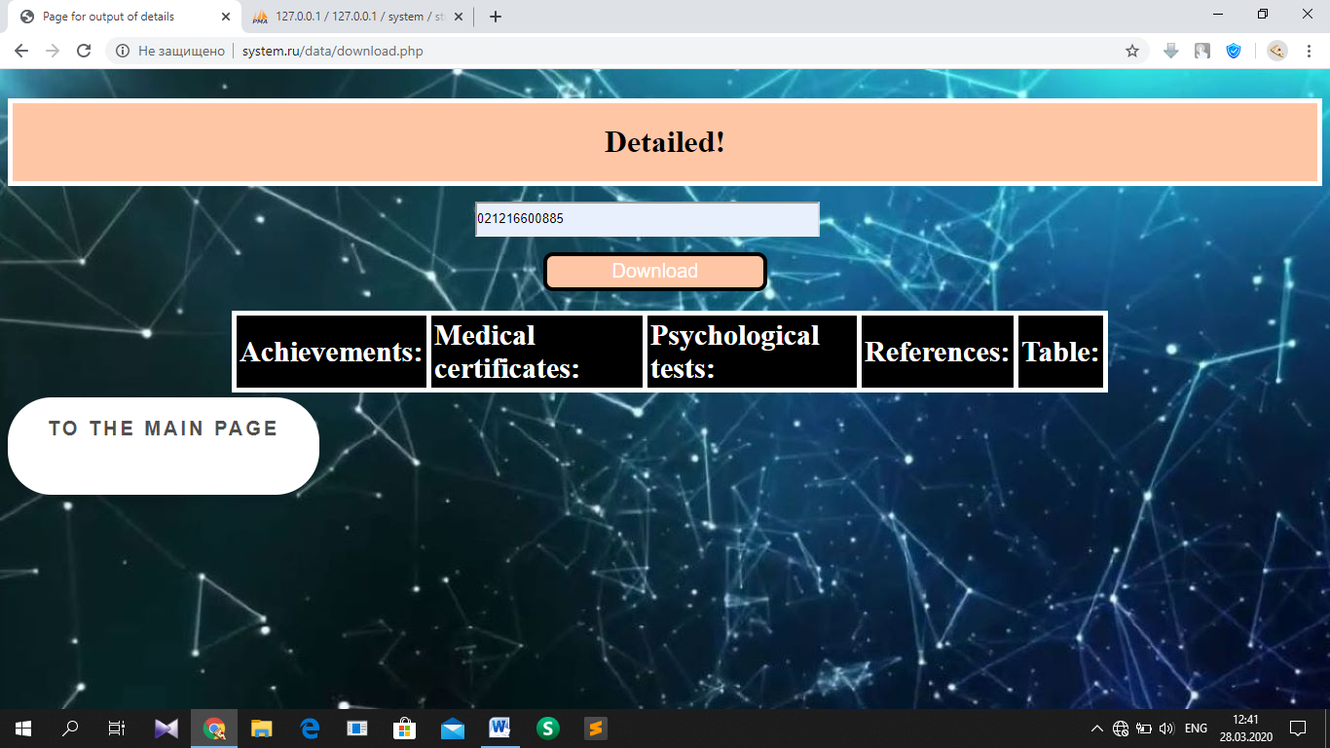

T9.1.1. Page for output of details where user wrote the same IIN of searching student

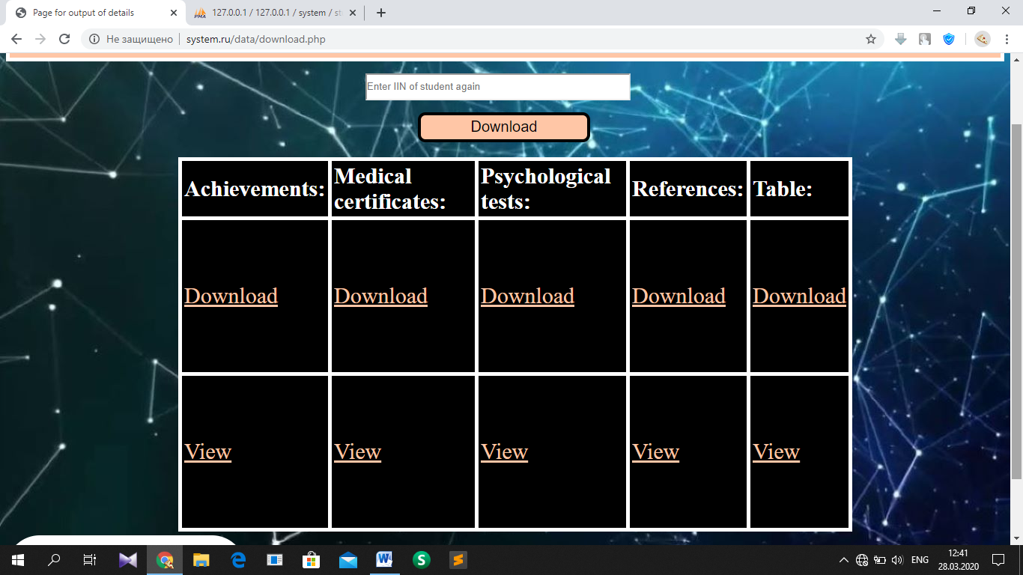

T9.2.1. Files, which belong to student with this IIN has appeared in the table

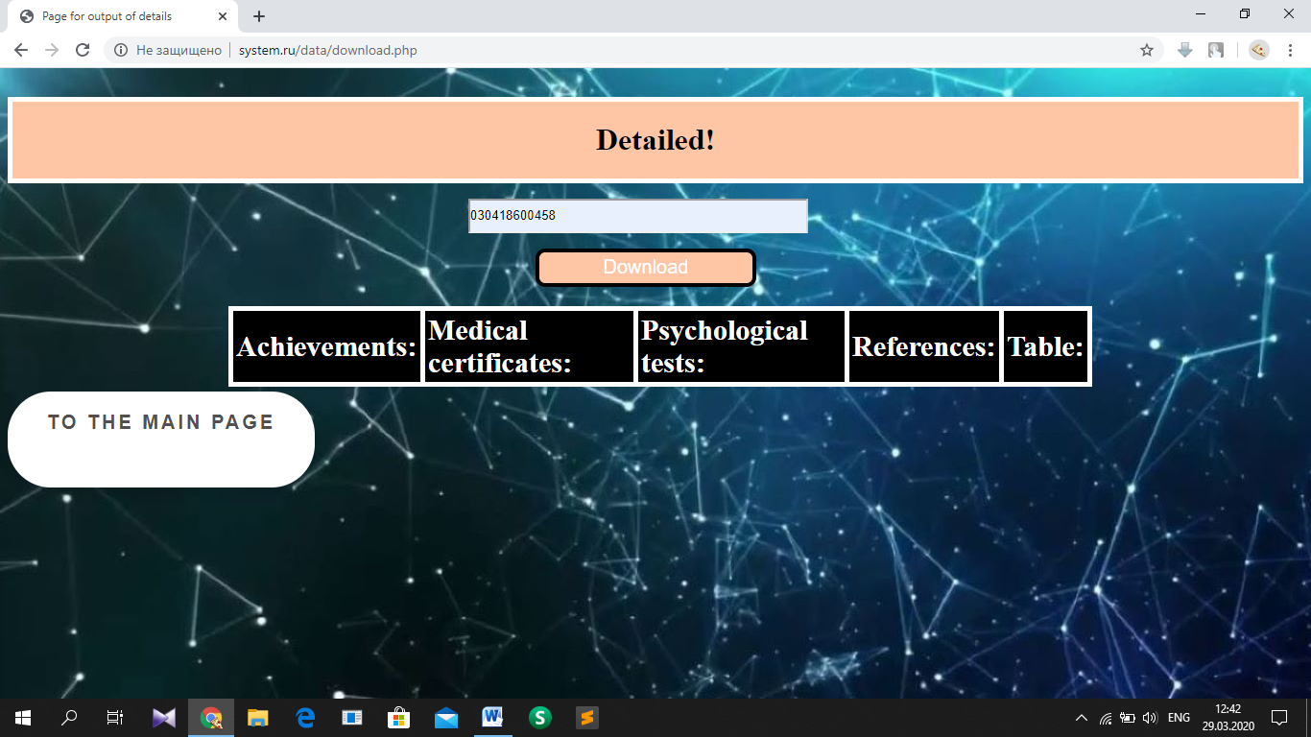

T9.3.1. Page for output of details where user wrote not existing IIN of student

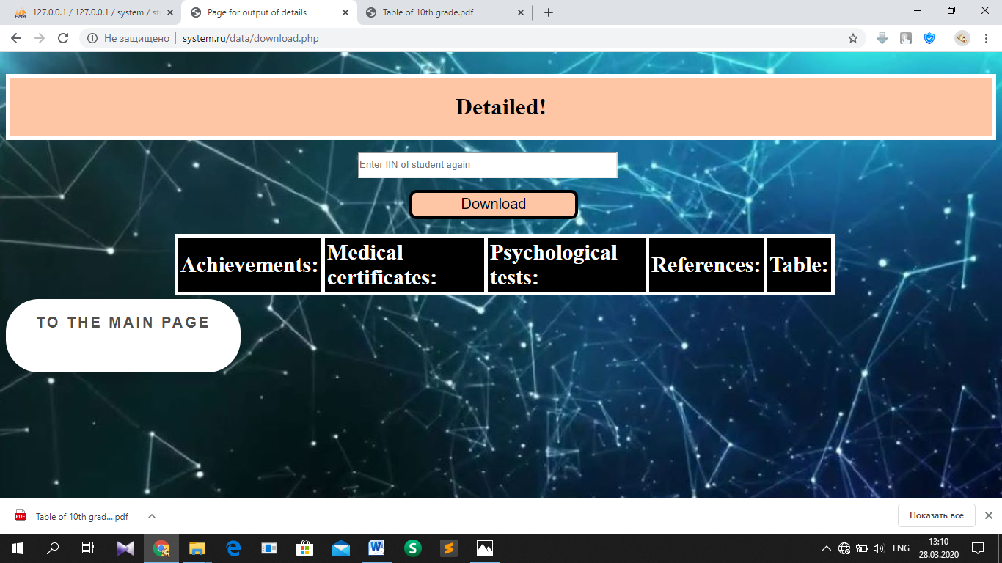

T9.3.2. Nothing has appeared in page after writing not existing IIN

### Test №10

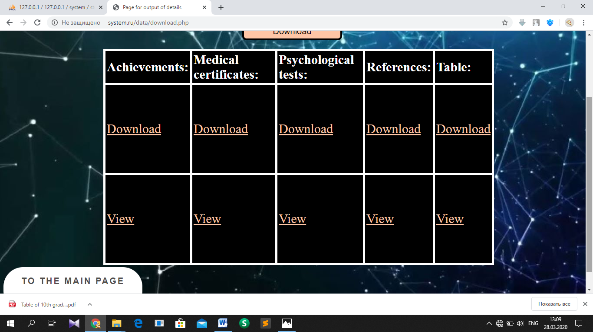

T10.1.1. After clicking button ‘Download’, ‘table’ file has been downloaded

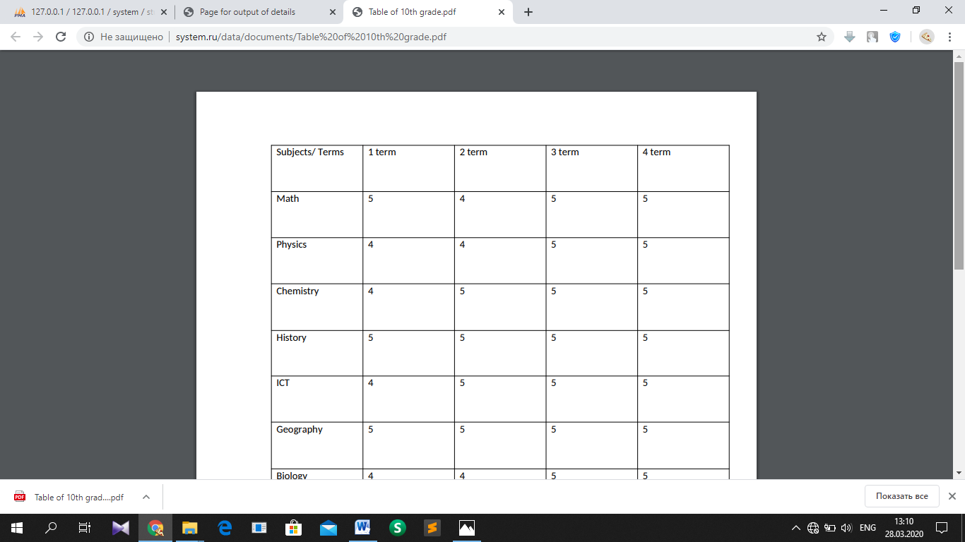

T10.2.1. After clicking button ‘View’, this file appeared in the new tab in electronic form

### Test №11

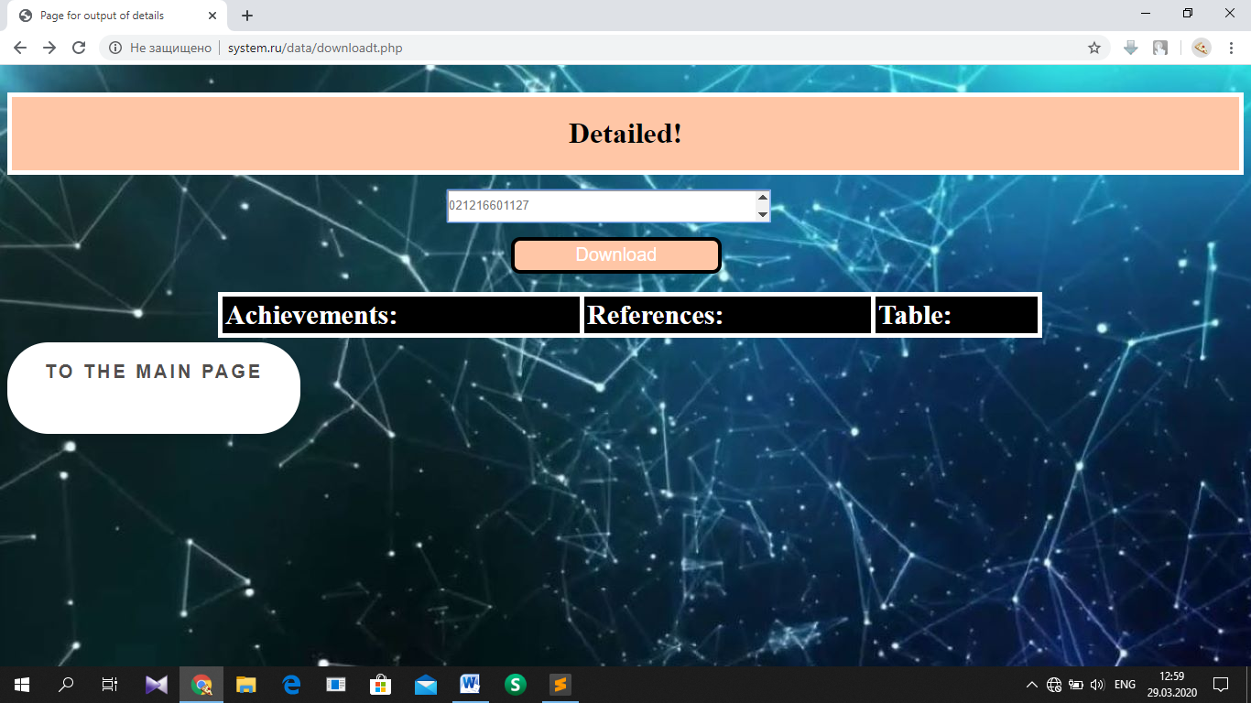

T11.1.1 Page for output of details for teachers where user wrote existing IIN of student

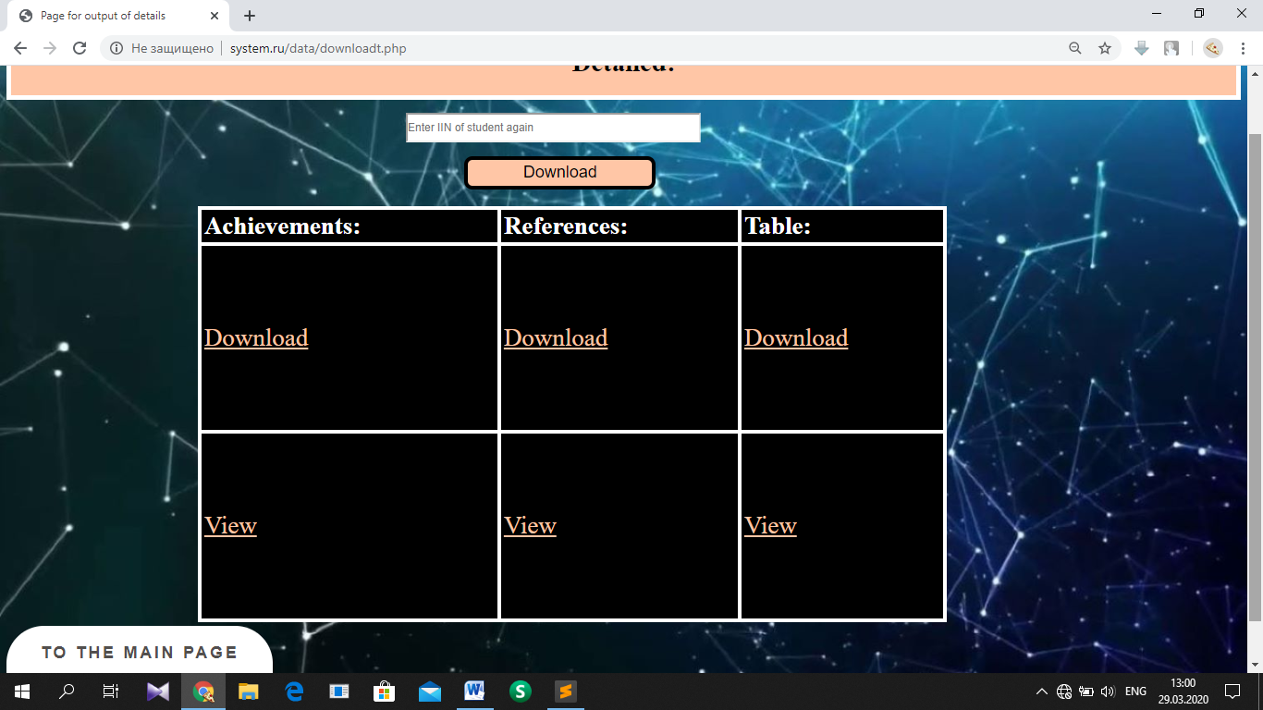

T11.2.1. Only three files appeared in the table that the teacher needs

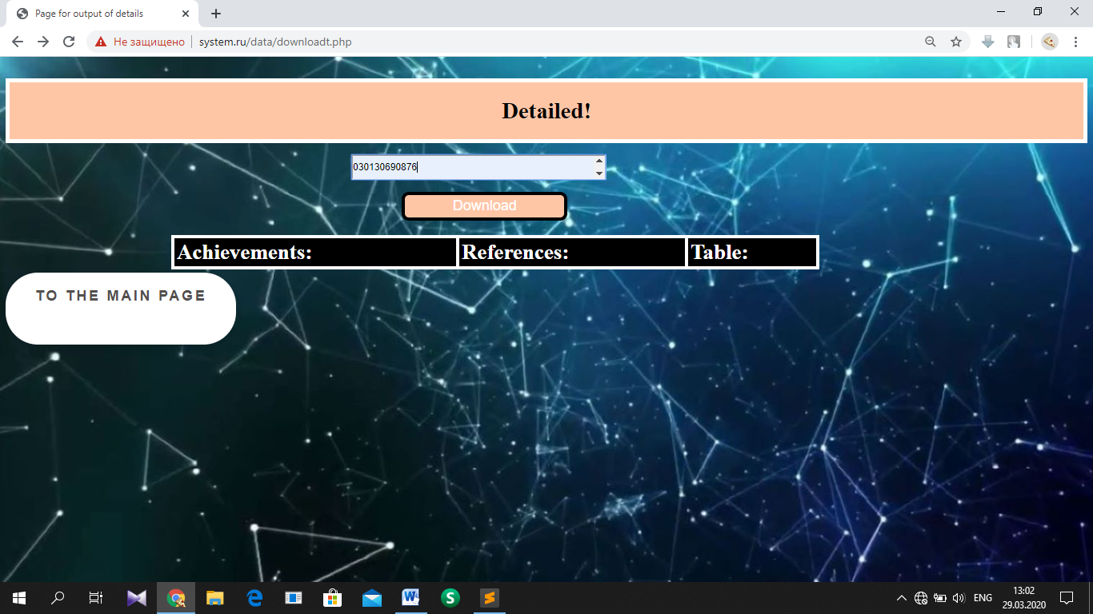

T11.3.1. Not existing IIN of student is written in field

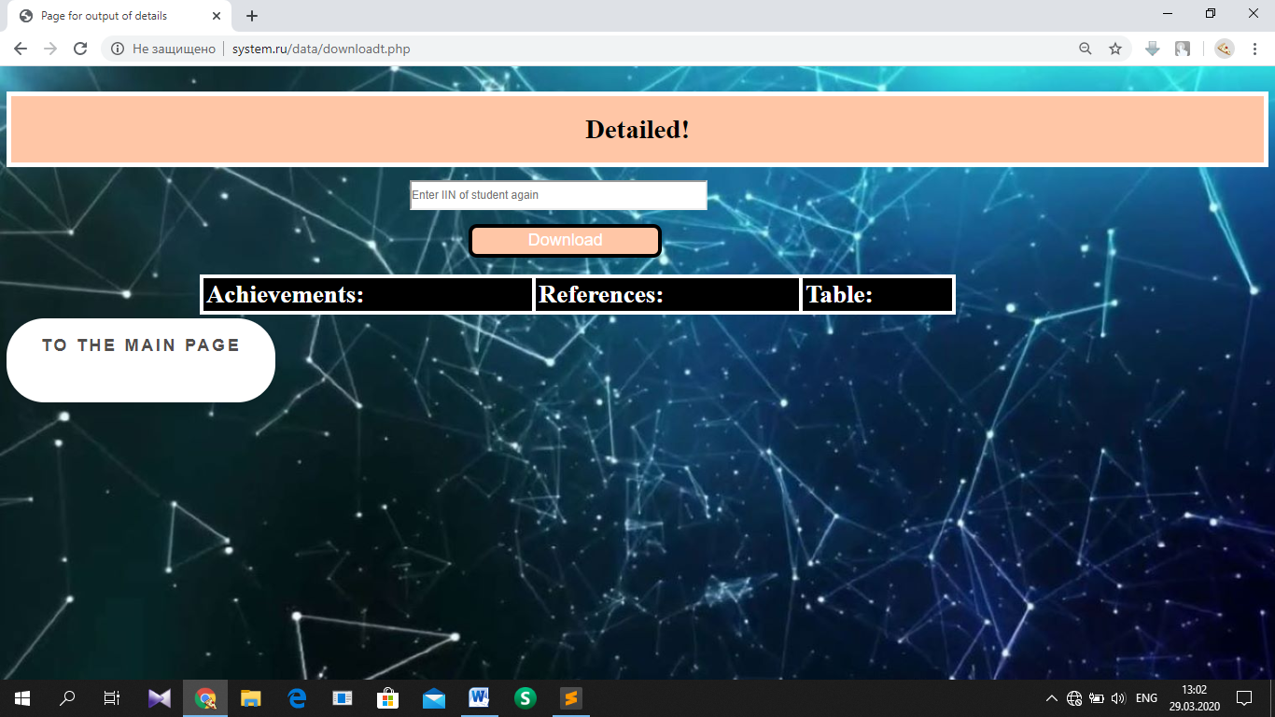

T11.3.2. Page has been refreshed after inputting not existing IIN